# Final

* open book, open notes, Thursday, two parts, 2 hours for each part

|  |  |
| --- | --- |
| **Topic** | **Lecture** |
| * *Memory*   + Chapter 9 – Main Memory   + Chapter 10 – Virtual Memory | 9: Memory  10: Paging, VM |
| * *File System*   + Chapter 13 – File System Interface   + Chapter 14 – File System Implementation   + Chapter 15 – File System Internals | 11: File System - Theory  12: File System - Implementation |
| * *Storage Management*   + Chapter 12 – I/O Systems | 13: I/O Systems |

## Main Memory

Another place where you have resource, you have resource within the system that you need to manage. Managing the main memory on behalf of processes that are running in the computer system. The OS is doing the management. Memory management not only managing the resources, also has to do what’s going on in terms of the address translation. Memory address translation based upon how the memory is being managed, what strategy is being used for that, determine how that address translation happens. Translation is determined by which scheme you’re using.

* Swapping
* Allocation
  + **Contiguous** versus **Non-contiguous**
    - Segmentation, paging, … (noncontiguous)
  + Algorithms

Tell you how to manage memory. Most of the algorithms are essentially looking at the allocation of memory spaces to processes, whether they need contiguous space in their allocation. Or then the additional, more flexible approach is noncontiguous schemes are being used.

* Fragmentation – issues
  + Type: internal, external
* Memory address translation
  + Memory access time

calculating the time it takes to access memory when the instruction does the memory reference.

Look into how to calculate it.

* Paging
  + Page table, entries, …
  + TLB (Translation Look-aside Buffer)

When we have large page tables, doing memory address translation, using page table, especially when they get large might have overheads associated with that. And we want to make that fast because we want our instructions to go fast, in that case TLB gets used. Now calculation of memory access time, we have the possibility that we actually find a page to frame entry in the translation lookaside buffer and can very quickly do the address translation, versus, if not, having to go to the page table, and taking a look longer time.

* Question: Is it correct to think TLB as a quick memory cache for the page table?

Answer: Yes. Thinking without virtual memory, but just saying from the perspective that I am issuing logical addresses from my instructions, those have to be translated to physical addresses. I have a page table that records frame numbers that associated with my logical pages.

Right now I am going to assume that all these pages are in memory, and make an assumption that my page table also in memory.

So when I calculate the memory access time for page based memory management, then the first thing I need to do is accessing the page table, it costs me something to do that.

* + If the page table is in the memory and I don’t have translation look-aside buffer, then I pay that cost on every reference. That is an overhead, at least one memory reference, in order to then get back the frame number and I make another memory reference, read or write depends on what my instruction is doing to do that operation.

So translation look-aside buffer is trying to make fast certain references that you have done in the immediate past. In contrast to just a cache, it is more of a special memory, and it will have a particular size associated with it, and it’s faster.

Generally when you are given a problem that says calculate the memory access time in this circumstance, you’ll also be told

* + what is the cost of going to memory,
  + what is the time it takes to get into the translation look-aside buffer, and
  + what is the percentage of time that you will find a page in that TLB.

Based upon these 3 values, you should be able to calculate what the average memory address time is.

## Page-based Memory Allocation

Page-based memory allocation is that we essentially looking at our logical address space, and we’re partitioning that into a number of fixed sized pages. These are logical pages, these are pages determined by logical addresses. If I had a 32-bit address, I would have a logical address space that is of $2^{32}$ in size. And each one in a page-based memory allocation, we then say that’s how much I have, then divide this upon to pages of particular fixed size, e.g., 4K ($2^{20}$), 8K.

* Programs are provided with a logical address space
* Role of the OS to fetch data from either physical memory or disk
  + Done by a mechanism called (demand) paging
* Divide the logical address space into units called (logical) “**pages**” each of which is of a fixed size (usually 4K or 8K)
  + Example: 1M logical address space has 256 4K pages
* Divide physical address space into (physical) “**frames**” each the same size as a page
  + Example: we might have only 32 4K-sized pages

The number of pages that you can talk about once you divide your logical address space into pages, can be quite large, and a page-based memory allocation approach, all those pages are needed to be represented in a page table. Because all of them are potentially addressable.

Physical memory are also going to be divided up into the same size of the page called frames.

A large logical memory space 🡪 only a small physical space

## Page Tables

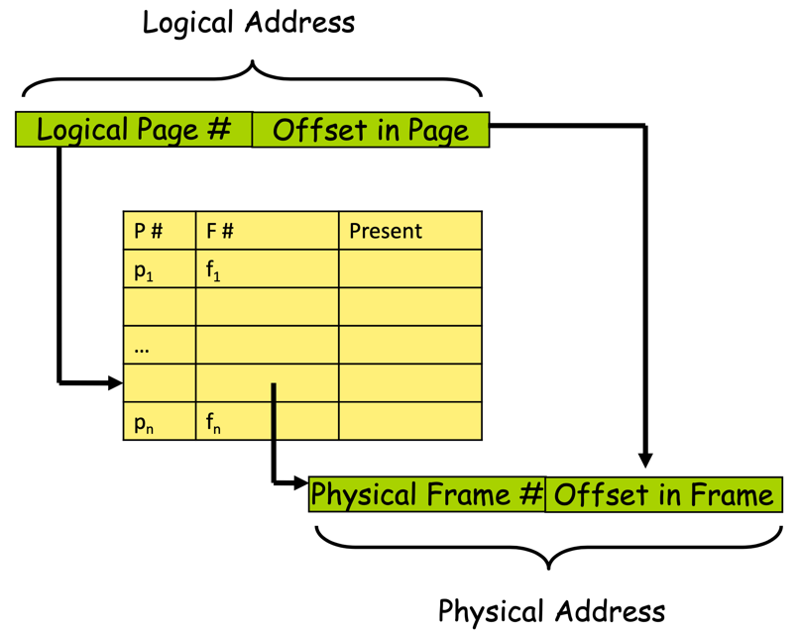A page table is representing those mappings from page number to frame number, we index by the page number, we take bits of the address to do that, then we use offset into the page after we found the frame # to go into that physical address.

This page table is needing to have an entry for every single logical page because we can have a large number of addressable bits, bits in the address that page table itself can get large.

That poses a problem: how to store the page table?

Since the page table is getting large and indexing it can cause some problems if the page table has to be the size of the number of pages in the logical address space, even when those logical pages are not being referenced.

Some approaches can be used to address this problem.

## Virtual Memory

Memory access time for virtual memory includes page fault handling.

Idea: satisfying memory requests, memory references, and so forth.

- A transition from memory management techniques to really thinking about how to support processes who may have larger memory requirements than the actual size of physical memory.

It can be a single process that has more requirements, it can be the set of processes that are running that has more requirements in the size of the physical memory. That becomes a problem.

In contrast to logical memory is the additional thinking about memory is being an infinite resource that can be accessed by a process beyond physical limits, the actual physical memory. That’s the problem it’s trying to solve.

This problem is solved by building in support within the OS and computer system, for essentially managing memory using paging primarily, whereby you are also using a backing store, which is a storage system for putting pages that do not have associated frames during the execution.

This was bringing forward the idea of swapping (which is also using the backing store), in the case it’s swapping entire process memory back and forward between physical memory and backing store. To bring forward in the virtual memory, we’re doing that on a per-frame, per-page basis and associated frame that is holding that page. If a page is being accessed by a process, and the page does not have a frame allocated to it, then the state of that page, the data in that page is stored on the backing store. When a page is referenced, and it’s not in memory that’s a page fault, then the basic idea is the OS handles the page fault by finding an empty frame and bringing in the page on the backing store into that frame. Then doing the right thing to the page table, all during this time, the process that had the page fault cannot proceed, it’s stopped (halted) and waiting for its page fault to be handled. Once it’s handle, that process can be restarted in a way that it will re-execute the instruction that caused the page fault. From the process’s point of view, it just sees an unlimited virtual memory, because it’s all being provided by the OS and computer system hardware.

* What is virtual memory?

It’s all about page fault handling, all about page replacement.

In situations where you have physical memory being heavily utilized to the point that there are not very many free frames floating around. You have to decide how to identify a frame is currently used by some process and force it to give up that frame (swap out to backing store), make it free, so you can satisfy page fault from another process, even possibly the same process.

* Page fault handling
  + Performance estimations
  + Memory initialization
* Page replacement
  + Algorithms

compare different algorithms based on their performance

* + Belady’s anomaly
* Aspects of virtual memory
  + When to update: copy-on-write

Backing store is not necessarily like the normal storage system for files, because it’s so intimately tide to virtual memory that typically those backing stores would be ideally implemented in some types of faster storage system (device).

* + Sharing: shared pages between processors

You can have sharing with pages, also can have sharing with virtual memory.

* + Use with I/O: memory-mapped files

There’s also idea of paging in virtual memory to support memory-mapped files, memory-mapped I/O.

* Thrashing

Memory is a critical resource. You have a large number of processes running, each one of them having some minimum number of frames that needs to have allocated pages just be able to make any progress. So you started to divide up, the number of frames divide up the memory into frames, and allocated across every increasing number of processes you are going to run out, you are going to hit a limit where processes are not given enough locality in the number of frames assign to them, for them to make progress. In other words, for them not to start encounter higher page fault rates.

The more you put that pressure on, the more you’re going to see what’s called thrashing.

Where you are spending more time on handling page fault whether that’s on an individual process, or whether it’s across the set of processes. Then you do not get any work done.

Pressure: too many processes running in the system.

* Working sets

A way to manage frame and memory.

It’s basically making judgement about what’s the number of frames it’s currently necessary for this process and using page fault to consider how that size is changing both in terms of shrinking as well as growing.

Essentially using a combination, it’s a memory management technique but it’s also a sort of involving this process management as well. It’s trying to model for any particular process, how many frames it needs, at any time. Based on what it sees, and observes due to the page fault rate of that process, it makes the decision of either shrink the size of the working set or to grow it.

Sometimes it’s necessary to stop processes from executing, put them on halt, take away their frames, so you can get other processes making progress.

## Page Fault Handling

You have to have a page table for sure, valid/invalid bit assigned to that page, any frame is assigned to that page.

If you have a page fault, have to find a frame, it might be necessary to take a frame away from another process, or from these processes, some other pages, just to make it free.

Then reset the page tables, reset valid bits, restart the instruction.

* If there is a reference to a page, first reference to that page will trap to OS:
  + Page Fault
* OS looks at another table to decide:
  + Invalid reference?
    - YES 🡪 abort

if there’s a page fault 🡪

* + Just not in memory?
* Get empty frame
* Swap page into frame
* Reset tables
* Reset validation bit = v (valid)
* Restart the instruction that caused the page fault

## File Systems

Represents an information structure in your computer system for putting things that last longer than just a process’s execution. It’s not only relevant to a process’s execution.

Representing a part of the system that the OS is providing access to by this living longer over longer period of time.

Layered set of interfaces, a process wants to do is get access to the file system, perform operations on file and so forth. Found a file in a particular file system or not.

What’s happening on the lower level, the OS is supporting locating files on actual physical storage devices.

* File system **concepts**
  + File system layers
  + Files, directories, file systems
  + Operations and usage
  + Remote file systems (did not really cover)
* File system **implementation**
  + What’s on the disk? How’s it formatted?
  + What’s in memory? How’s it represented?
  + File Control Blocks (FCB)
* File system **usage**
  + file allocation
  + getting a file caching
  + free space management
  + recovery (did not really cover)

## I/O Systems

How the OS essentially interfaces with IO devices, and provides access to those IO devices through upper level layers that the processes would be using to do operations with these IO devices.

Controllers are acting as a way of bridging between the rest of the computer system and what are the specific details of the interfaces, and how they operate. Then the OS is interfacing with IO devices that configured with device drivers and lower level IO control software that will be working with the hardware level interface, in terms of how that type of device is needing to be interfaced and managed or operated with. We have upper layers that might then use these device drivers, IOCTO layers below it in a particular way to work with the IO devices, whether they are using the device driver is based upon a polling mechanism, in terms it’s interfacing with the IO device, or whether that IO device might be an interrupt enabled IO device that allows for interrupts, to be generated reflecting events that take place in that particular device.

DMA in which a way interfacing an IO device could be managed by another hardware component, a DMA controller, which acts as a component to take over program-based IO, that we typically used to send data back and forward between the devices, whereby having an instruction executing on the CPU to do that program based IO. Along with the DMA controller, we take over essentially that part of the IO interfacing and do the memory access because that DMA controller would have master capability on the memory bus as well as then do the necessary IO bus side operations to move the data, that data being now a block of data rather than just an individual byte that programmed IO would do.

DMA has the advantage of taking this programmed IO, and doing it through a programmed DMA controller DMA interface thereby relieving the OS with the device driver in this case. From having to do all that, therefore needing the CPU in order to execute the instructions to do that.

This is basically the idea.

* I/O hardware
  + Devices
  + Controllers
* Interfacing with I/O devices (two styles of device driver)
  + Polling, Interrupts
  + DMA
* Types of I/O operation
  + Blocking / Nonblocking
  + Synchronous / Asynchronous
* I/O system structure in OS

Be reflective of different variety of IO devices, how each one of them need to have their own device driver and IO controller that are just configured components of the OS. And the OS at a higher level above that is trying to implement some mechanisms that within allow for those configured lower layers, the device drivers, the IO controllers based upon what you have within your particular computer system configuration.

# Lecture 9 – Main Memory (Chapter 9 & 10)

## Outline

* Background
* Swapping
* Contiguous Memory Allocation
* Segmentation
* Paging
* Structure of the Page Table
* Examples
  + The Intel 32 and 64-bit Architectures
  + ARM Architecture

Segmentation 🡪 segments are first noncontiguous allocation, segments in the context initially backing store

You can have multiple segments

## Background

Processes need to have memory, need to be able to get loaded to the system, allocated, time on the CPU as well as allocated memory resources.

* Program must be brought (from external storage) into memory and “loaded” in a process for it to be run
  + A program goes through several steps before producing an executable code image that the OS uses to create a process
* A program starts with “logical” addresses that are in the “logical” address space its process
  + Instructions produce addresses with respect to logical addresses (“virtual” addresses)
  + Need to bind (map) between “logical” addresses and “physical” addresses in memory
* All this depends on both software and hardware
  + Software includes compilers, loaders, and OS
  + Hardware include memory system, address translation, …

## Address Binding

* Addresses represented in different ways at different stages of a program’s life
  + Need to bind one address to another
  + Source code addresses usually symbolic (i.e., names) name of things
  + Compiled code has addresses that need to bind to **relocatable** addresses
  + Linker or loader will bind relocatable addresses to **absolute** addresses
  + Each binding maps one address space to another
* All of these addresses are “logical” addresses

### Memory and Address Binding

We need to have storage space allocated to a process and be addressable by that process. The only two things we have that are addressable by instructions are registers living in the CPU and the stack.

* Main memory and CPU registers are the only storage directly addressable by a program
  + CPU registers are accessed in one CPU block (or less)
  + 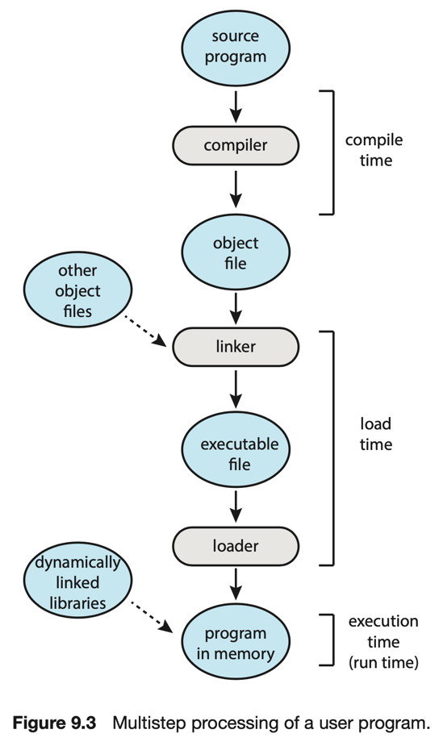Memory system sees addresses from read/write operations
* Addresses used in CPU instructions are logical addresses
  + Reference the logical address space of a process
  + These logical addresses must be “translated” to physical addresses
* What does address translation (address binding)?
* ***Compile time***:
  + if a memory location is known *a priori*, code can be generated with absolute addresses, but needs to be recompiled if the location changes
* ***Load time***:
  + If a memory location is known *relative* to an address, code can be generated with relocatable addresses
* ***Execution time***:
  + addresses are mapped dynamically during execution using *memory management* hardware

## Multistep Processing of a User Program

|  |  |
| --- | --- |
|  | Everything on the left side of the CPU, all of that is the address binding part in the logical address space. Having to deal with logical addresses but also relative to these different types of address spaces, from source code all the way down to the binary code that’s going to run on the CPU.  You can think of everything in blue as a logical address that’s being generated and finally goes through that memory translation, and you get physical memory. |

## Logical vs. Physical Address Space

The logical address space is what we’ve been talking about up to this point. The physical address space is the address is what we use to access memory.

* Logical -> think these are the addresses i need to reference things IN MY PROCESS and they are the addresses that ultimately get generated in the CPU instructions. Logical addresses are accessing the process address space.
* But the physical address -> is where things actually live in physical memory when they are being used and when memory is allocated to a process in main memory. They represent physical memory.
* The concept of ***logical address space*** that is bound to a separate ***physical address space*** is central to proper memory management
  + *Logical address (virtual address)* – generated by the CPU
    - *logical address space* is the set of all logical addresses generated
  + *Physical address* – address seen by the memory unit
    - *physical address space* is the set of all physical addresses used
* Logical and physical addresses are the same in compile-time and load-time address-binding schemes
* Logical and physical addresses MUST be different at execution time. Why?
  + Hardware-based address binding schemes here must do this
  + They must be fast

## Memory Management Unit

We need support from the hardware (software would be problematic and slow). This hardware is called the Memory Management Unit.

* Hardware device that maps a logical (virtual) address to a physical address
* How it does this is at the heart of all memory management schemes
* *Memory Management Unit (MMU)* changes the logical address into a physical address

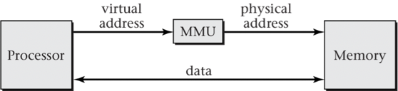Logical address is the virtual address you see here, we need to map this to the physical memory. So that particular address goes through the MMU, and the MMU changes it to a physical address so we can get the address in memory and do read or write on it.

## Contiguous Allocation

One approach to managing memory is to say that all the addresses that I will be considering for a process are allocated in a contiguous piece of addresses. They are contiguous in the sense that the addresses go from one low value to a high value. <- these are for the logical addresses.

Contiguous allocation takes those contiguous logical addresses and allocates a contiguous size of physical memory for those addresses.

* Main (physical) memory must support both OS and user processes
  + A limited resource
  + Must allocated efficiently
* *Contiguous allocation* is one early method
* Main memory usually into 2 partitions:
  + Resident Operating System
    - usually held in low memory with interrupt vector
  + User processes
    - held in high memory
* Each process contained in single contiguous section (partition) of memory

### Contiguous Allocation Address Translation

Now how do I do the mapping? How do I take the logical address and map it to a physical address? Use two registers. 1) a base register contains the index into the memory where this partition starts 2) the limit register is used as a limit to set a bound on the address space starting at that point. It essentially said how large the partition between the limit and the base is.

We also use the term relocation register which is something that is set to an address which is the beginning of a partition. And it also has a limit to make sure that the address falls within the partition.

* One mechanism is to *offset* all logical address
  + A ***base register*** contains a value that is added to every logical address before it is sent to memory
  + A ***limit register*** is used to set a bound on the maximum address
* Another mechanism is to *relocate* an address
  + One or more relocation register(s) contains a value that is added to every logical address of a memory region before it is sent to memory
* User program’s generate logical addresses
  + Their logical addresses change to physical addresses

### Base and Limit Registers with Partitioning

|  |  |
| --- | --- |
| * How do we support the *logical address space*?   + A pair of *base and limit registers* * CPU must check every memory access generated in user mode to be sure it is between base and limit for that user   + If not 🡪 an exception occurs * Need hardware support for doing this * Useful for mapping entire process address space into a fixed address region * OS sets up base/limit values |  |

What is being mapped?

A logical address that starts at 0 is being mapped to the base

And any address that’s within that space of addresses will be added to that base when you map it in physical memory

## Hardware Address Protection

* If the OS did the check it would be slow
* Hardware is used instead

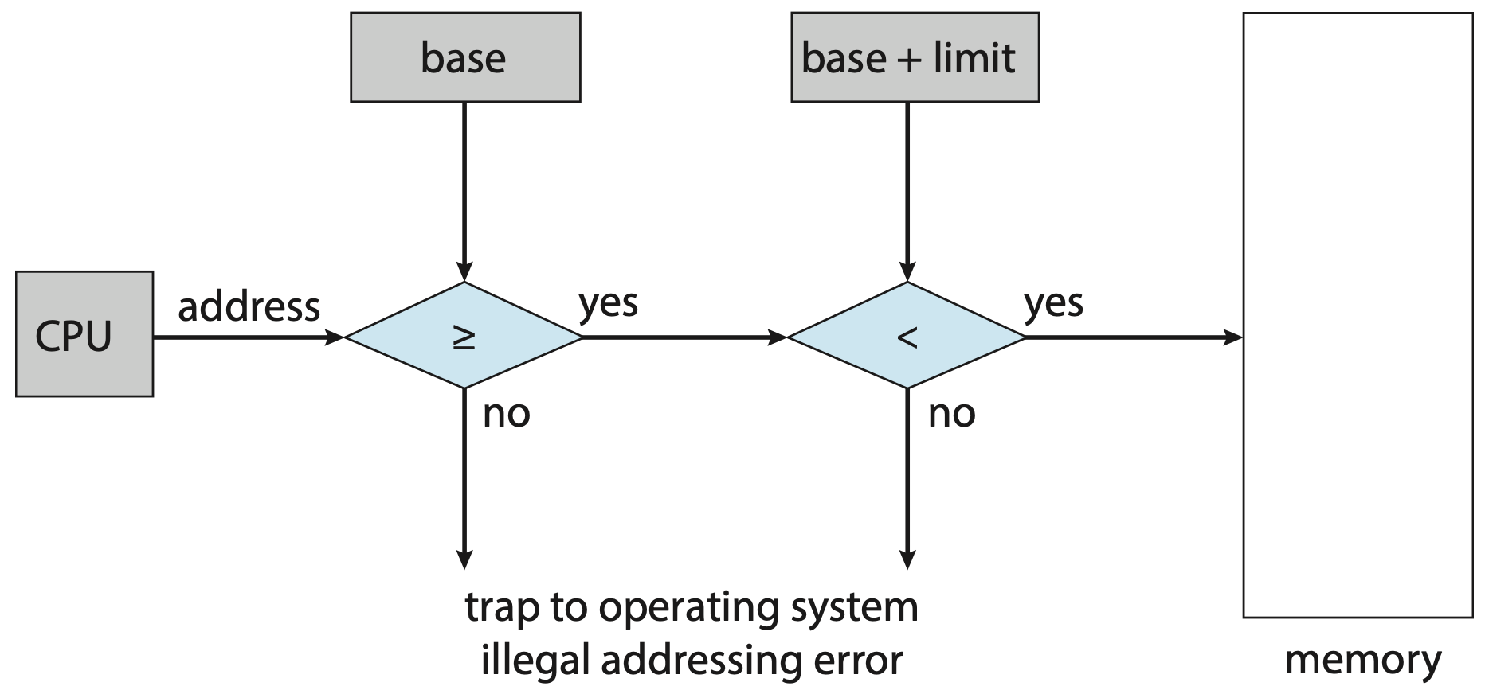

We’re taking logical addresses in contiguous allocation, which we are assuming start at 0 and go to a certain number of addresses. The address that comes out of the CPU is a logical address and we assume it starts at 0, we want to shift that address to start from the base and go to the limit. And if I don't exceed the limit, then I can actually access physical memory.

The memory management unit is doing exactly this!

Who sets the base and the limit registers? The OS sets the base and the limit registers based on what the process tells the OS it needs to have for memory allocation.

## Dynamic Relocation via Relocation Register

* 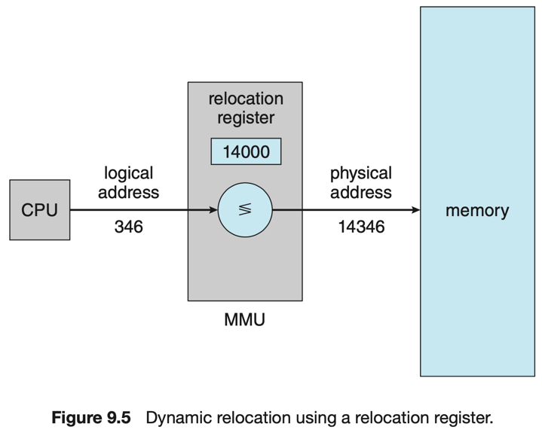CPU logical address is converted to a physical address by adding the value in the relocation register
* Like a base register except you can have registers
  + One for each memory region
    - Code region
    - Heap region
  + Different routines

(dynamic loading)

* Little support from the OS is required
  + Implemented through program design
  + Used in coordination with base/limit register

If we had a relocation register, which is like a base register but you could have multiple relocation registers that get used in your program, the idea is still the same. It’s still a contiguous allocation and we have contiguous addresses that we want to shift to physical memory. So we set a relocation register for this particular process. That particular process has memory management unit information set up by the OS to do memory translation. And just like the CPU state, when we do process context switching, this is part of the context.

The memory managing is part of the context for a process because it’s doing address translation. You have to know what are the settings for the process, because that’s how the OS sets aside memory for the process.

DIFFERENCE BETWEEN BASE REGISTER AND RELOCATION REGISTER:

* With the standard base register, what we’re assuming is that all of the addresses that a process would use are all in this contiguous range of addresses, so it’s very basic and simplistic.
* But with a relocation register, it’s a more general concept, maybe a process has different sets of contiguous addresses. And what we want to do is to map each set into physical memory (For base register, we only have 1)
  + You have different regions of the process, so you could have a contiguous space for each of the addresses.

## Dynamic Linking

Sometimes addresses are not known until execution time, like dynamic linking - they get linked to your application at execution time.

Two types of linking of binaries:

* Static linking: everything is in your binary
* Dynamic linking: might be at execution time that you find out you need a piece of code you might not have had in your image but you need to go find it at execution time.
  + At execution time you have to link the logical address to the physical address
* ***Static Linking***
  + System libraries and program code combined by the loader into the binary program image
* ***Dynamic Linking***
  + Linking postponed until execution time
* Stub used to locate the appropriate memory-resident library routine
  + stub - small piece of code
* Stub replaces itself with the address of the routine and executes the routine
* OS checks if routine is in the processes memory addresses
  + If not in address space 🡪 add to address space
* Dynamic linking is particularly useful for library (Why?)
  + System libraries loaded when the program starts are also known as ***shared libraries***
* Consider dynamic linking use to patching system libraries
  + Versioning may be needed

## Multiple-partition Allocation

* Degree of multiprogramming limited by number of partitions
* Variable-partition sizes for efficiency (sized to a given process’ needs)
* Hole
  + Block of available memory
  + Holes of various size are scattered throughout memory
* When a process arrives, it is allocated memory from a hole large enough to accommodate it
* Process exiting frees its partition, adjacent free partitions combined
* OS maintains information about:

1. Allocated partitions
2. Free partitions (holes)

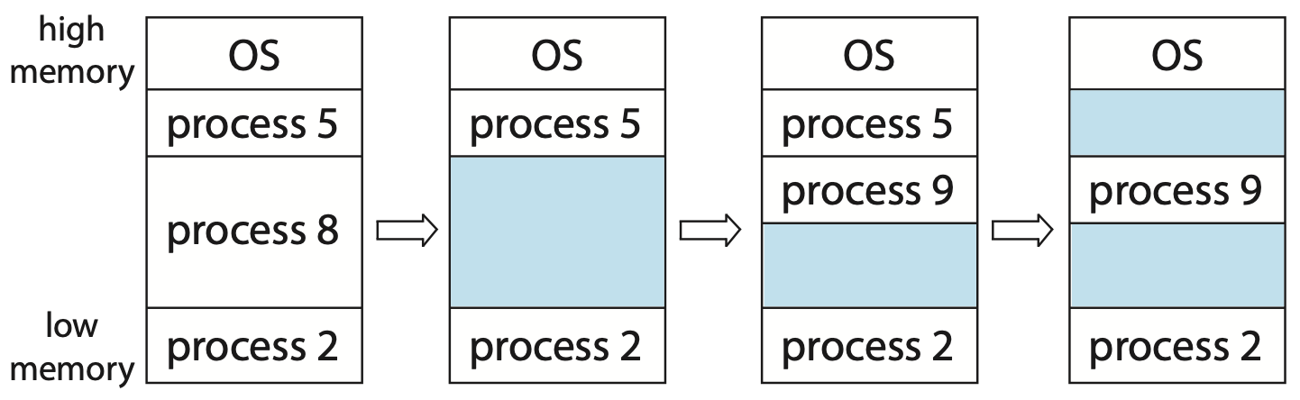

Example, process 8 finishes so it frees the memory. Process 9 comes along and gets in the space, then project 10 comes and there’s little space left over.

So a problem arises with contiguous allocation -> fragmentation (the physical memory starts to get fragmented- get holes in it, some of which are too small to hold any process. We could do something about this by moving processes around, to for example have all the free space in one contiguous space in memory). <- this is external fragmentation

### Dynamic Storage Allocation Problem

How do we assign free space to processes?

* How to satisfy a request of size *n*?
  + Assume there is a list of free holes
* **First-fit**
  + Allocate the first hole that is big enough
* **Best-fit**
  + Allocate the smallest hole that is big enough; must search entire list, unless ordered by size
  + Produces the smallest leftover hole
* **Worst-fit**
  + Allocate the largest hole; must search entire list
  + Produces the largest leftover hole
* First-fit and Best-fit better than Worst-fit in terms of speed and storage utilization
* Neither First fit nor Best fit is clearly better than the other in terms of storage utilization, but First fit is generally faster.

## Fragmentation

* **External fragmentation**
  + Total memory space exists to satisfy a request, but it is not contiguous
* **Internal fragmentation**
  + Allocated memory may be slightly larger than requested memory
  + This size difference is memory internal to a partition, but not being used
* First fit analysis reveals that given *N* blocks allocated, 0.5 *N* blocks lost to fragmentation
  + 1/3 may be unusable 🡪 *50-percent rule*

### Fragmentation Improvement

* Reduce external fragmentation by ***compaction*** - shuffle memory around and get all the free holes into one contiguous space.
  + Shuffle memory contents to place all free memory together in one large block
  + Compaction is possible only if relocation is dynamic, and is done at execution time
  + I/O problem
    - Keep job in memory while it is involved in I/O
    - Do I/O only into OS buffers

## Swapping

* Physical memory space is finite
* OS takes up some portion of the physical memory
* Suppose we allocate physical memory to meet the needs of a process as discussed
  + What happens when the total physical memory space requested by processes exceeds physical memory?
  + Just consider 2 processes
    - One way to approach this is to say “tough love, we can only execute one process at a time.” so the other process must wait until the first one is done and gives up its memory.
    - Another idea is swapping.
* Swapping is the idea of sharing physical memory space by having one 1 process use the space at any time
* Still think about this with respect to contiguous memory allocation for a process

### Schematic View of Swapping

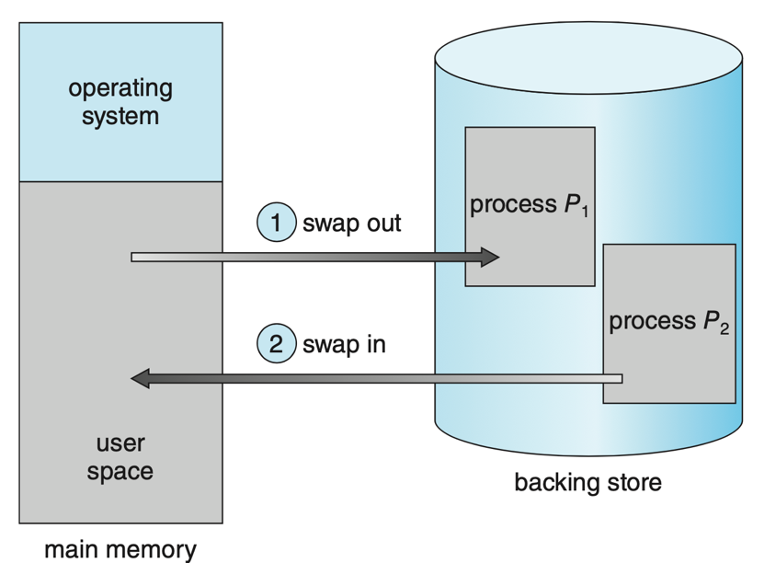Here we have the OS and two processes. If we add the space needed by the 2 processes it is bigger than what we have. So we could say each of the processes have a contiguous memory allocation and I can’t have them both in memory at the same time. So I could have process 1 in memory and then decide I want to run process 2 now. Before I do that I copy everything in process 1’s physical memory into a space we call the backing store. Basically, copy everything in physical memory into an image in the backing store (everything is the same size, everything is the same), then copy process 2’s image into physical memory and tell process 2 to run.

If I can do this completely invisible to the processes execution it’s like what we talked about context switching - the processes will never know! They’ll never know they shared a CPU, and they’ll never know they’re sharing the same physical memory.

Swapping out and swapping in might be expensive, but it also allows the computer system to run multiple processes simultaneously.

When a process is in the backing store it doesn't have memory associated with it, it’s context switched out and it’s just sitting there. It’s not running, but it’s also not terminating.

When you swap the process back, it doesn't matter where it goes to memory. It doesn't have to go back to the same physical memory address.

### Swapping Support

* A process can be **swapped** temporarily out of memory
  + Moved to a backing store – fast disk large enough to accommodate copies of all memory images for all users
  + Later brought back into memory for continued execution
* Swapping is used along with process scheduling
  + **Roll out, roll in** – swapping variation used for priority-based scheduling algorithms
    - Lower-priority process is swapped out so higher-priority process can be loaded and executed
* Major part of swap time is transfer time
  + Total transfer time is directly proportional to the amount of memory swapped
* System maintains a ready queue of ready-to-run processes which have memory images on disk

### Swapping Methods

* Does the swapped-out process need to swap back into same physical addresses?
* Depends on address binding method
  + Also consider pending I/O since it might be associated with particular addresses
* Modified versions of swapping are found on many systems (i.e., UNIX, Linux, Windows)
  + Swapping normally disabled
  + Started if greater than a memory allocation threshold
  + Disabled again once memory demand reduces

### Context Switch Time including Swapping

Swapping is expensive and has a lot of overhead.

* If next processes to be put on CPU is not in memory, need to swap out a process and swap in target process
* Context switch time can then be very high
  + Consider 100MB process swapping to hard disk
  + Transfer rate of 50MB/s
    - Swap out time of 2000ms
    - + swap in of same sized process (+ 2000ms)
    - Total context switch swapping component time of 4000ms
* Can reduce if reduce size of memory swapped
  + Know how much memory really being used
  + System calls to inform OS of memory use via request_memory() and release_memory()

### Swapping Constraints

* Other constraints as well on swapping
  + Cannot swap out if process has pending I/O
    - Otherwise I/O would occur to wrong process
  + Could transfer I/O to kernel space, then to I/O device
    - Known as ***double buffering***, adds overhead
* Standard swapping not really used in modern OS
  + But modified version common
    - Swap only when free memory extremely low

### Swapping on Mobile Systems

* Not typically supported
  + Flash memory based
    - small amount of space
    - limited number of write cycles
    - poor throughput between flash memory and CPU for mobile
* Instead use other methods to free memory if low
  + IOS asks apps to voluntarily relinquish allocated memory
    - read-only data thrown out and reloaded from flash if needed
    - failure to free can result in termination
  + Android terminates apps if low free memory, but first writes application state to flash for fast restart
  + Both OSes support paging

## Non-contiguous Memory Allocation

* Contiguous memory allocation is not all that great for managing memory
* Its advantages are that address translation is very straightforward and fast
  + Just need a base and limit register
* However, there are disadvantages
  + All logical addresses must be contiguous
  + Holes can develop requiring compaction to fix
* Suppose we loosen constraints and allow for non-contiguous memory allocation
  + Segments
  + Pages

## Segmentation

Think of the logical part of the program as being in different segments. And then we will associate a logical address space for each of these segments. In fact, these segments have contiguous space for each segment.

* Memory-management scheme that supports a user view of memory
  + 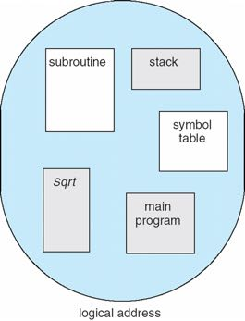Allows different parts to be allocated separately
* A program is a collection of segments
  + A **segment** is a logical unit
  + Instructions
    - main program
    - procedures and functions
    - libraries
  + Data
    - global variables
    - stack
    - arrays
* Associate (contiguous) logical addresses with each segment

### Logical View of Segmentation

|  |  |
| --- | --- |
|  | Here we have 4 segments and each of them have their own contiguous memory space. But the good thing is that these segments do not have to be contiguous with respect to each other. Each segment is separately stored. |

### Segmentation Architecture

How do we do the mapping now? Each segment has its own base register.

Each segment has a segment number, and each segment number has an index to the segment table, which holds the base register, to which I add the offset to get me the index into the physical memory allocated for that segment.

* Logical address consists of a tuple:

<segment-number, offset>

* ***Segment table***
  + Maps two-dimensional physical addresses
  + Each table entry has:
    - *base register* containing the starting physical address where the segments reside in memory
    - *limit register* specifying the length of the segment
* *Segment-Table Base Register (STBR)* points to the segment table’s location in memory
* *Segment-Table Length Register (STLR)* indicates number of segments used by a program
  + Segment number *s* is legal if *s < STLR*

### Segmentation Hardware

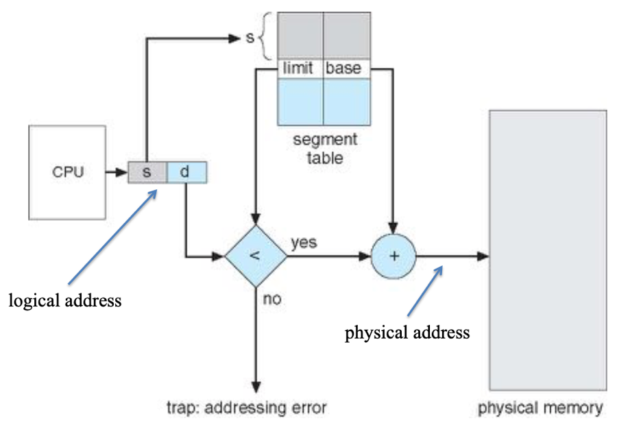The addresses that come out of the CPU Are logical addresses. But the way I have organized these logical addresses are such that I have an upper portion of that address representing the segment number, and the lower portion representing the offset (or d- stands for displacement) into that segment. And the segment table is indexed by the segment number, but what you get out of it is the base register and limit registers for the segment.

So the address translation that’s going on is to see whether your displacement is within the size of the segment and if it’s not then you have an error (something went wrong), so for the segment if the displacement is valid it gets added to the base register where that segment is located, and that becomes the physical address.

All of what you see in this picture has to be in the MMU, it has to be executed at instruction rate.

For every single instruction this should be implemented. This process is implemented in the hardware (MMU).

### Segmentation Architecture Protection

* Protection
  + With each entry in segment table associate:
    - *validation bit* = 0 🡪 illegal segment
    - read/write/execute privileges
* ***Protection bits*** associated with segments
  + Code sharing occurs at segment level
* Since segments vary in length, memory allocation is a dynamic storage-allocation problem
  + Could possibly still result in areas of physical memory that are too small to be allocated to a segment (holes)

### Segmentation and Segment Sharing Example

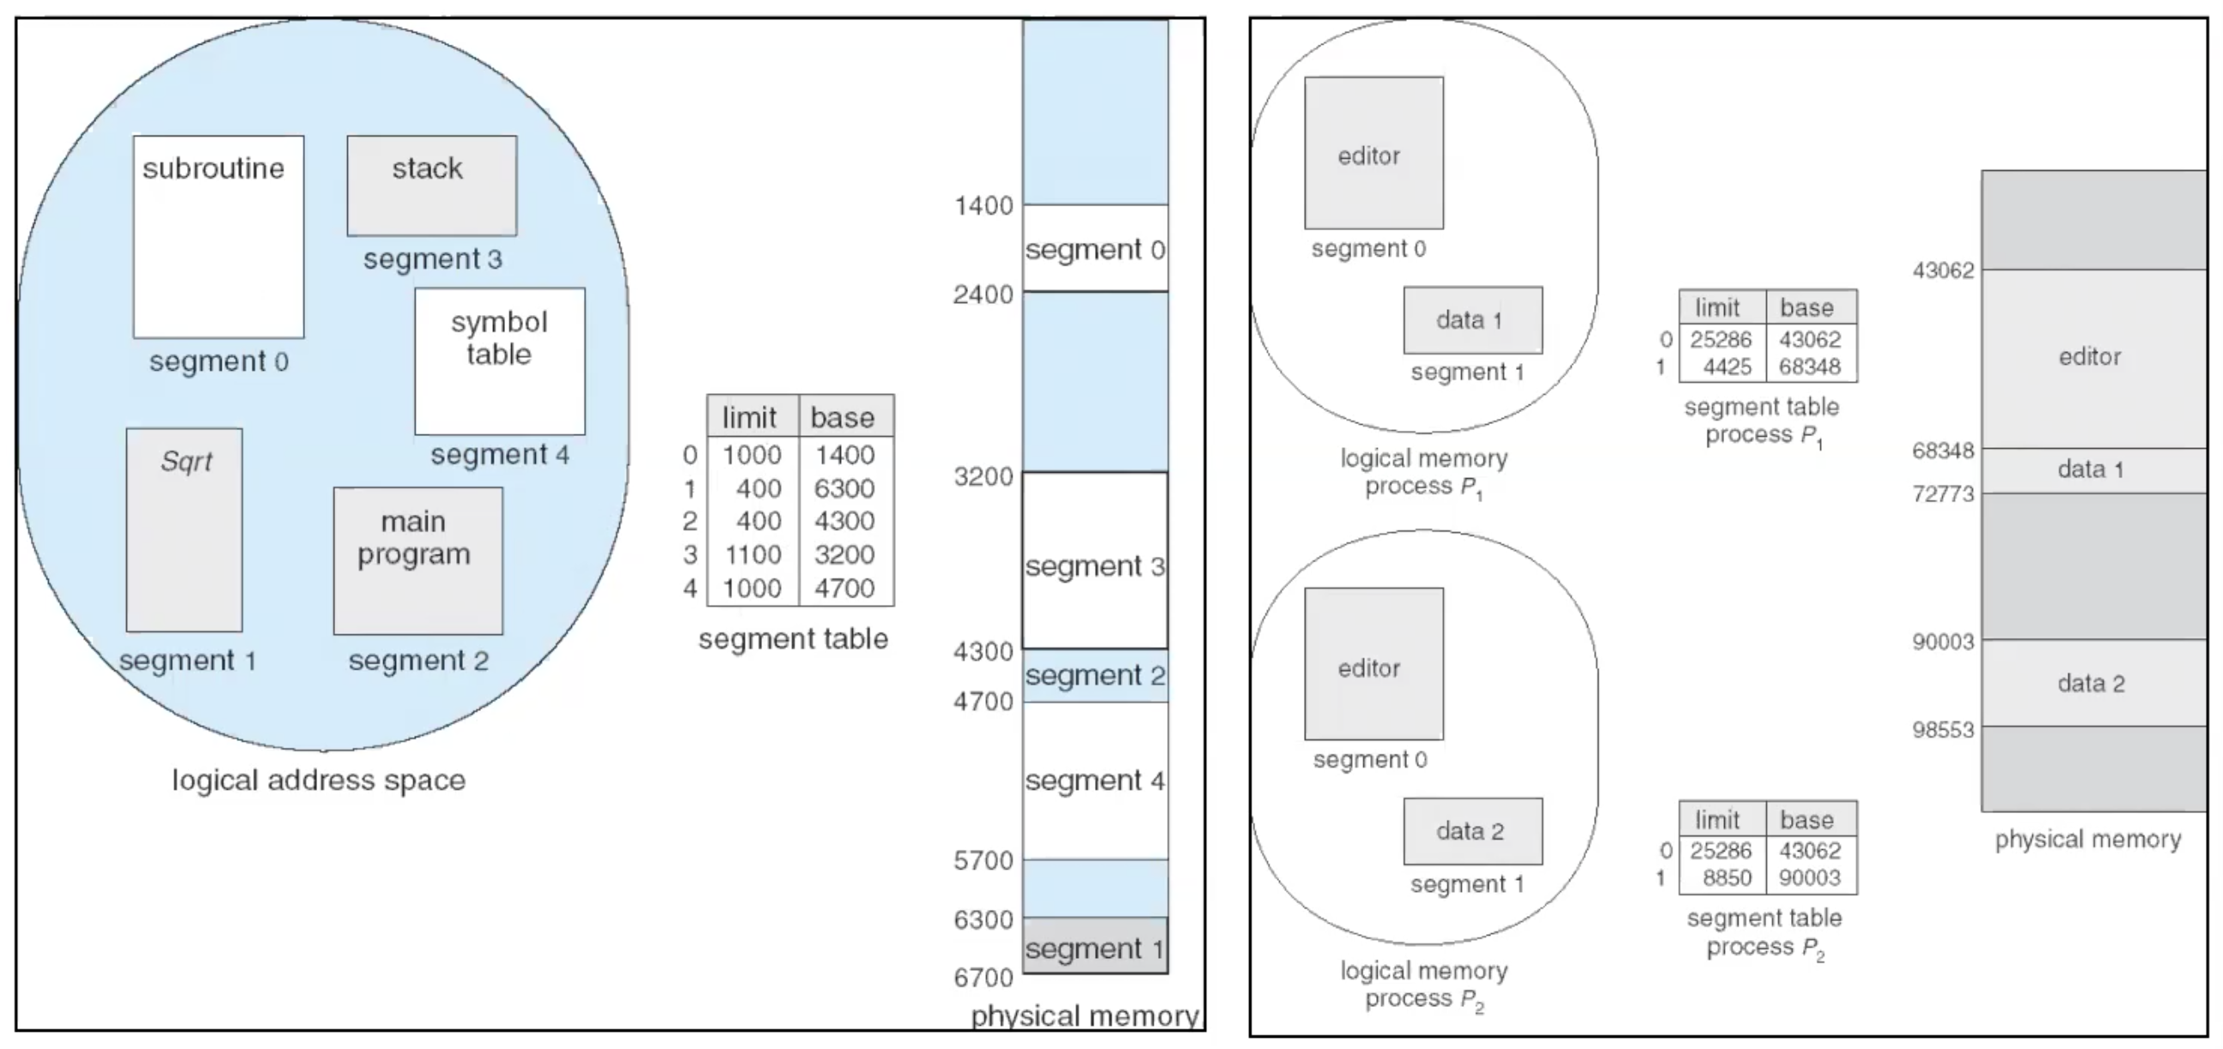

|  |  |
| --- | --- |
| **Left**:  this is for one process, it has 5 segments (0-4). And we have the segment table with the associated index for each segment. And we can map the segments by the indices at the segment table, to the physical memory for that segment. | **Right**:  we have an example with two processes. Each has their own segment tables.  Why do we care about segments?   * It helps to separate out the types of space needed by a process in such a way that we have a little bit more flexibility on how we allocate addresses to the processes. * It also helps in terms of external fragmentation. |

## Paging

Idea:

* Divide physical memory into frames
* Divide logical memory into pages
* Now associate a frame to every page a process is using!
  + If we have a program that requires n pages, we need to find n free frames. And those frames don’t have to be contiguous with respect to each other within main memory
* Problem:
  + Instead of a segment table we now have to have a page table.

We need to find the address of the frame (frame number)

* Suppose we want to eliminate external fragmentation entirely
* Divide physical memory into fixed-sized blocks called ***frames***
  + Size is power of 2, between 512 bytes and 16 Mbytes
* Divide logical memory into blocks of same size called ***pages***
* Keep track of all free frames
* To run a program of size *N* pages, need to find *N* free frames and load program
* Set up a *page table* to translate logical to physical addresses
* Physical address space of a process is noncontiguous
* Memory management reduces to finding frames for pages
  + Process is allocated physical memory wherever pages are available
  + Avoids external fragmentation
  + Avoids problem of varying sized memory chunks
* Backing store likewise split into pages!
* Still have internal fragmentation… Why?

### Address Translation Scheme

Problem: how to assign pages to frames?

The OS assigns frames. It knows what page is associated with each frame.

If the process needs a free page, the OS gives it a free frame and says this is the frame associated with your page.

* Address generated by CPU is divided into:
  + *Page number (p)* – used as an index into a *page table* which contains base address of each page in physical memory
  + *Page offset (d)* – combined with base address to define the physical memory address that is sent to the memory unit

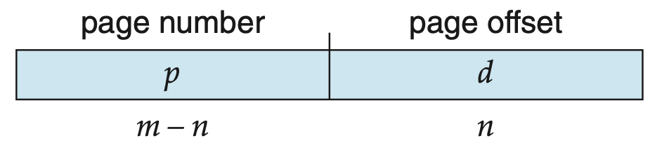

* + For given logical address space 2m and page size 2n

### Paging Hardware (Address Translation)

What happens?

Here’s our physical memory divided up into fixed frames. What’s stored in the page table is the frame number. Because the sizes of the frames and pages are exactly the same; to create this physical address from the logical address, I look up the page into the page table using the page number part of the address as an index to find the frame, and that set of bits goes directly into the physical address and it goes directly to memory.

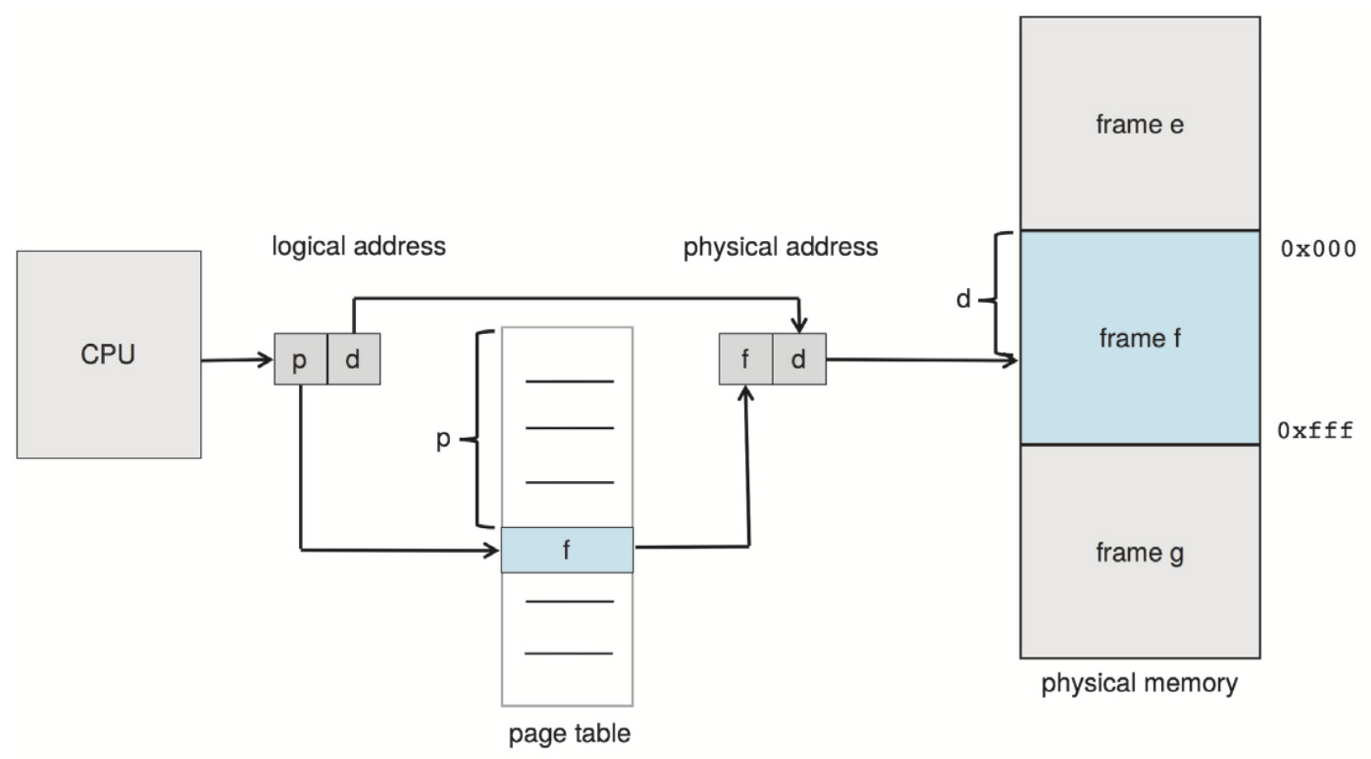

Paging gets rid of external fragmentation, and the reason is as long as I have one free frame I can map a page to it and any time a process does not need that frame anymore it just goes to the free frame list.

But we have other problems:

* We still have internal fragmentation
* If we have a process that requires a million pages, then we have a million entries into a page table. This table needs to be fast!
  + But this problem can be solved!
* Most computers use page based memory management!

### Paging Model of Logical / Physical Memory

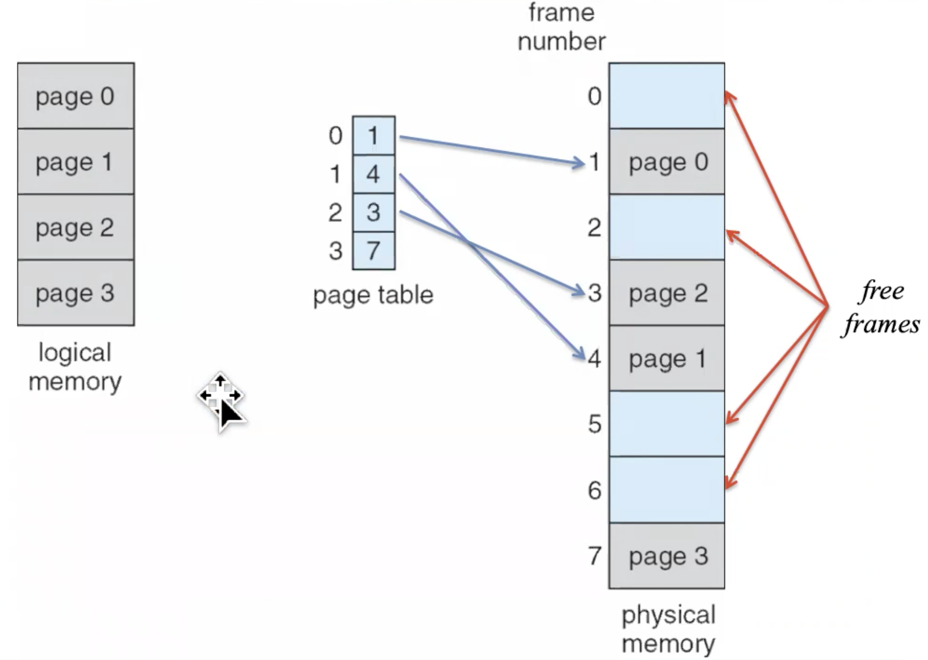



### Paging Example

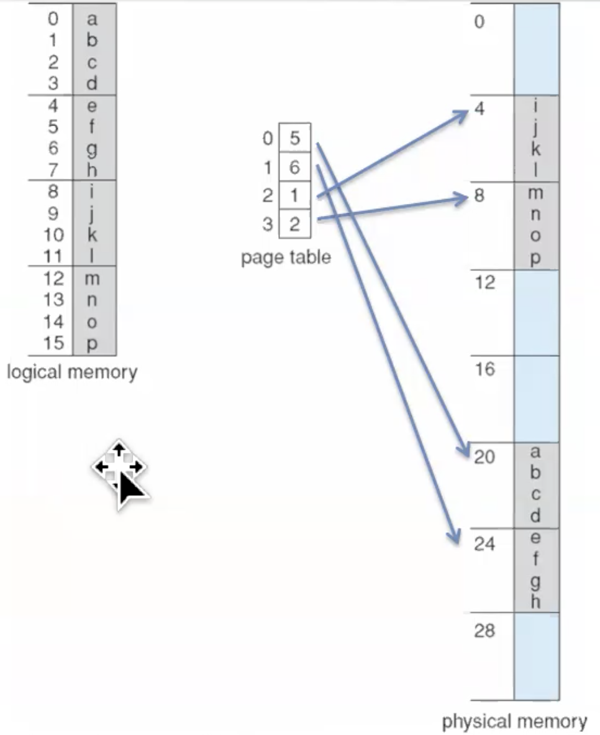



n = 2 and m = 4 32-byte memory and 4-byte pages

### Paging and Fragmentation

having smaller pages might reduce internal fragmentation, but would increase the size of the page table.

* Calculating internal fragmentation
  + Page size = 2,048 bytes
  + Process size = 72,766 bytes
  + 35 pages + 1,086 bytes
  + Internal fragmentation of 2,048 – 1,086 = 962 bytes
  + Worst case fragmentation = 1 frame – 1 byte
  + On average fragmentation = 1 / 2 frame size
  + So small frame sizes desirable?
  + But each page table entry takes memory to track
  + Page sizes growing over time
    - Solaris supports two different page sizes – 8KB and 4MB
* Process view and physical memory now very different
* By implementation process can only access its own memory

### Free Frames

A free frame is an unassigned frame.

The OS is maintaining knowledge about where these free frames are

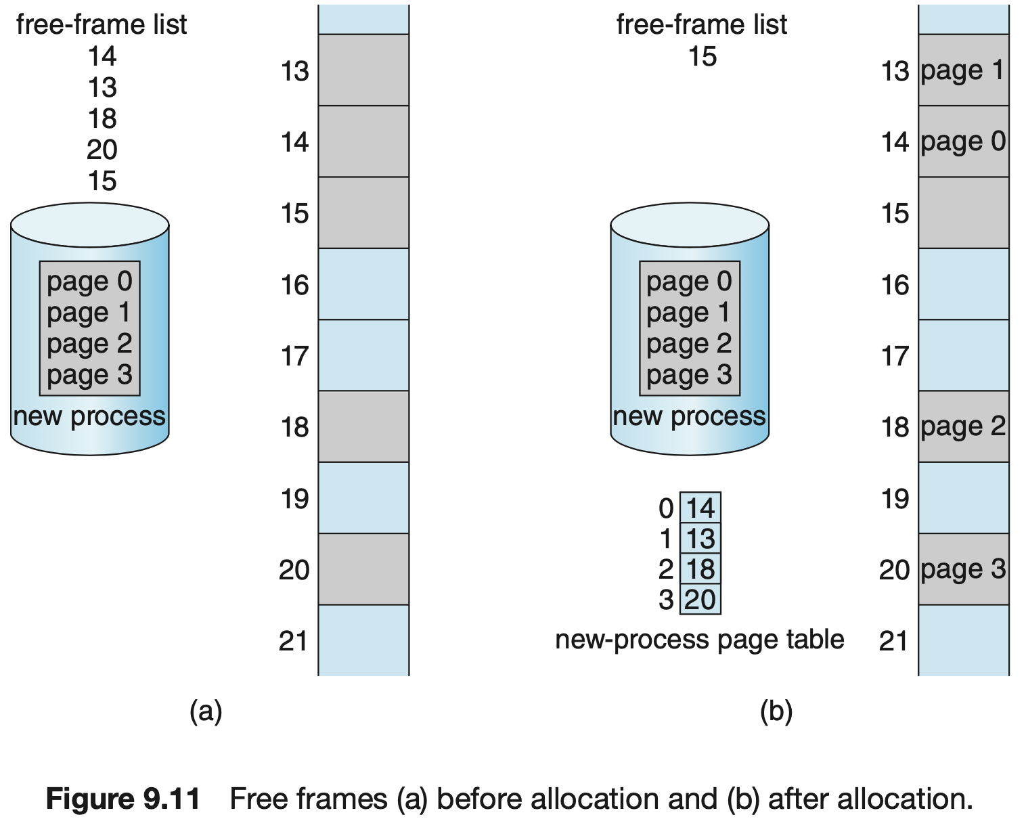

## Implementation of Page Table

* Page table is kept in main memory
* ***Page-Table Base Register (PTBR)*** points to the page table
* ***Page-Table Length Register (PTLR)*** indicates size of the page table
* In this scheme every data/instruction access requires two memory accesses
  + One for the page table
  + One for the data / instruction
* Two memory accesses can be improved by the use of a special fast-lookup hardware cache called ***Translation Look-aside Buffers (TLBs)***
  + Implemented with associative memory

### Page Table TLB

In contrast to the page table, the TLB is a piece of hardware that lives closely to the CPU, probably even on the same chip! And it’s shared between the processes

* TLBs typically small (64 to 1,024 entries)
* On a TLB miss, value is loaded into the TLB for faster access next time
  + Replacement policies must be considered
  + Some entries can be wired down for permanent fast access
* Some TLBs store *address-space identifiers (ASIDs)* in each TLB entry – uniquely identifies each process to provide address-space protection for that process
  + Otherwise need to flush (erase) at every context switch

### Associative Memory

* Associative memory – parallel search

|  |  |
| --- | --- |
| Page # | Frame # |
|  |  |
|  |  |
|  |  |
|  |  |

* Address translation *(p, d)*
  + If *p* is in associative register, get frame # out
  + Otherwise, get frame # from page table in memory

### Paging Hardware with TLB

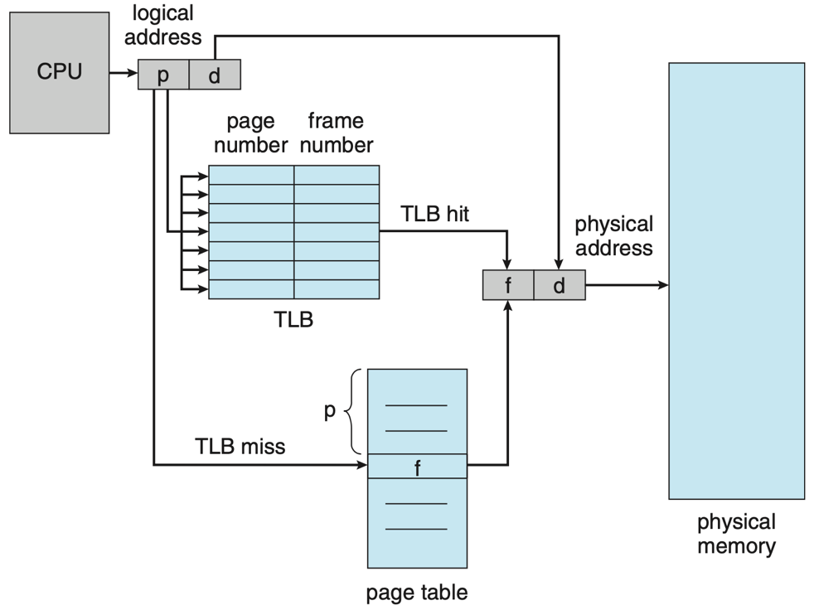What is the TLB? It’s a special piece of memory, called the associative memory, that stores a small number of recently seen page numbers and their associated frame number.

What is special about this is that it's associative which makes it so that the page number can essentially be compared to all the page numbers that are in that translation lookaside buffer, and if it’s there then you also have the frame number that is stored.

We look at the TLB and if it’s there then we also have the frame number that is stored. We call this a TLB hit, which means that the frame number that will be produced by that special piece of memory, the output is valid and can go directly in the frame number field of the physical address.

Another thing that makes the TLB special is that it is fast! It’s able to be fast because it’s small, but it’s also fast because it can compare quickly the page key to all the entries in that TLB.

But it’s small, so there’s a probability that the page won't be in the TLB, in which case we call it a TLB miss and we inform the same standard page table lookup, using the page number as a lookup. If we get a miss, that page number - frame number pair will now be in the TLB.

### Effective Access Time

* Associative lookup = ε time unit
  + Can be < 10% of memory access time
* Hit ratio = α
  + ***Hit ratio*** – percentage of times that a page number is found in the associative registers; ratio related to number of associated registers
* ***Effective Access Time (EAT)***

$EAT=\left(1+ε\right)α+\left(2+ε\right)\left(1-α\right)=2+ε-α$

* Consider $α=80\%, ε=20ns$ for TLB search, 100ns for memory access

$EAT=\left(100+20\right)×0.80+\left(200+20\right)\left(1-0.80\right)=140ns$

* Consider more realistic hit ration 🡪 for TLB search, 100ns for memory access

$EAT=0.99×120+0.01×220=121ns$

## Memory Protection

* Memory protection implemented by associating *protection bit* with each frame to indicate if read-only or read-write access is allowed
  + Can also add more bits to indicate page execute-only, and so on
* Use a ***valid-invalid bit*** attached to each entry in the page table:
  + *valid* – indicates that the associated page is in the process’ logical address space, and is thus a legal page
  + *invalid* – indicates that the page is not in the process’ logical address space
  + or use Page-Table Length Register (PTLR)
* Any violations result in a trap to the kernel

### Valid (v) or Invalid (i) Bit in a Page Table

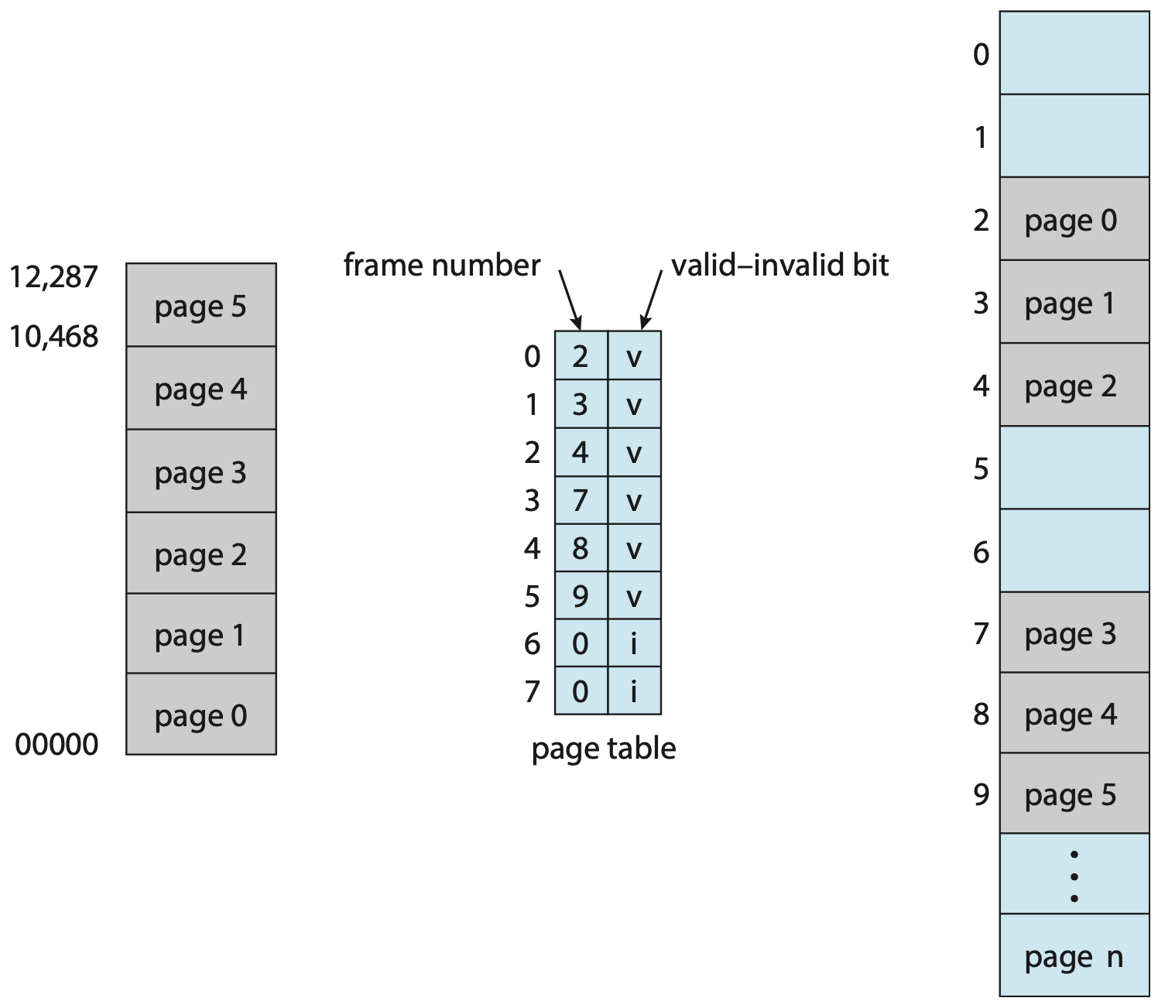

## Shared Pages

* Shared code
  + One copy of read-only (reentrant) code shared among processes

(i.e., text editors, compilers, window systems)

* + Similar to multiple threads sharing the same process space
  + Also useful for interprocess communication if sharing of read-write pages is allowed
* Private code and data
  + Each process keeps a separate copy of the code and data
  + The pages for the private code and data can appear anywhere in the logical address space
* Example

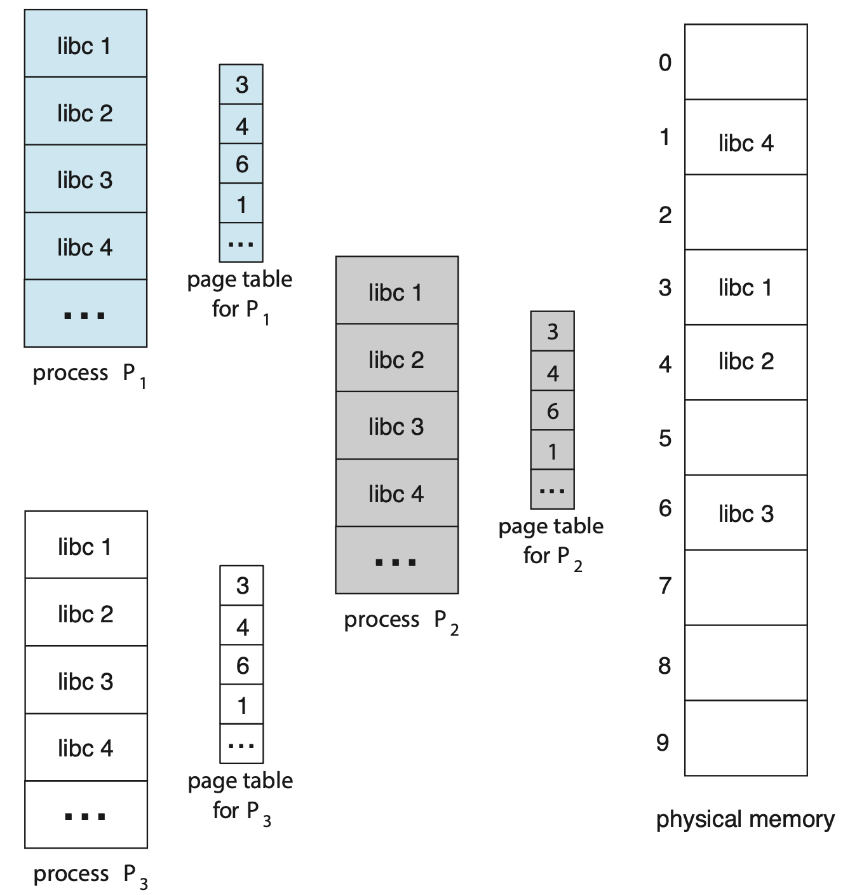

## Structure of the Page Table

* Memory structures for paging can get huge using straightforward methods
  + Consider a 32-bit logical address space as on modern computers
  + Page size of 4KB (212)
  + Page table would have 1 million entries (232 / 212)
  + If each entry is 4 bytes 🡪 4MB of physical address space / memory for page table alone
    - that amount of memory used to cost a lot
    - do not want to allocate that contiguously in main memory
* **Hierarchical Paging**
* **Hashed Page Tables**
* **Inverted Page Tables**

## Hierarchical Page Tables

* Break up the logical address space into multiple page tables
* A simple technique is a two-level page table
* We then page the page table
* Two-Level Page-Table Scheme

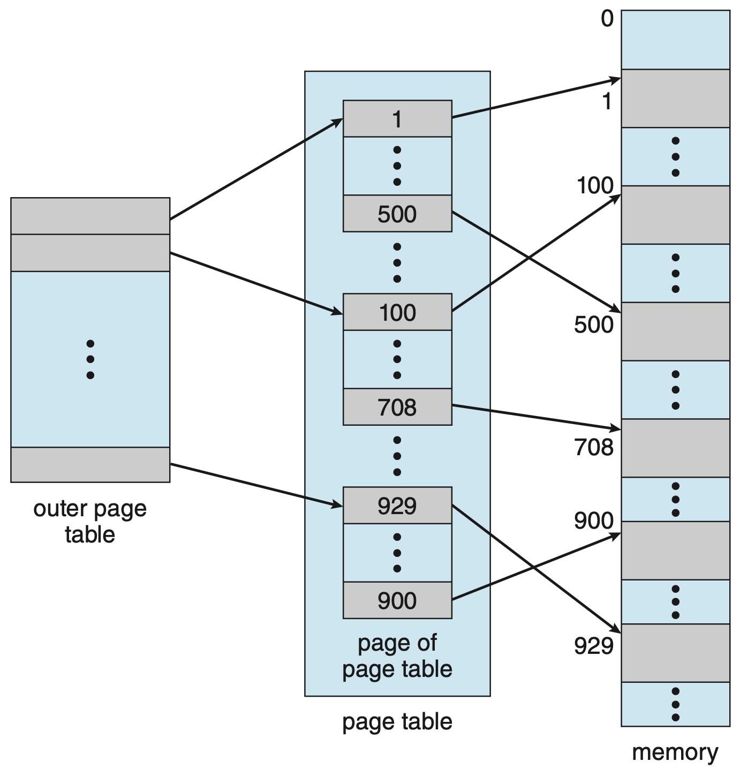

### Two-Level Paging Example

* A logical address (on 32-bit machine with 1K page size) is divided into:
  + A page number consisting of 20 bits
  + A page offset consisting of 12 bits
* Since the page table is paged, the page number is divided into:
  + 10-bit page number
  + 12-bit page offset

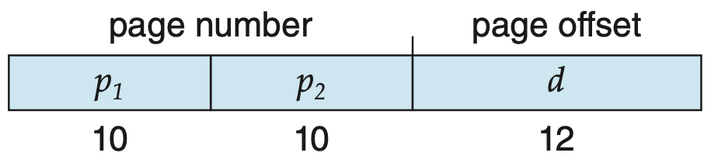

$p_{1}$ is an index into the outer page table

$p_{2}$ is the displacement within the page of the inner page table

* Known as ***forward-mapped page table***

Address translation for a two-level 32-bit paging architecture

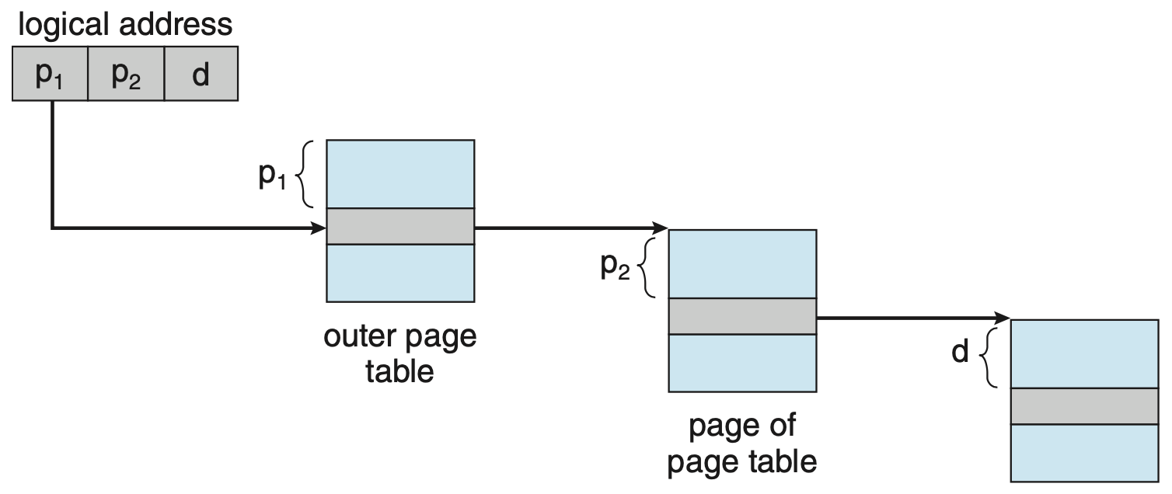

### 64-bit Logical Address Space

* Even two-level paging not sufficient
* If page size is 4KB (212)
  + Then page table has 252 entries
  + If two level scheme, inner page tables could be 210 4-byte entries
  + Address would look like

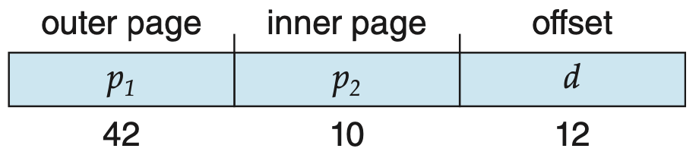

* + Outer page table has 242 entries or 244 bytes

### 2nd Outer Page Table

* One solution is to add a 2nd outer page table
* In this example, the 2nd outer page table is still 234 bytes in size
  + Possibly 4 memory access to get to one physical memory location



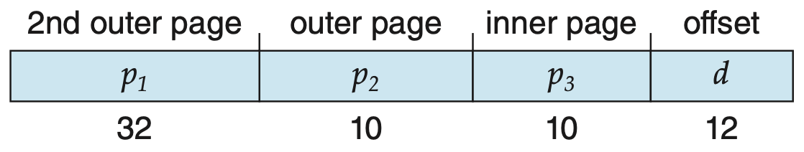

## Hashed Page Tables

* Common in address spaces > 32 bits
* The virtual page number is hashed into a page table
  + This page table contains a chain of elements hashing to the same location
* Each element contains:

1. The virtual page numbers
2. The value of the mapped page frame
3. A pointer to the next element

* Virtual page numbers are compared in this chain searching for a match
  + If a match is fount 🡪 the corresponding physical frame is extracted

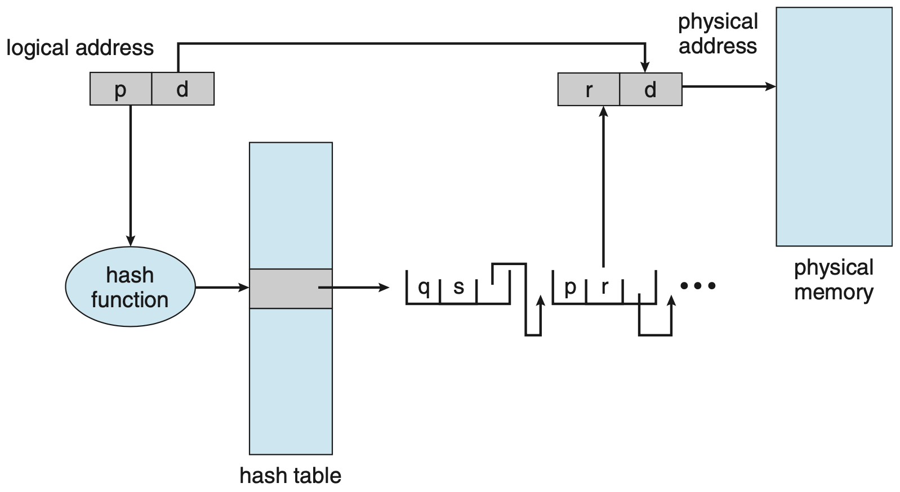

* Variation used for 64-bit addresses **is *clustered page tables***
  + Similar to hashed but each entry refers to several pages (such as 16) rather than 1
    - Therefore, a single page-table entry can store the mappings for multiple physical-page frames
  + Especially useful for sparse address spaces (where memory references are non-contiguous and scattered)
* Hashing has to be done by the MMU… Why?

## Inverted Page Table

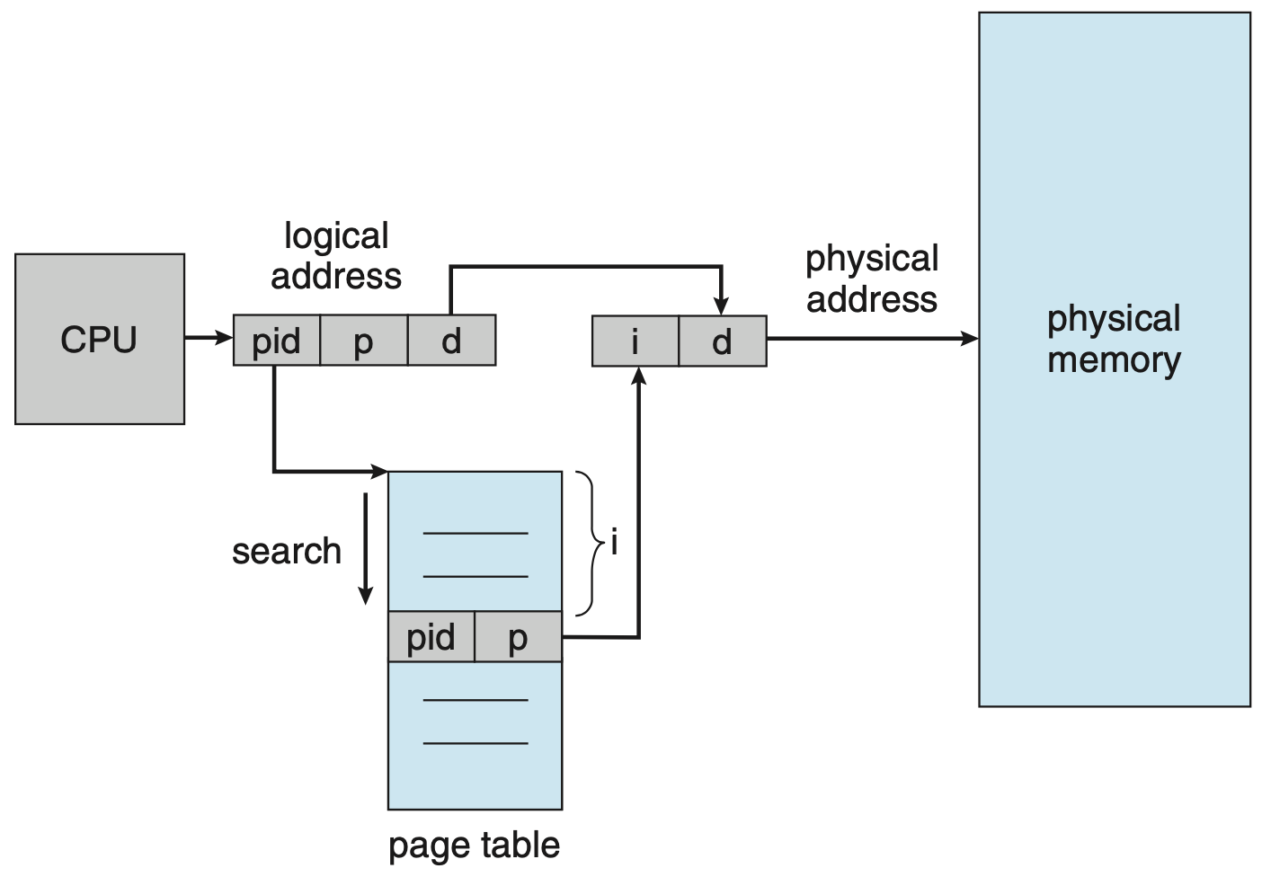

* Rather than each process having a page table and keeping track of all possible logical pages, track all physical frames
* One entry for each real page (frame) of memory
* Entry consists of the virtual address of the page stored in that real memory location, with information about the process that owns that page
* Decreases memory needed to store each page table, but increases time needed to search the table when a page reference occurs
* Use hash table to limit the search to one or at most a few page table entries
  + TLB can accelerate access
* But how to implement shared memory?
  + With standard paging
    - each process has its own page table, which allows multiple virtual addresses to be mapped to the same physical address.
  + Cannot be used with inverted page tables
    - Because there is only one virtual page entry for every physical page
    - One physical page cannot have two (or more) shared virtual addresses.
  + Therefore, with inverted page tables, only one mapping of a virtual address to the shared physical address may occur at any given time.
  + A reference by another process sharing the memory will result in a page fault and will replace the mapping with a different virtual address.

## The Intel 32 and 64-bit Architectures

* Dominant industry chips
* Pentium CPUs are 32-bit
  + Called IA-32 architecture
* Current Intel CPUs are 64-bit
  + Called IA-64 architecture
* Many variations in the chips, cover the main ideas only

### The Intel IA-32 Architecture

* Supports both segmentation and segmentation with paging
  + Each segment can be 4GB
  + Up to 16K segments per process
  + Divided into 2 partitions
    - 1st partition of up to 8K segments are private to process

(kept in *local descriptor table (LDT)*)

* + - 2nd partition of up to 8K segments shared among all processes

(kept in *global descriptor table (GDT)*)

### The Intel IA-32 Architecture Addresses

* CPU generates logical address
  + Selector given to segmentation unit
    - which produces linear addresses

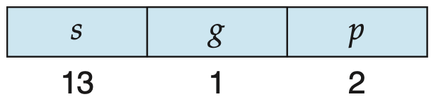

* + Linear address given to paging unit
    - which generates physical address in main memory
    - paging units form equivalent of MMU
    - pages sizes can be 4KB or 4MB
  + For 4-KB pages, IA-32 uses a two-level paging scheme in which the division of the 32-bit linear address is as follows:

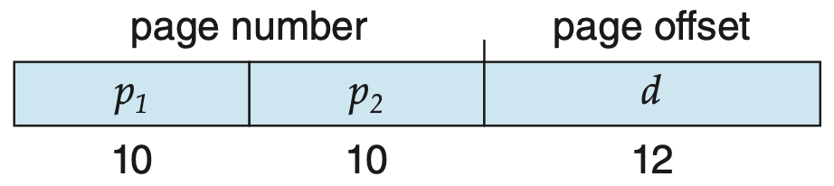

### IA-32 Logical to Physical Address Translation

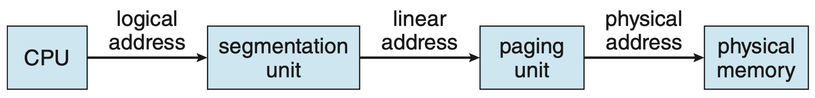

### Intel IA-32 Segmentation

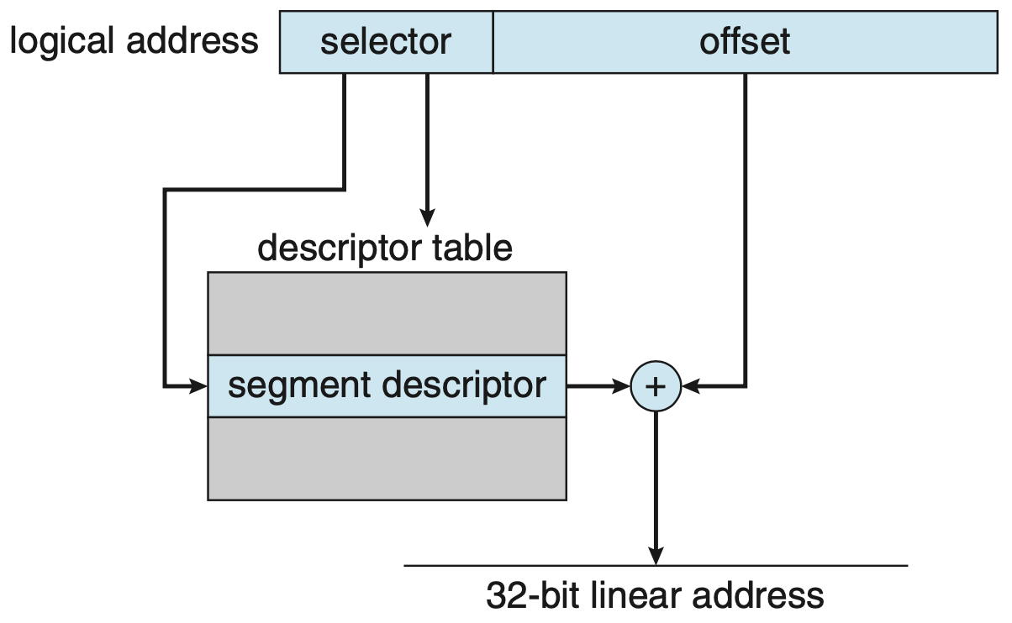

### Intel IA-32 Paging Architecture

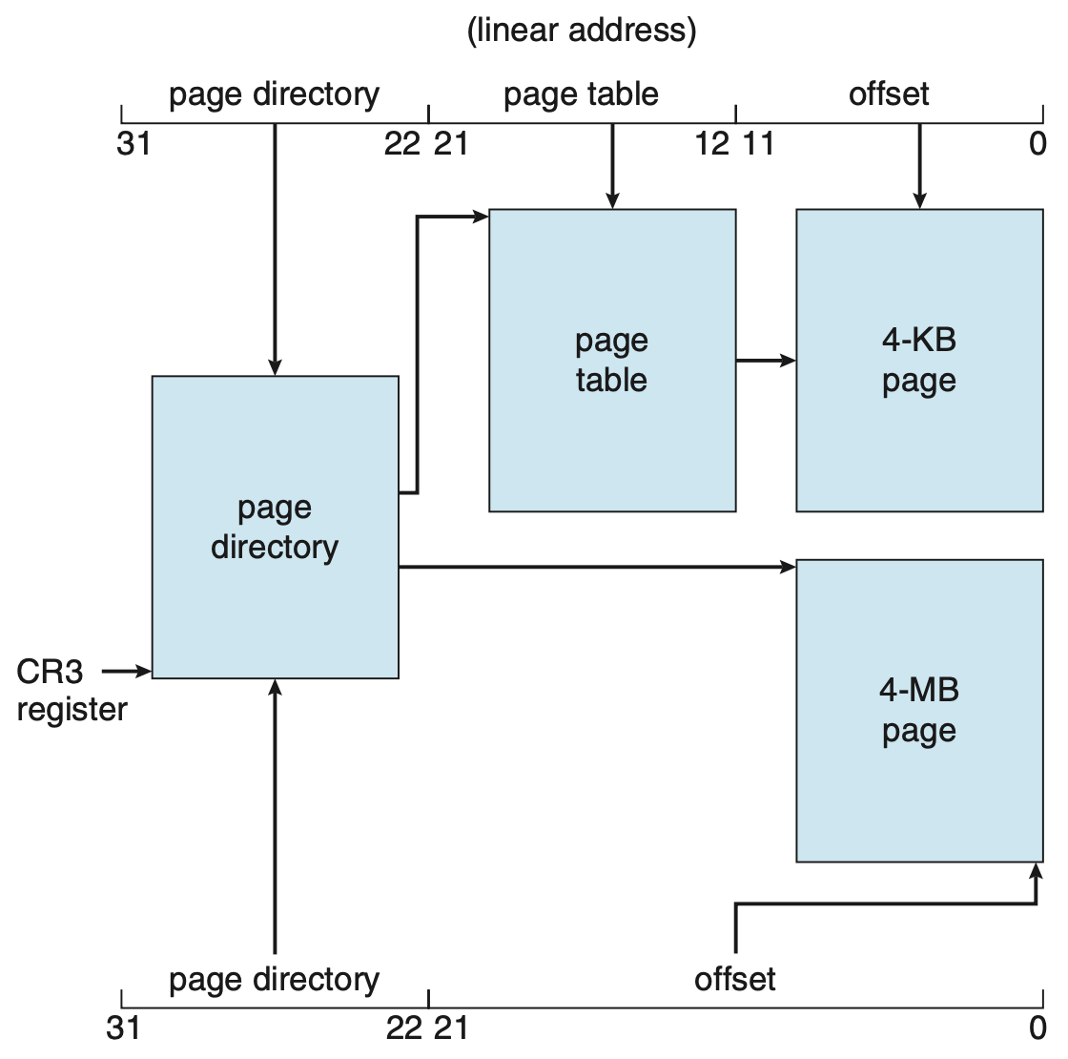

### Intel IA-32 Page Address Extensions

* 32-bit address limits led Intel to create *Page Address Extension (PAE)*, allowing 32-bit apps access to more than 4GB of memory space
  + Paging went to a 3-level scheme
  + Top two bits refer to a page directory pointer table
  + Page-directory and page-table entries moved to 64-bits in size
  + Increases address space to 36 bits (64GB physical memory)

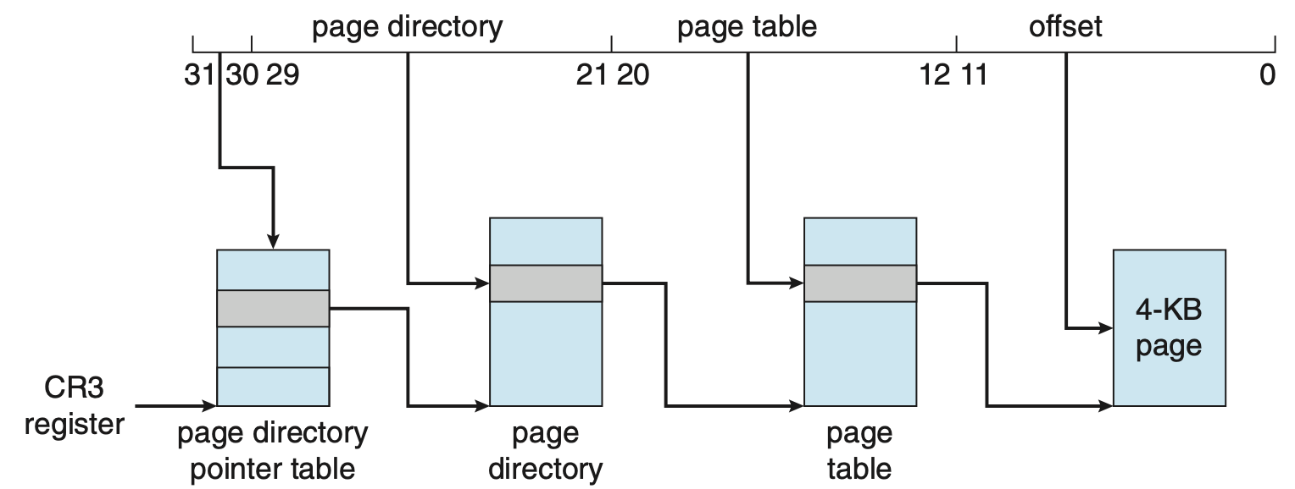

### Intel x86-64

* Current generation Intel x86 architecture
* 64 bits is ginormous (>16 exabytes)
* In practice only implement 48-bit addressing
  + Page sizes of 4KB, 2MB, 1GB
  + 4 levels of paging hierarchy
* Can also use PAE so virtual addresses are 48 bits and physical addresses are 52 bits



#### Example: ARM Architecture

* Dominant mobile platform chip
* Modern, energy efficient, 32-bit CPU
* 4KB and 16KB pages
* 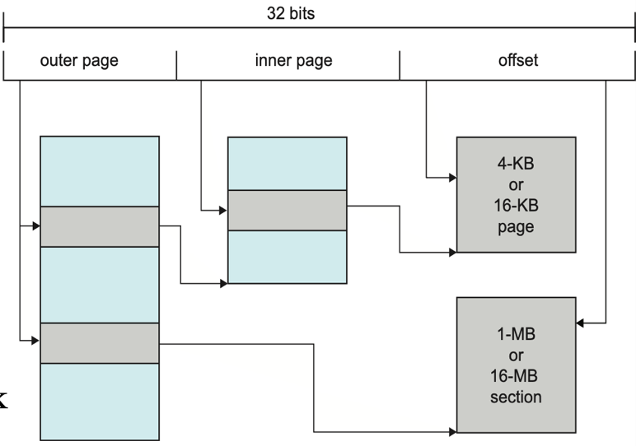1MB and 16MB pages (termed sections)
* One-level paging for sections, two-level for smaller pages
* Two levels of TLBs
  + Outer level has two micro TLBs (one data, one instruction)
  + Inner is single main TLB
  + First inner is checked, on miss outer are checked, and on miss page table walk performed by CPU

## Summary

* **Memory** is central to the operation of a modern computer system and consists of a large array of bytes, each with its own address.
* One way to allocate an address space to each process is through the use of base and limit registers. The base register holds the smallest legal physical memory address, and the limit specifies the size of the range.
* **Binding symbolic address** references to actual physical addresses may occur during

1. Compile time
2. Load time
3. Execution time

* An address generated by the CPU is known as a **logical address**, which the **memory management unit (MMU)** translates to a physical address in memory.
* One approach to allocating memory is to allocate partitions of **contiguous memory** of varying sizes. These partitions may be allocated based on three possible strategies:

1. first fit
2. best fit
3. worst fit.

* Modern operating systems use **paging** to manage memory. In this process, physical memory is divided into fixed-sized blocks called **frames** and logical memory into blocks of the same size called **pages**.
* When paging is used, a logical address is divided into two parts: a page number and a page offset.
  + The **page number** serves as an index into a per-process page table that contains the frame in physical memory that holds the page.
  + They **offset** is the specific location in the frame being referenced.
* A **translation look-aside buffer (TLB)** is a hardware cache of the page table. Each TLB entry contains a page number and its corresponding frame.
* Using a TLB in address translation for paging systems involves obtaining the page number from the logical address and checking if the frame for the page is in the TLB.
  + If it is 🡪 the frame is obtained from the TLB.
  + If the frame is not present in the TLB 🡪 it must be retrieved from the page table
* **Hierarchical paging** involves dividing a logical address into multiple parts, each referring to different levels of page tables. As addresses expand beyond 32 bits, the number of hierarchical levels may become large. Two strategies that address this problem are **hashed page tables** and **inverted page tables**.
* **Swapping** allows the system to move pages belonging to a process to disk to increase the degree of multiprogramming
* The **Intel 32-bit architecture** has two levels of page tables and supports either **4-KB** or **4-MB** page sizes. This architecture also supports page-address extension, which allows 32-bit processors to access a physical address space larger than 4 GB. The x86-64 and ARMv9 architectures are 64-bit architectures that use hierarchical paging.

# Lecture 10 – Paging, Virtual Memory

## Outline

* Background
* Demand Paging
* Copy-on-Write
* Page Replacement
* Allocation of Frames
* Thrashing
* Working sets
* Memory-Mapped Files
* Allocating Kernel Memory
* Other Considerations
* Operating-System Examples

## Background

* Code needs to be in memory to execute, but entire program rarely used
  + Error code, unusual routines, large data structures
* Entire program code not needed at same time
* Consider ability to execute partially-loaded program
  + Program no longer constrained by physical memory limits
  + Each program takes less memory while running
    - More programs run at the same time
    - Increased CPU utilization and throughput with no increase in response time or turnaround time
  + Less I/O needed to load or swap programs into memory results in each user program running faster

## Virtual Memory

What’s trying to be provided to a process is an abstraction of memory.

* Separation of logical memory from physical memory
  + If you can figure out how to have only part of the program needs to be in memory for execution
  + … then can separate the logical address space from physical address space and it can be larger
* Benefits:
  + Can have programs with memory requirements much larger than physical memory
  + Allows address spaces to be shared by several processes
  + Allows for more efficient process creation
  + More programs running concurrently
  + Less I/O needed to load or swap processes
* We call this “memory” ***Virtual Memory*** to distinguish from physical memory

### Virtual Address Space

* Each process has a logical address space
  + Usually start at address 0, contiguous addresses until the end of space defined by # bits in the address
* The ***virtual address space*** of a process is exactly the same as the logical address space
* Memory management problem is the same
  + 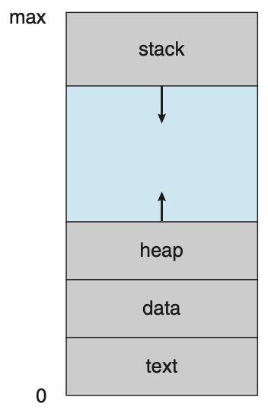Memory Management Unit (MMU) must map logical address space to physical address space
  + Look at our memory management mechanisms
* What is different from our discussion before?
  + Allow the amount of logical memory space used to be greater than the size of the physical memory
  + Allow a process to run without all its memory in physical memory
* Usually design logical address space for stack to start at Max logical address and grow “down” while heap grows “up”
  + Maximizes address space use
  + Unused address space between the two is hole
    - No physical memory needed until heap or stack grows to a given new page
* Enables sparse address spaces with holes left for growth, dynamically linked libraries, …
* System libraries shared via mapping into virtual address space
* Page can be shared during fork(), speeding process creation

#### Shared Library Using Virtual Memory

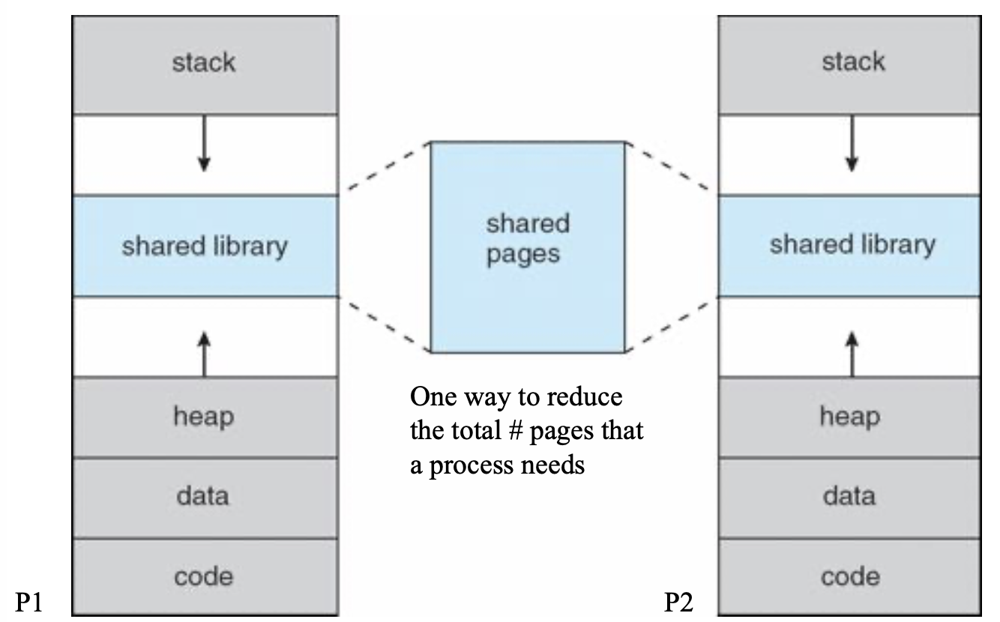

### Virtual Memory > Physical Memory

* Diagram showing virtual memory that is larger than physical memory.

On the left is your virtual memory, memory map is how you map the pages in virtual memory to physical memory. But now we are extending that physical memory with a backing store, this backing store can be larger than the physical memory.

So this mapping is the general logic of mapping these virtual pages to physical memory, and backing store. Some pages might be in frames in physical memory, and some pages might be in backing store frames.

What we need to implement is how this memory mapping is happening and what the OS is doing to support it.

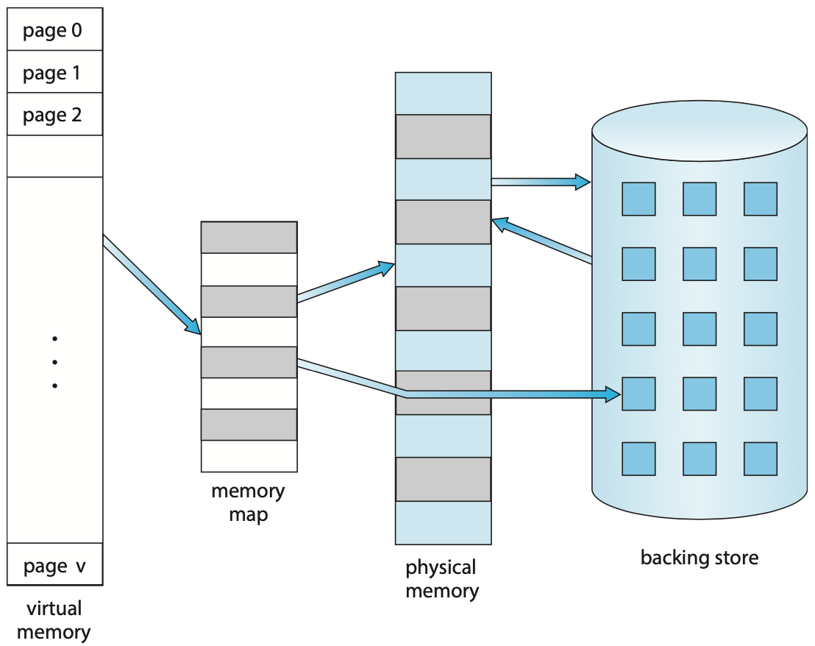

## How to get frame in the first place?

* Load all pages a process needs
  + Too many
* Load only what a process needs now
* Load pages one at a time

### Swapping with Paging

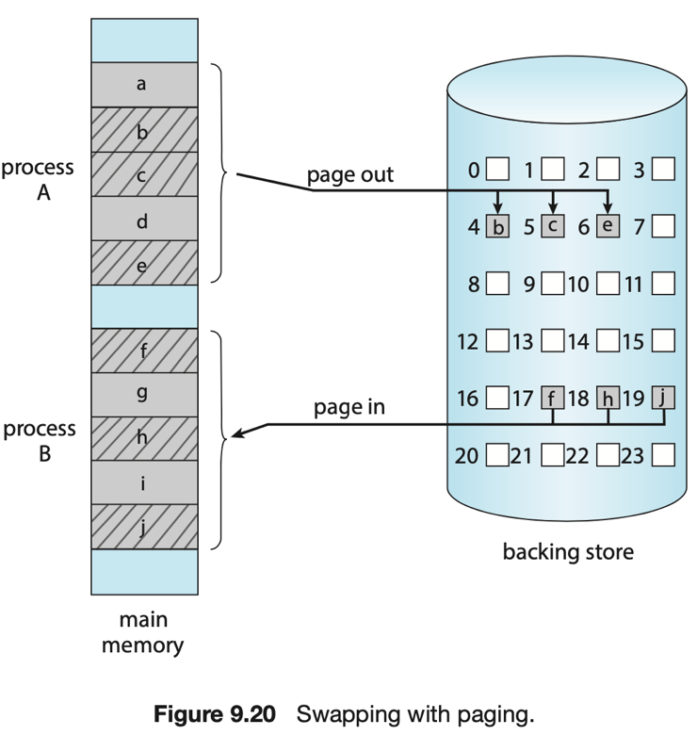

## Demand Paging

* Could bring entire process into memory at load time
* Or bring a page into memory only when it is needed
  + Less I/O needed, no unnecessary I/O
  + Less memory needed
  + Faster response
  + More users
* Similar to paging system with swapping (diagram below)
* Page is needed → reference to it
  + Invalid reference → abort
  + Not-in-memory → bring to memory
* Lazy swapper
  + Never swaps a page into memory unless page will be needed
  + Swapper that deals with pages is a pager

### Demand Paging Basic Concepts

* With swapping, pager guesses which pages will be used before swapping out again
* Instead, pager brings in only those pages into memory
* How to determine that set of pages?
  + Need new MMU functionality to implement demand paging
* If pages needed are already memory resident (in memory)
  + No difference from non demand-paging
* If pages needed are not memory resident (not in memory)
  + Need to detect and load the page into memory from storage
    - Without changing program behavior
    - Without programmer needing to change code

### A screenshot of a cell phone Description automatically generatedValid-Invalid Bit

* With each page table entry, a ***valid-invalid bit*** is associated
  + ***v*** → in-memory (memory resident)
  + ***i*** → not-in-memory
* Initially, valid-invalid bit is set to *i* on all entries
* During MMU address translation, if valid-invalid bit in page table entry is *i*, a page fault occurs

#### Page table when some pages are not in main memory.

* At any time my page table indicated to me which of my pages are assigned frames, and which of them are not. And if it is not, then it could be the case that that page is living in the backing store.
* Looking at this picture, it seems like 0, 2, and 5 are resident in memory. The others are not. And as it turns out they are resident in the backing store (note that A and C also are on the backing store)!
* If you have pages in memory then that’s active data for that process.

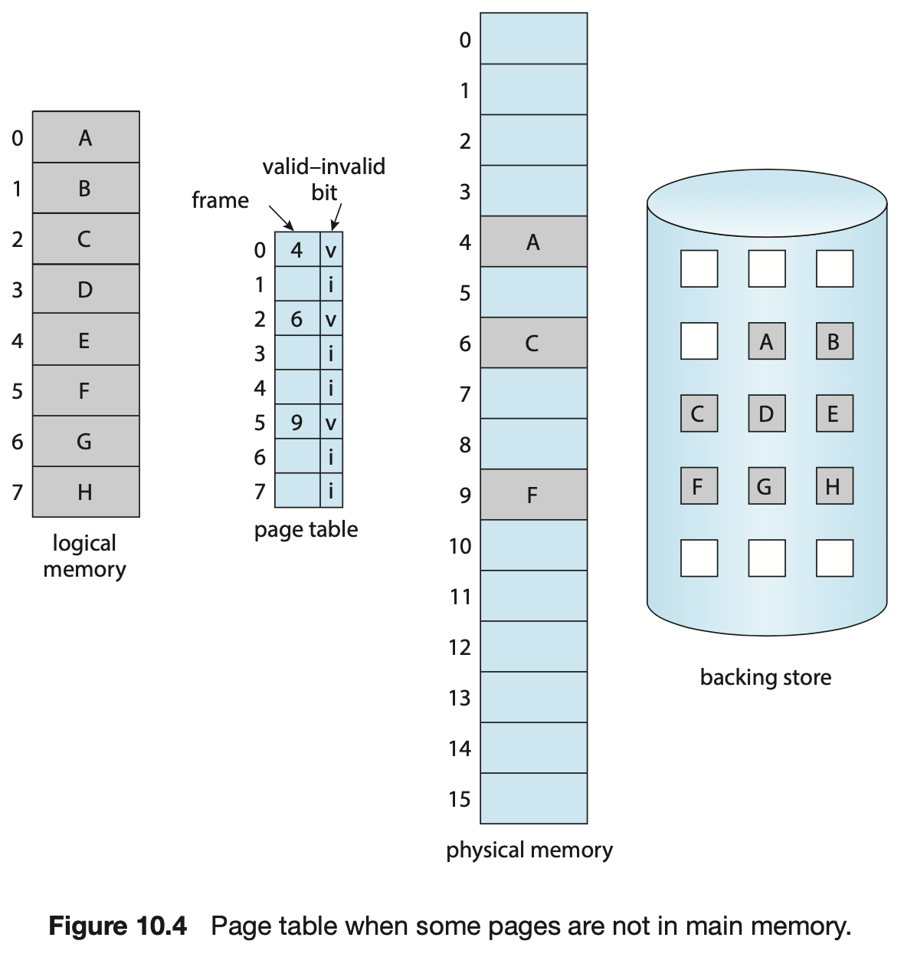

## Page Fault Processing

* If there is a reference to a page, first reference to that page will send a trap to the operating system … why?
* Operating system looks at another table to decide:
  + Invalid reference → abort
  + Just not in memory (*page fault*) (first reference is)
* Find free frame
* Swap pages into frame via scheduled disk operation
* Reset tables to indicate page now in memory
  + Set validation bit = *v*
* Restart the instruction that caused the page fault.

### A picture containing screenshot Description automatically generatedSteps in Handling a Page Fault

At 1, here’s the reference. It checks the page table, and finds out that there’s an invalid bit. There is no frame associated with the bit. Traps the OS. OS checks to see if it’s on the backing store (if it’s a brand new page, that you’ve never referenced before then no). If it is in the Backing store you have to load that page into a free frame.

This is the core idea of virtual memory, it makes it possible to have this abstraction of virtual memory that goes beyond the bounds of the actual physical memory.

## Aspects of Demand Paging

Idea: suppose you use the page faulting mechanism to load pages into memory.

Basically, let it page fault!

* Extreme case - start process with no pages in memory
  + OS sets instruction pointer to first instruction of process
  + Immediately a seg fault occurs … why?
  + First access to any page will generate a page fault
  + ***Pure demand paging***
* Actually, a given instruction could access multiple pages, generating multiple page faults
  + Consider fetch and decode instruction which adds 2 numbers from memory and stores result back to memory
  + Pain decreased because of locality of reference
* Hardware support needed for demand paging
  + Page table with *valid / invalid bit*
  + Secondary memory (swap device with swap space)
  + Instruction set

## Instruction Restart

* Consider an instruction that could access several different locations
  + Block move

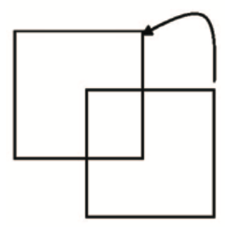

* + Auto increment/decrement location
* What should be done in this case?
  + Restart the whole operation?
  + What if source and destination overlap?

### Stages in Demand Paging (Worst Case)

1. Trap to the OS
2. Save the user registers and process state
3. Determine that the interrupt was a page fault
4. Check that the page reference was legal and determine the location of the page on the disk
5. Issue a read from the disk to a free frame:
   1. Wait in a queue for this device until the read request is services
   2. Wait for the device seek and/or latency time
   3. Begin the transfer of the page to a free frame
6. While waiting, allocate the CPU to some other user
7. Receive an interrupt from the disk I/O subsystem (I/O completed)
8. Save the registers and process state for the other user
9. Determine that the interrupt was from the disk
10. Correct the page table and other tables to show page is now in memory
11. Wait for the CPU to be allocated to this process again
12. Restore the user registers, process state, and new page table, and then resume the interrupted instruction

### Performance of Demand Paging

* 3 major activities
  + Service the interrupt
    - careful coding means just several hundred instructions needed
  + Read the page
    - Lots of time
  + Restart the process
    - Just a small amount of time
* Page Fault Rate $0≤p≤1$
  + If $p=0$ → no page faults
  + If $p=1$ → every reference is a fault
* ***Effective Access Time (EAT)***

$EAT=\left(1-p\right)×memory access$

$+p×(page fault overhead+swap out+swap in+memory access)$

### Demand Paging Example

* Memory access time = 200 nanoseconds
* Average page-fault service time = 8 million seconds
$$EAT=\left(1-p\right)×200+p×\left(8ms\right)=\left(1-200\right)p+8,000,000p=200+7,999,800p$$

* If one access out of 1,000 causes a page fault, then EAT = 8.2 microseconds
* This is a slowdown by a factor of 40
* If want performance degradation < 10 percent

$220>200+7,999,800p$

$20>7,999,800p$

$p<0.0000025<$ one page fault in every 400,000 memory accesses

### Demand Paging Optimizations

* Swap space I/O faster than file system I/O
  + Swap allocated in larger chunks, less management needed
* Copy entire process image to swap space at process load time
  + Then page in and out of swap space
  + Used in older BSD Unix
* Demand page in from program binary on disk, but discard rather than paging out when freeing frame
  + Used in Solaris and current BSD
  + Still need to write to swap space
    - Pages not associated with a file (like stack and the heap) - anonymous memory
    - Pages modified in memory but not yet written back to the file system
* Mobile systems
  + Typically do not support swapping
  + Instead, demand page from file system and reclaim read-only pages (Such as code)

## Copy-on-Write

* ***Copy-on-write (COW)*** allows both parent and child processes to initially share the same pages in memory
  + If either process modifies a shared page, only then is the page copied
* COW allows more efficient process creation as only modified pages are copied
* In general, free pages are allocated from a pool of zero-fill-on-demand pages
  + Pool should always have free frames for fast demand page execution
    - Do not want to have to free frame as well as other processing on page fault
  + Why zero-out a page before allocating it?
* vfork() variation on fork() system call has parent suspend and child using copy-on-write address space of parent
  + Designed to have child call exec()
  + Very efficient

### Before Process 1 Modifies Page C

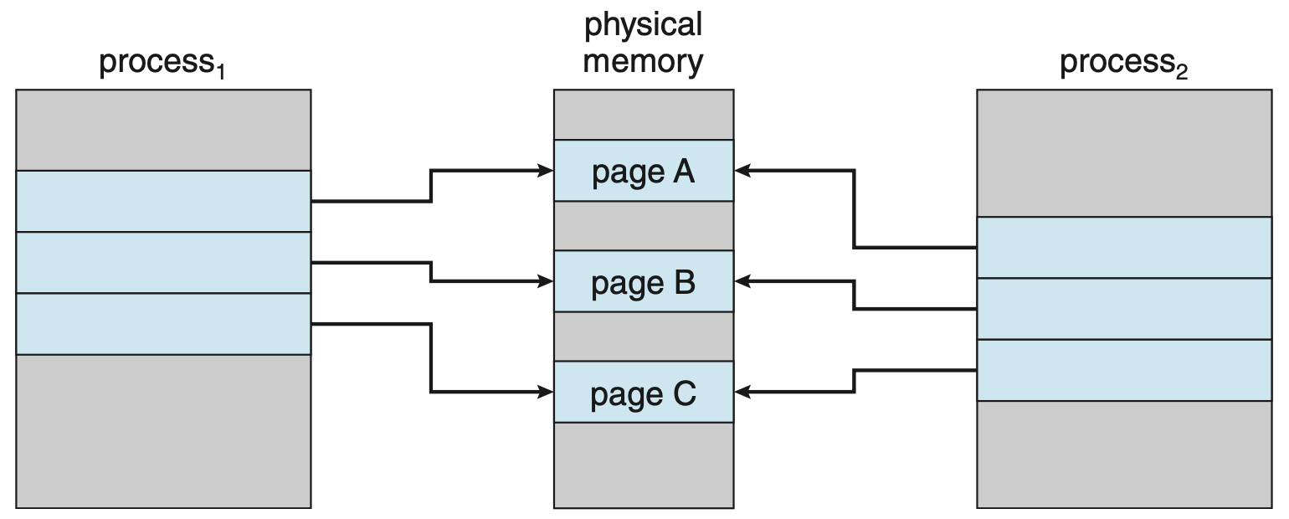

### After Process 1 Modifies Page C

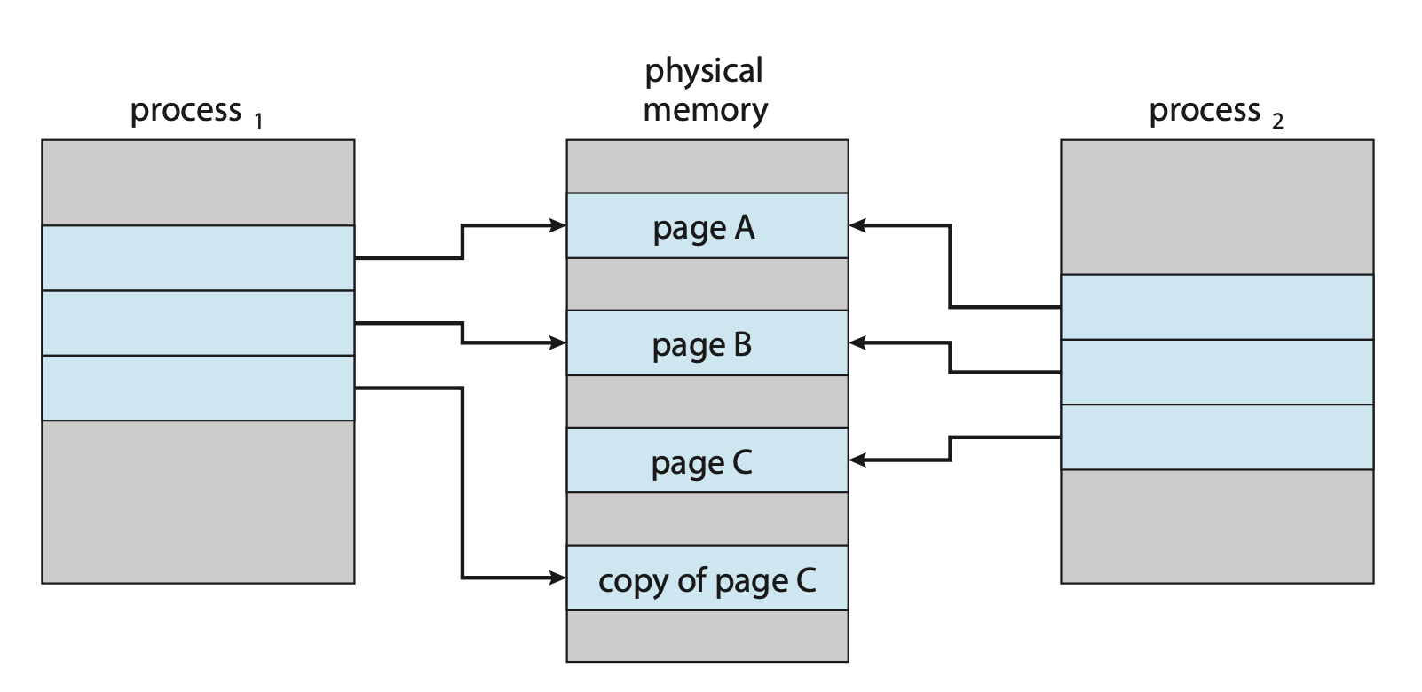

### What Happens If No Free Frame?

* Used up by process pages
* Also in demand from the kernel, I/O buffers, etc.
* How much to allocate to each?
* ***Page replacement***- find some page in memory, but not really in use, page it out
  + Algorithm - terminate? Swap out? Replace the page?
  + Performance - want an algorithm which will result in minimum number of page faults
* Same page may be brought into memory several times

## Page Replacement

* Prevent over-allocation of memory by modifying page-fault service routine to include page replacement
* Use ***modify (dirty) bit*** to reduce overhead of page transfers - only modified pages are written to disk
* Page replacement completes separation - large virtual memory can be provided on a smaller physical memory

### Need For Page Replacement

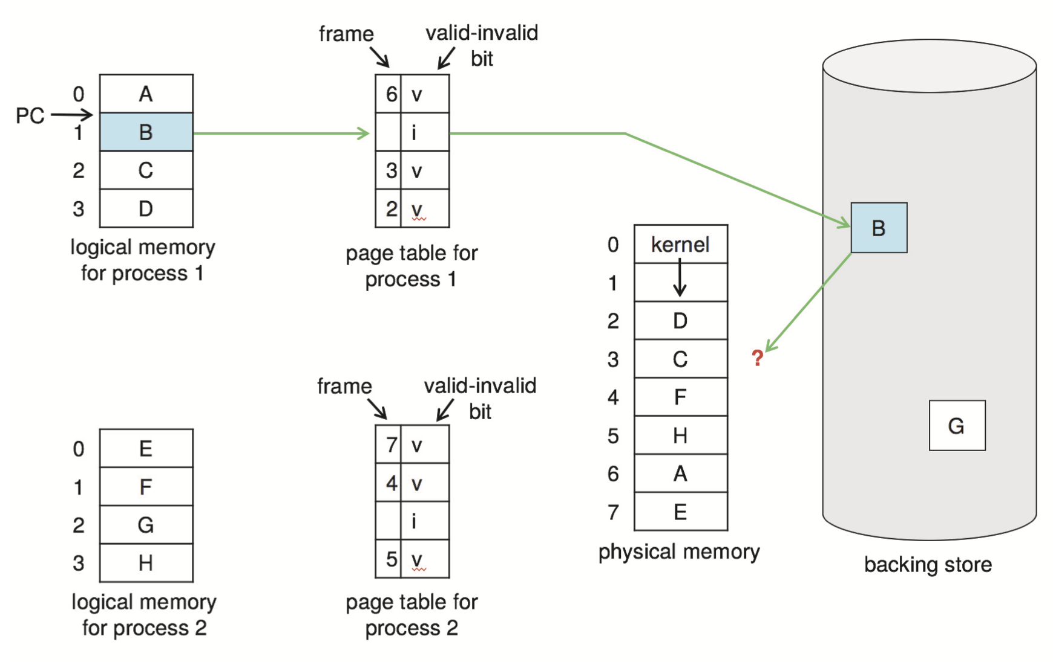

### Basic Page Replacement

* Find the location of the desired page on disk
* Find a free frame:
  + If there is a free frame, use it
  + If there is no free frame, use a page replacement algorithm to select a *victim frame*
  + Write victim frame to disk if dirty
* Bring the desired page into the (newly) free frame; update the page and frame tables
* Continue the process by restarting the instruction that caused the trap
* Note now potentially 2 page transfers for page fault increasing EAT

### Page Replacement

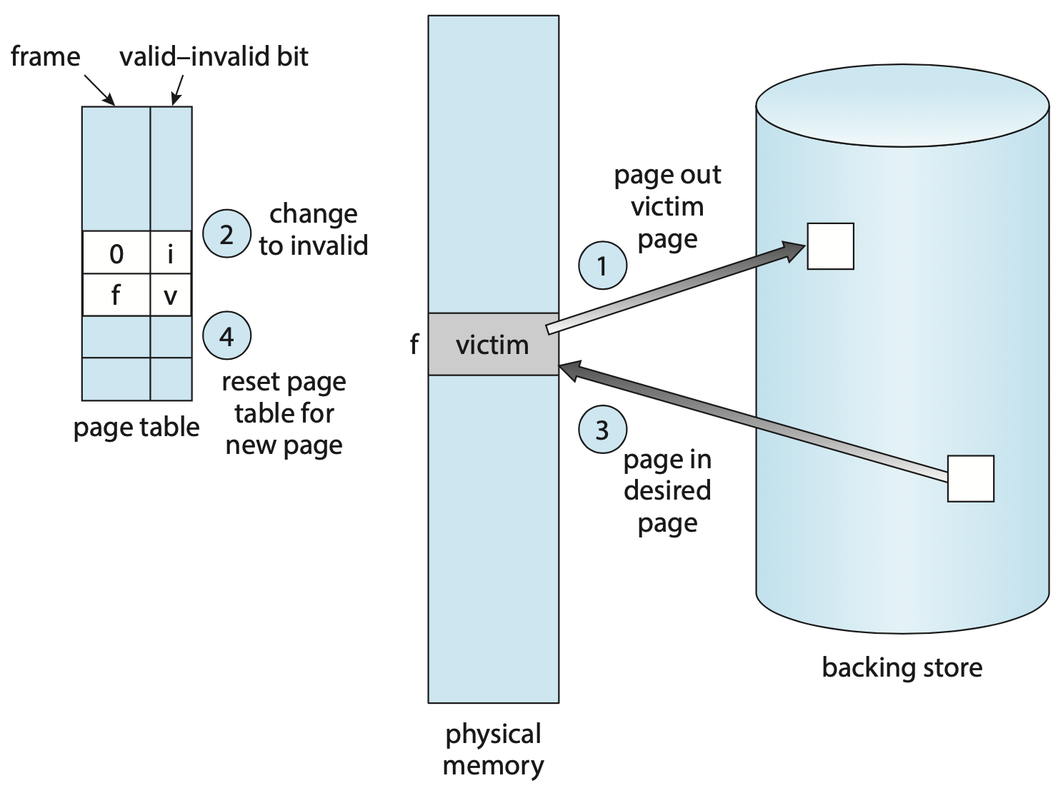

## Page and Frame Replacement Algorithms

* Frame-allocation algorithm determines
  + How many frames to give each process
  + Which frames to replace
* Page-replacement algorithm
  + Want lowest page-fault rate on both first access and re-access
* Evaluate algorithms by running it on a particular string of memory references (reference string) and computing number of page faults on that string
  + String is just page numbers, not full addresses
  + Repeated access to the same page does not cause a page fault
  + Results depend on number of frames available
* In all out examples, the reference string of referenced page numbers is:

7,0,1,2,0,3,0,4,2,3,0,3,0,2,1,2,0,1,7,0,1

### Graph of Page Faults vs. Number of Frames

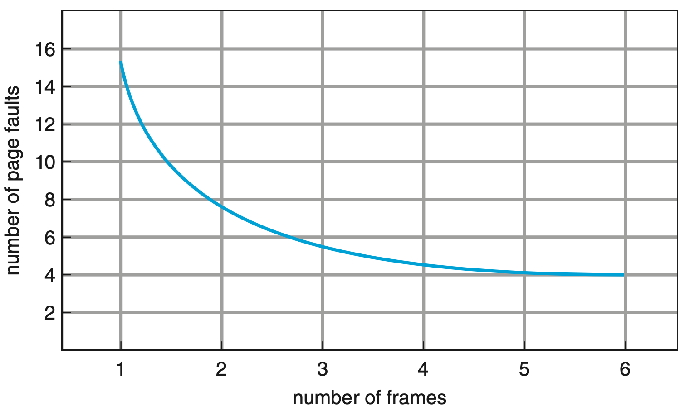

## First-In-First-Out (FIFO) Algorithm

* Reference string: 7,0,1,2,0,3,0,4,2,3,0,3,0,2,1,2,0,1,7,0,1
* 3 frames (3 pages can be in memory at a time per process)

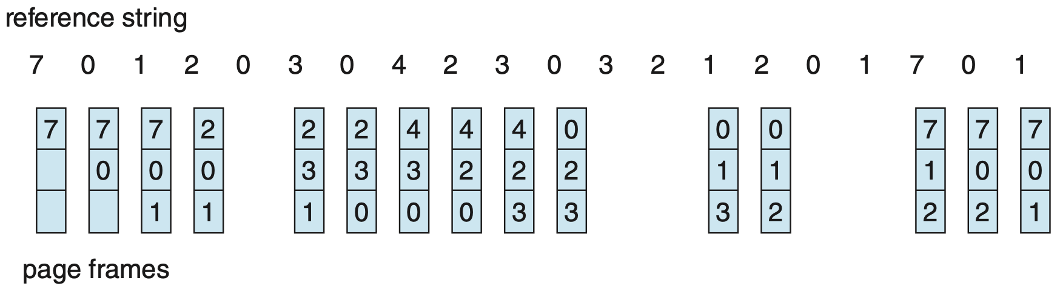

15 page faults

* Can vary by reference string: consider 1,2,3,4,1,2,5,1,2,3,4,5
  + Adding more frames can cause more page faults!
    - ***Belady’s anomaly***
* How to track ages of pages?
  + Just use a FIFO queue!

### FIFO Illustrating Belady’s Anomaly

* Page-fault curve for FIFO replacement on a reference string.

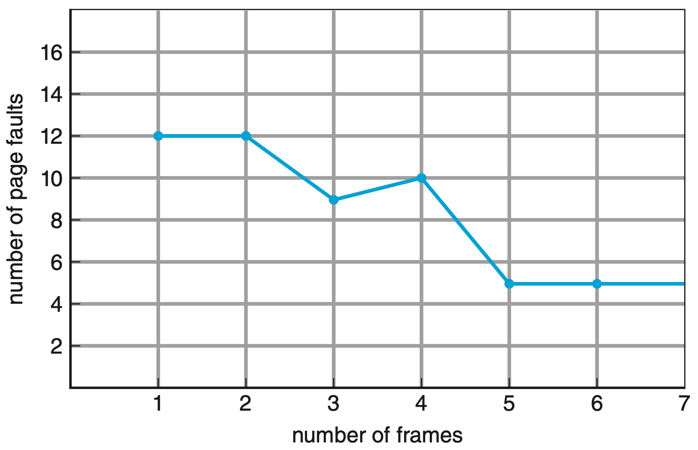

## Optimal Algorithm

difficult to implement, because it requires future knowledge of the reference string

* Replace page that will not be used for longest period of time
  + 9 is optimal for the example
* How do you know this?
  + Cannot read the future
* Used for measuring how well your algorithm performs

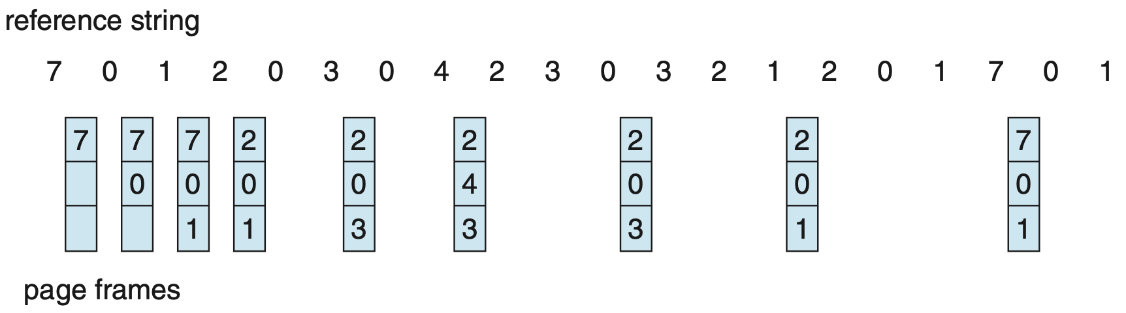

## Least Recently Used (LRU) Algorithm

* Use past knowledge rather than future
* Replace page that has not been used in the most amount of time
* Associate time of last use with each page

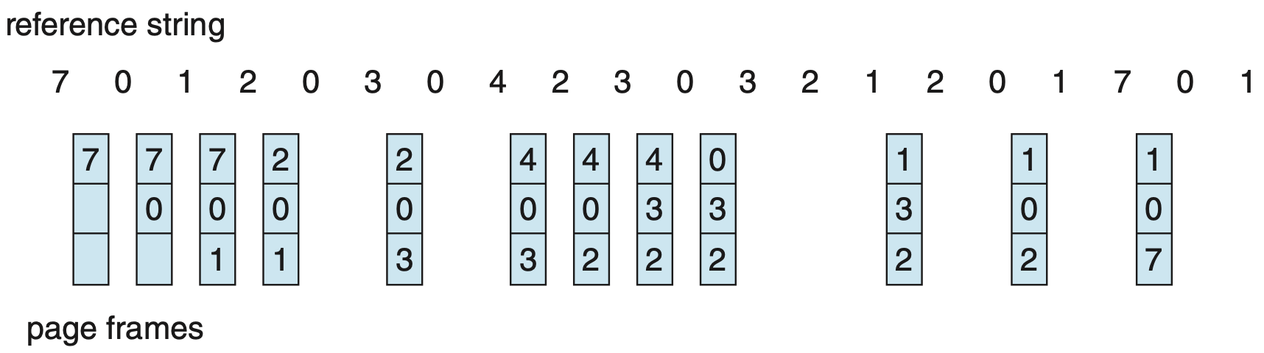

* 12 faults - better than FIFO but worse than OPT
* Generally good algorithm and frequently used

### LRU Algorithm Implementation

* Counter implementation
  + Every page entry has a counter;

every time page is referenced through this entry, copy the clock into the counter

* + When a page needs to be changed, look at the counters to find smallest value
    - search through table needed
* Stack implementation
  + Keep a stack of page numbers in a double link form:
  + Page referenced:
    - Move it to the top
    - Requires 6 pointers to be changed
  + But each update more expensive
  + No search for replacement
* LRU and OPT are cases of stack algorithms that don’t have Belady’s Anomaly

#### Use of a stack to record the most recent page references

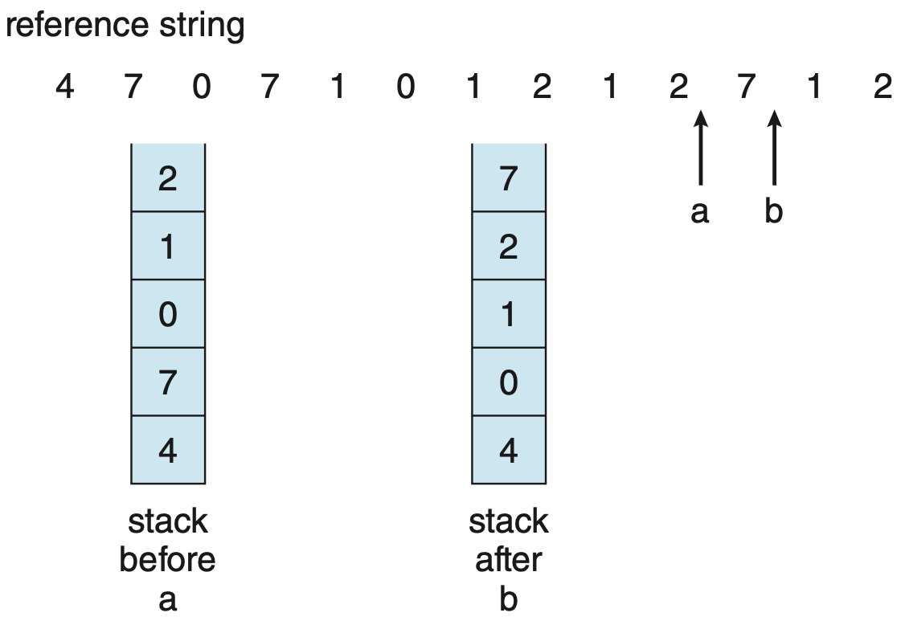

## LRU Approximation Algorithms

* LRU needs special hardware and still slow
* Reference bit
  + With each page associated a bit, initially = 0
  + When page is referenced, bit = 1
  + Replace any with reference bit = 0 (if any exists)
    - We do not know the order, however
* Second-chance algorithm
  + Generally FIFO, plus hardware-provided reference bit
  + Clock replacement
  + If page to be replaced has
    - reference bit = 0 🡪 replace it
    - reference bit = 1 then:
      * set reference bit = 0, leave page in memory
      * replace next page, subject to same rules

### Second-Chance (Clock) Page-Replacement

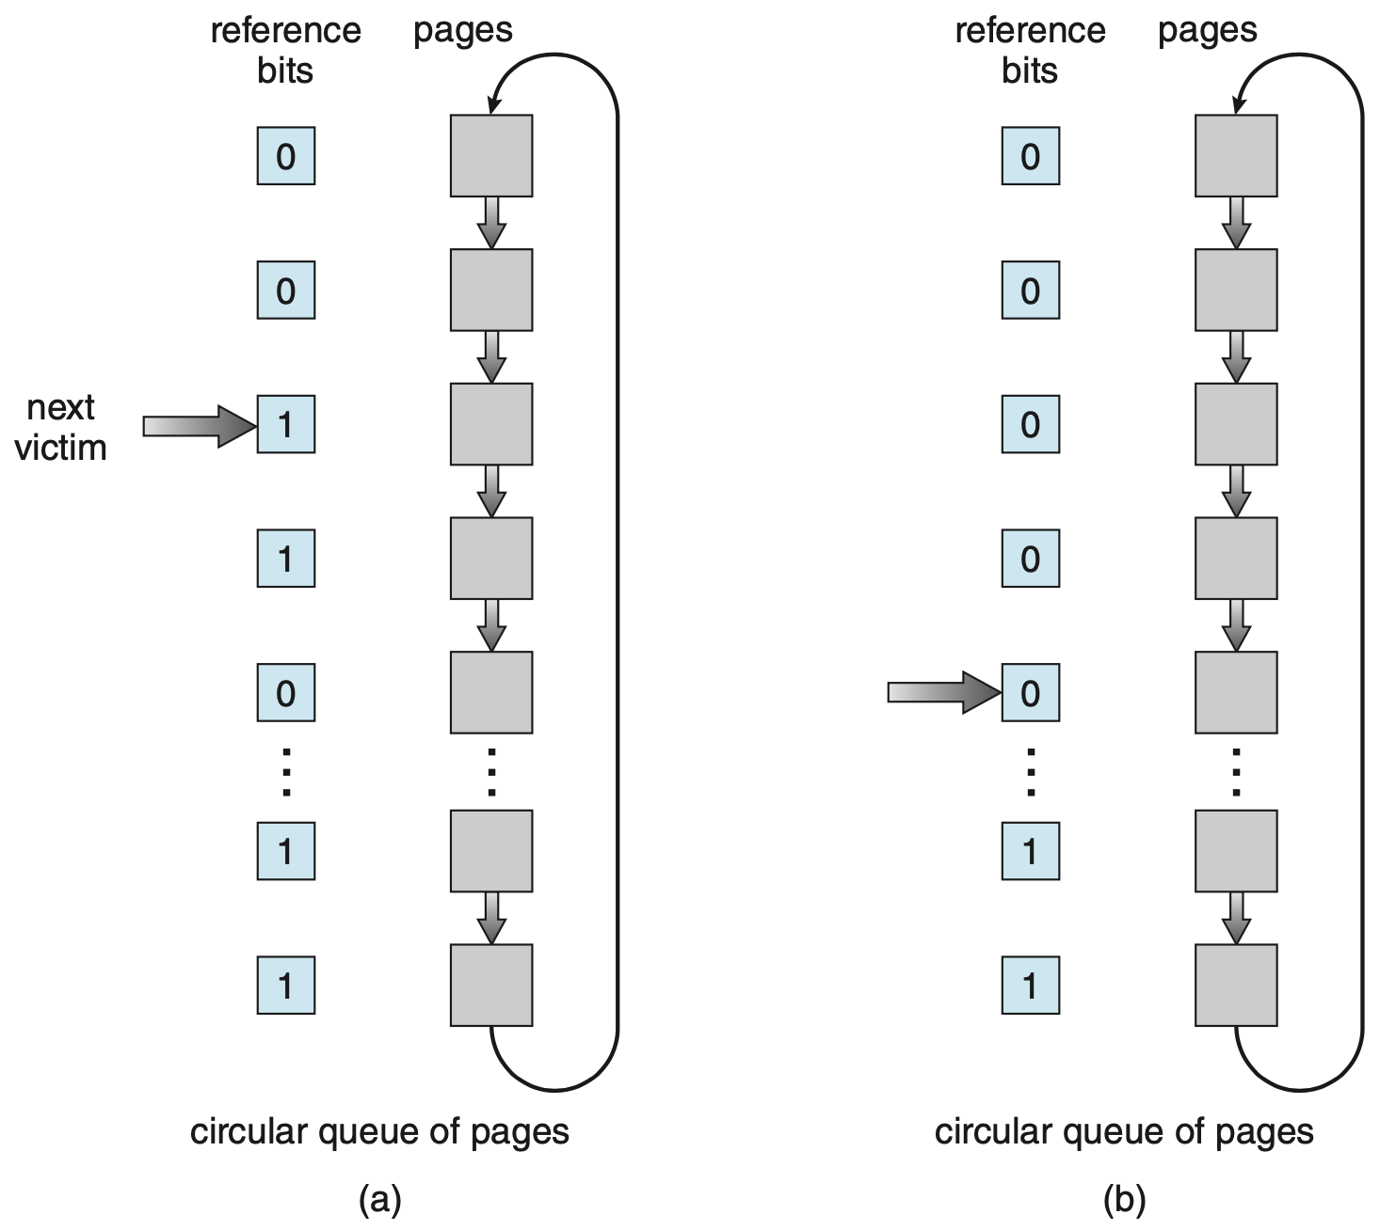

### Enhanced Second-Chance Algorithm

* Improve algorithm by using reference bit and modify bit (if available) in concert
* Take ordered pair (reference, modify)
  + **(0,0)**
    - neither recently used or modified
    - best page to replace
  + **(0,1)**
    - not recently used but modified
    - not quite as good, must write out before replacement
  + **(1,0)**
    - recently used but clean
    - probably will be used again soon
  + **(1,1)**
    - recently used and modified
    - probably will be used again soon and need to write out before replacement
* When page replacement called for, use the clock scheme but use the four classes, replace page in lowest non-empty class
  + Might need to search circular queue several times

## Counting Algorithms

* Keep a counter of the number of references that have been made to each page
  + Not common
* Least Frequently Used (LFU) Algorithm
  + replaces page with smallest count
* Most Frequently Used (MFU) Algorithm
  + based on the argument that the page with the smallest count was probably just brought in and has yet to be used.

## Page-Buffering Algorithms

* Keep a pool of free frames, always
  + Then frame available when needed, not found at fault time
  + Read page into free frame and select victim to evict and add to free pool
  + When convenient, evict victim
* Possibly, keep a list of modified pages
  + When backing store otherwise idle, write pages there and set to non-dirty
* Possibly, keep free frame contents intact and note what is in them
  + If referenced again before reused, no need to load contents again from disk
  + Generally useful to reduce penalty if wrong victim frame selected

## Application and Page Replacement

* All of these algorithms have OS guessing about future page access
* Some applications have better knowledge - i.e. databases
* Memory intensive applications can cause double buffering
  + OS Keeps copy of page in memory as I/O buffer
  + Application keeps page in memory for its own work
* OS can give direct access to the disk, getting out of the way of the application
  + Raw disk mode
* Bypasses buffering, locking, and so on

## Allocation of Frames

* Each process needs minimum number of frames
* Example: IBM 370 - 6 pages to handle SS MOVE instruction:
  + Instruction is 6 bytes, might span 2 pages
  + 2 pages to handle from
  + 2 pages to handle to
* Maximum of course is total of frames in the system
* Two major allocation schemes
  + ***Fixed Allocation***
  + ***Priority Allocation***
* Many variations

## Fixed Allocation

* ***Equal allocation*** - for example, if there are 100 frames (after allocating frames for the OS) and 5 processes, give each process 20 frames
  + Keep some as free frame buffer pool
* ***Proportional allocation*** - allocate according to the size of the process
  + Dynamic as degree of multiprogramming, process sizes change

|  |  |
| --- | --- |
| $s_{i}=size of process p_{i}$ $S=\sum{s_{i}}$ $m=total number of frames$ $a_{i}=allocation for p_{i}=\frac{s_{i}}{S}×m$ | $m=64$ $s_{1}=10$ $s_{2}=127$ $a_{1}=\frac{10}{137}×62≈4$ $a_{2}=\frac{127}{137}×62≈57$ |

## Priority Allocation

* Use a proportional allocation scheme using priorities rather than size
* If process $P_{i}$ generates a page fault,
  + Select for replacement one of its frames
  + Select for replacement a frame from a process with lower priority number

## Global Vs. Local Allocation

We have some trade offs. For the process that we’re taking pages from it could be bad for it. We would pause it and when we get back to executing it we see that the page is not there.

As for the local one, the OS gives the process a certain amount of frames. But maybe that wasn't enough? Or actually this might be too much! Why not make them available for global replacement?

* ***Global replacement*** - process selects a replacement frame from the set of all frames; one process can take a frame from another
  + But then process execution can vary greatly
  + But greater throughput so more common
* ***Local replacement*** - each process selects from only its own set of allocated frames
  + More consistent per-process performance
  + But possibly underutilized memory

## Non-Uniform Memory Access

* So far all memory accessed equally
* Many systems are NUMA – speed of access to memory varies
  + Consider system boards containing CPUs and memory, interconnected over a system bus
* Optimal performance comes from allocating memory “close to” the CPU on which the thread is scheduled
  + And modifying the scheduler to schedule the thread on the same system board when possible
  + Solved by Solaris by creating lgroups
    - Structure to track CPU / Memory low latency groups
    - Used by schedule and pager
    - When possible schedule all threads of a process and allocate all memory for that process within the lgroups

## Thrashing

Basically an overcommitment of resources

* If a process does not have “enough” pages, the page-fault rate is very high
  + Page fault to get page
  + Replace existing frame
  + But quickly need replaced frame back
  + This leads to:
    - low CPU utilization
    - operating system thinking that it needs to increase the degree of multiprogramming
    - another process added to the system
* Thrashing ≡ a process is busy swapping pages in and out rather than getting any work done

### Thrashing Behavior

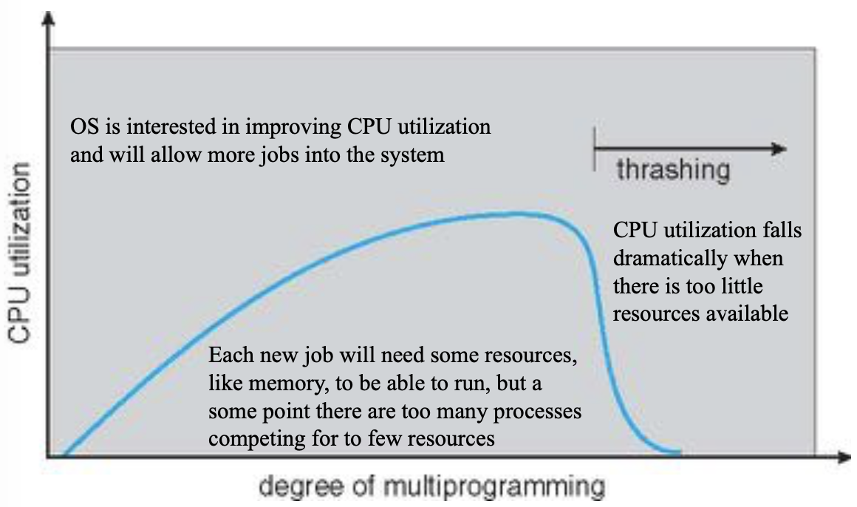

* What could cause thrashing?
  + I don't have enough memory, so my process is thrashing!
  + But maybe we have a lot of processes running at the same time, which means that they’re all thrashing.
* I am increasing the level of multiprogramming because I’m getting good progress, but at some point I have too many processes with their localities running that end up being more than the amount of physical memory I have. Thus they all start to thrash and compete with each other to get frames. And utilization comes down.

## Demand Paging and Thrashing

* Why does demand paging work?
* Locality model
  + Process migrates from one locality to another
  + Localities may overlap
* Why does thrashing occur?

* + Limit effects by using local or priority replacement

## Locality in A Memory-Reference Pattern

* Programs do not reference their memory randomly
* There is both spatial and temporal locality
  + ***Spatial****:* memory addresses nearby to a reference are likely to be also addressed
  + ***Temporal***: a referenced memory address is likely to be referenced again in the near future

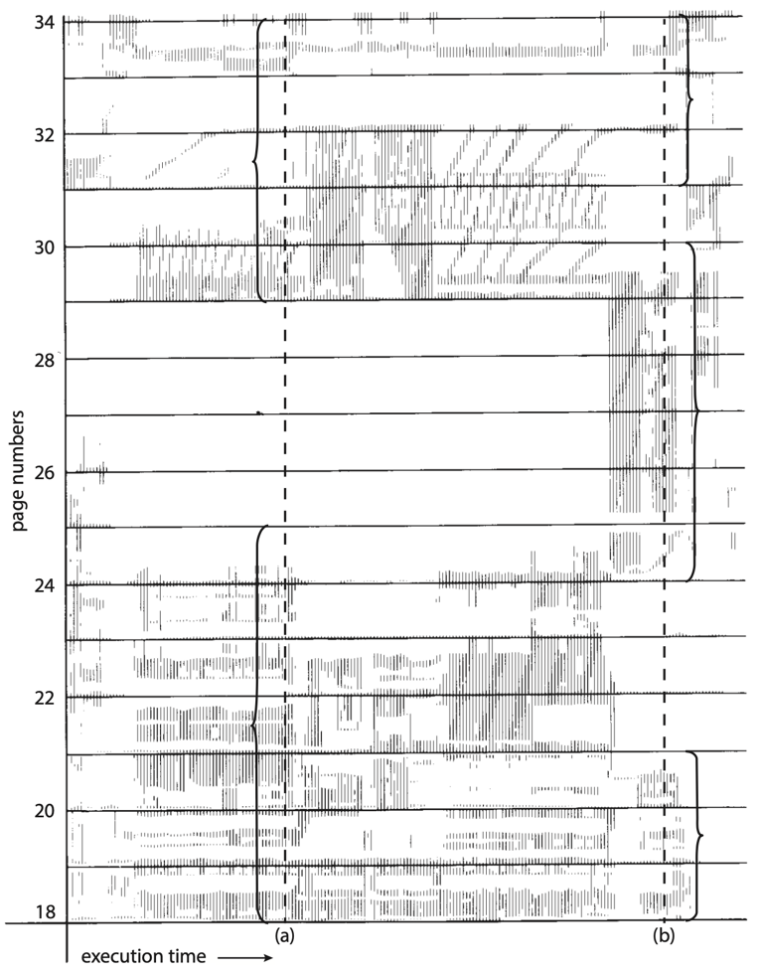

Shown are referenced addresses by a process over a period of time.

Each reference is shown as a dot on the plot. Locality can be seen, both spatial and temporal.

## Working-Set Model

The working size model tries to find the size of the working set window.

HOW? At any point in time what we are using is delta. For delta references, what are the pages we reference?

The working set -the pages currently needed in memory- changes during process execution.

* Δ ≡ working-set window ≡ a fixed number of page references
* ${WSS}_{i}$ (working set of process $P_{i}$) =

total number of pages referenced in the most recent Δ (varies in time)

* + if Δ too small → will not encompass entire locality
  + if Δ too large → will encompass several localities
  + if Δ = ∞ → will encompass entire program
* $D=\sum{{WSS}_{i}}≡$ total demand frames
  + Approximation of locality
* If $D>m ⇒$ Thrashing
* Policy if *D > m*, then suspend or swap out one of the processes

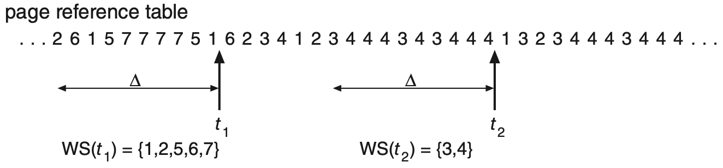

### Keeping Track of the Working Set

* Approximate with interval timer + a reference bit
* Example: $∆ =10,000$
  + Timer interrupts after every 5000 time units
  + Keep in memory 2 bits for each page
  + Whenever a timer interrupts copy and sets the values for all reference bits to 0
  + If one of the bits in memory = 1 ⇒ page in working set
* Why is this not completely accurate?
* Improvement = 10 bits and interrupt every 1000 time units

## Page-Fault Frequency

* 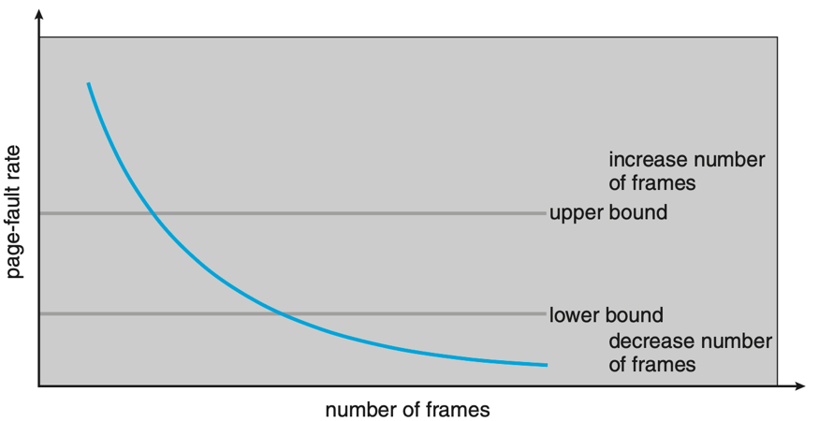More direct approach than WSS
* Establish “acceptable” ***Page-Fault Frequency (PFF)*** rate and use local replacement policy
  + If actual rate too low, process loses frame
  + If actual rate too high, process gains frame

## Working Sets and Page Fault Rates

* Direct relationship between working set of a process and its page-fault rate
* Working set changes over time
* Peaks and valleys over time

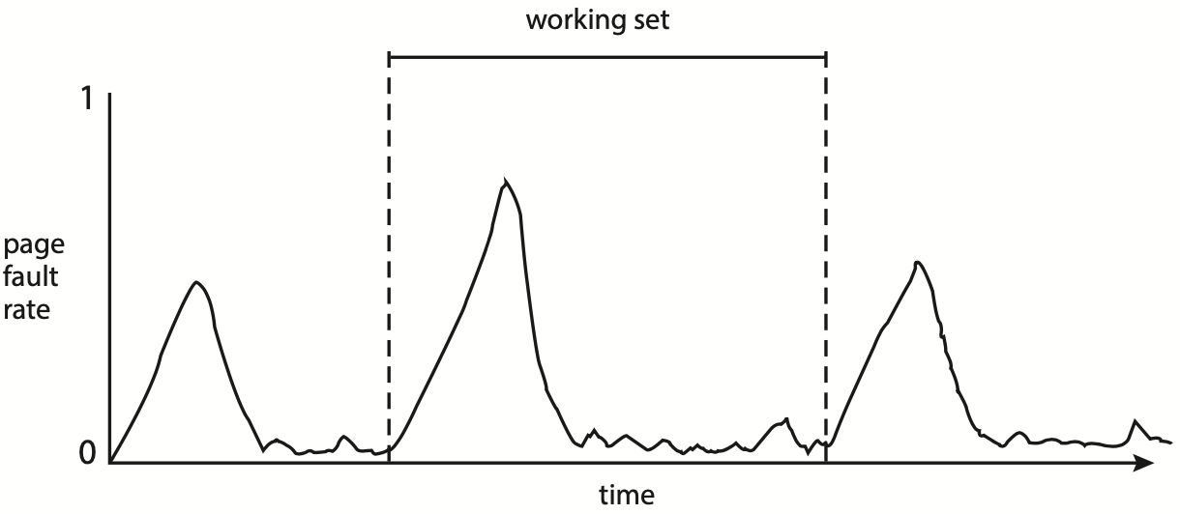

## Memory-Mapped Files

* ***Memory-mapped file I/O*** allows file I/O to be treated as a memory access by mapping a disk block to a page
* A file is initially read using demand paging
  + A page-sized portion of the file is read from the file system
  + It is placed into a physical frame
  + Subsequent reads/writes to/from the file are treated as ordinary memory accesses
* Simplifies and speeds file access
  + File I/O happens in memory
  + Must ultimately save back to file if modified
* Also allows several processes to map the same file allowing the pages in memory to be shared
* But when does written data make it to disk?
  + Periodically and / or at file close()time
  + For example, when the pager scans for dirty pages

## Memory-Mapped File Technique for all I/O

* Some OSes use memory mapped files for standard I/O
* Process can explicitly request memory mapping a file via mmap() system call
  + Now file mapped into process address space
* For standard I/O (open(), read(), write(), close()) can use mmap() anyway
  + But map file into kernel address space
  + Process still does read() and write()
    - copies data to and from between kernel space and user space
  + Uses efficient memory management subsystem
    - avoids needing separate subsystem
* Memory mapped files can be used for shared memory

(although again via separate system calls)

### Memory Mapped Files

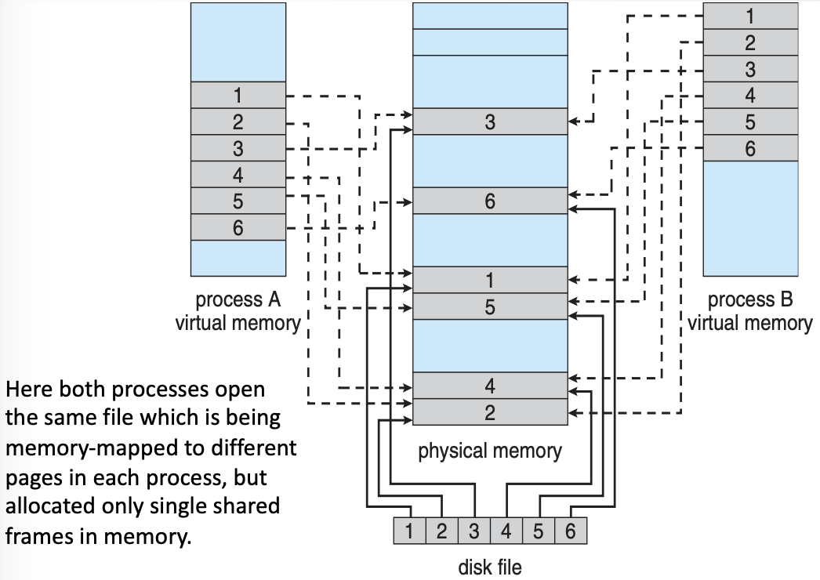

### Shared Memory via Memory-Mapped I/O

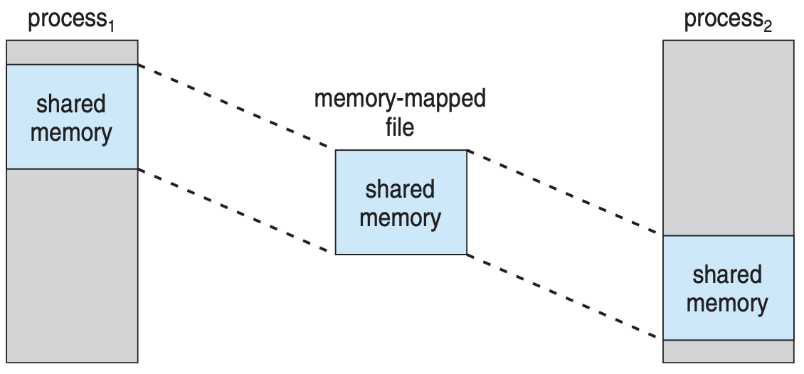

## Shared Memory in Windows API

* First create a file mapping for file to be mapped
  + Then establish a view of the mapped file in the process’s virtual address space
* Consider producer / consumer
  + Producer create shared-memory object using memory mapping features
  + Open file via CreateFile(), returning a HANDLE
  + Create mapping via CreateFileMapping() creating a named shared-memory object
  + Create view via MapViewOfFile()
* Sample code in textbook

## Allocating Kernel Memory

* Treated differently from user memory
* Often allocated from a free-memory pool
  + Kernel requests memory for structures of varying sizes
  + Some kernel memory needs to be contiguous such as for device I/O

## Buddy System

* Allocates memory from fixed-size segment consisting of physically-contiguous pages
* Memory allocated using power-of-2 allocator
  + Satisfies requests in units sized as power of 2
  + Request rounded up to the next highest power of 2
  + When smaller allocation needed than is available, current chunk split into two buddies of next-lower power of 2
    - Continue until approximate sized chunk available
* For example, assume 256KB chunk available, kernel requests 21KB
  + Split into $A_{L}$ and $A_{R}$ of 128 KB each
    - One further divide into $B_{L}$ and $B_{R}$ of 64KB
      * One further into $C_{L}$ and $C_{R}$ of 32 KB each - one used to satisfy request
* **Advantage** – quickly coalesce unused chunks into larger chunk
* **Disadvantage** – fragmentation

### Buddy System Allocator

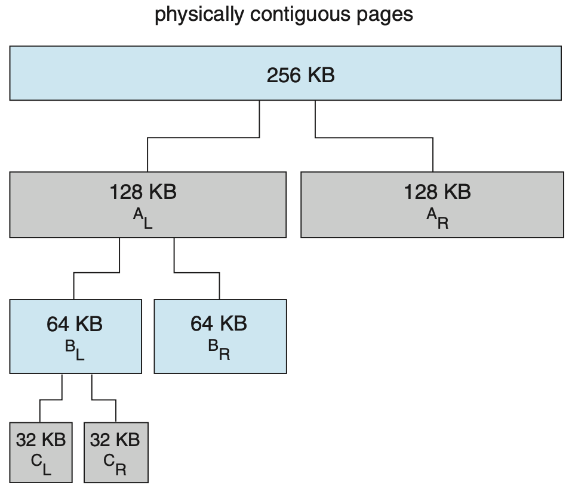

## Slab Allocator

* Alternate strategy
* Slab is one or more physically contiguous pages
* Cache consists of one or more slabs
* Single cache for each unique kernel data structure
  + Each cache filled with objects – instantiations of the data structure
* When cache created, filled with objects marked as free
* When structures stored, objects marked as used
* If slab is full of used objects, next object allocated from empty slab
  + If no empty slabs, new slab allocated
* **Benefits** include no fragmentation, fast memory request satisfaction

### Slab Allocation

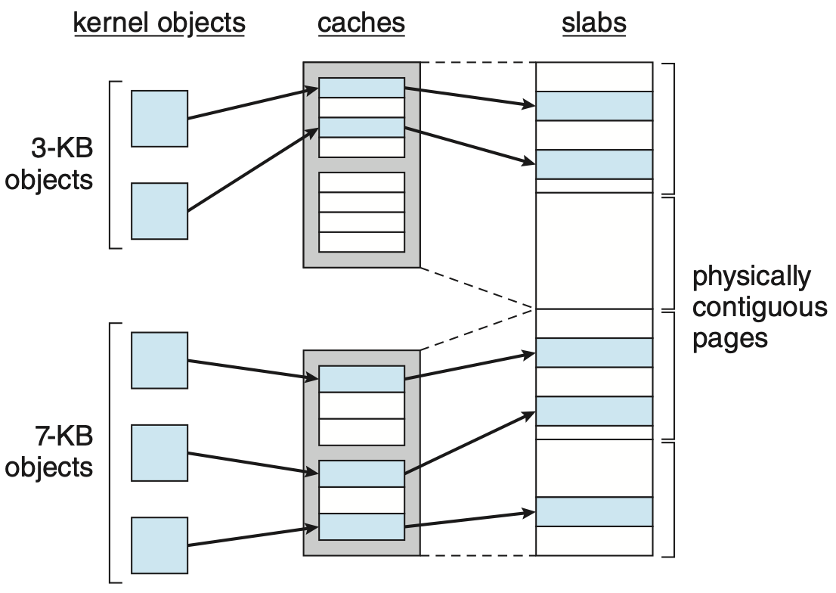

## Slab Allocator

* For example, process descriptor is of type *struct task_struct*
* Approx. 1.7KB of memory
* New task 🡪 allocate new struct from cache
  + Will use existing free *struct task_struct*
* Slab can be in three possible states
  + Full – all used
  + Empty – all free
  + Partial – mix of free and used
* Upon request, slab allocator
  + Uses free struct in partial slab
  + If none 🡪 takes one from empty slab
  + If no empty slab 🡪 create new empty

## Slab Allocator in Linux

* Slab started in Solaris, now wide-spread for both kernel mode and user memory in various OSes
* Linux 2.2 had SLAB, now has both SLOB and SLUB allocators
  + SLOB for systems with limited memory
    - Simple List of Blocks – maintains 3 list objects for small, medium, large objects
  + SLUB is performance-optimized SLAB removes per-CPU queues metadata stored in page structure.

## Other Considerations – Prepaging

* Prepaging
  + To reduce the large number of page faults that occurs at process startup
  + Prepage all or some of the pages a process will need, before they are referenced
  + But if prepaged pages are unused, I/O and memory was wasted
  + Assume s pages are prepaged and α of the pages is used
    - Is cost of $s×α$ save pages faults > or < than the cost of prepaging

$s*(1-α)$ unnecessary pages?

* + - α near zero ⇒ prepaging loses

## Other Issues – Page Size

* Sometimes OS designers have a choice
  + Especially if running on custom-built CPU
* Page size selection must take into consideration:
  + Fragmentation
  + Page table size
  + Resolution
  + I/O overhead
  + Number of page faults
  + Locality
  + TLB size of effectiveness
* Always power of 2, usually in the range $2^{12}$ (4,096 bytes) to $2^{22}$ (4,194,304 bytes)
* On average, growing over time

## Other Issues – TLB Reach

* TLB Reach
  + Amount of memory accessible from the TLB
* TLB Reach = (TLB Size) $×$ (Page Size)
* Ideally, the working set of each process is stored in the TLB
  + Otherwise there is a high degree of page faults
* Increase the Page Size
  + This may lead to an increase in fragmentation as not all applications require a large page size
* Provide Multiple Page Sizes
  + This allows applications that require larger page sizes the opportunity to use them without an increase in fragmentation

## Other Issues – Program Structure

* Program structure
  + int[128, 128] data;
  + Each row is stored in one page
  + Program 1

for (j = 0; j < 128; j++)

for (i = 0; i < 128; i++)

data[i, j] = 0;

128 $×$ 128 = 16,384 page faults

* + Program 2

for (i = 0; i < 128; i++)

for (j = 0; j < 128; j++)

data[i, j] = 0;

128 page faults

## Other Issues – I/O interlock

* I/O Interlock – Pages must sometimes be locked into memory
* Consider I/O – Pages that are used for copying a file from a device must be locked from being selected for eviction by a page replacement algorithm
* Pinning of pages to lock into memory

## Topic Entry

* Topic buffers store (pointers to) topic entries
* A topic entry is a structure containing

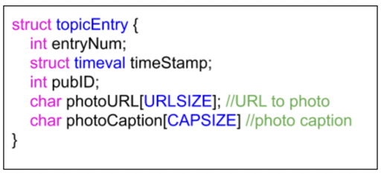

* Fields are filled in on insertion into a topic queue
  + entryNum is based on a per queue value (numEntries)

# Lecture 11 – Operating Systems File Systems – Theory

## Outline

* File Concept
* Access Methods
* Disk and Directory Structure
* File-System Mounting
* File Sharing
* Protection

## A System Problem?

* Got some data in your program
  + Want to keep it for a while
* Got a long running program
  + Want to prevent loss of data if it crashes
* Got a lot of programs, system resources, data, and so on stored
  + Want a mechanism to refer to them all

Files: things that have lifetime beyond a process execution

Using files to back up current program by using check point

Check point: if crash, restart the program from the where it was

## File System Interface

* Most visible part of the OS
* Consists of
  + Files
  + Directories
* And sometimes
  + Partitions

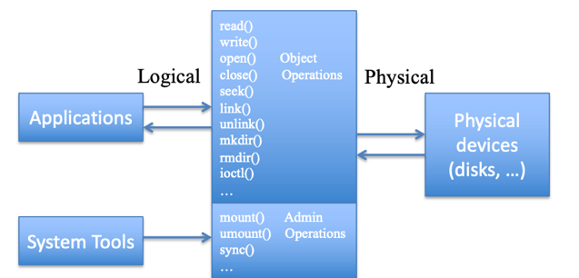

higher level interface can be mapped through lower level interface to the actual physical devices that storing the files

at the higher level, think of organization of the manner, how things exist

## What is a file?

* A repository for data
* Is long lasting (until explicitly deleted)
* Also, may refer to a system resource (device)

longer lasting than the process, sits in the memory of the process

## Why not just an address space?

* You may want data to **persist longer than a process**
* You may want data that is **larger than a virtual address space**
* Easier to share the data across processes

providing access, copying and giving to someone else, files can also be moved around

## Two Aspects To Consider

* **User’s view**
  + Naming the file

referring to the file, reference a file, using a logical handle that we have for that file

* + Type of file

different files have different attributes, different types of data, how is formatted

* + How is it structured
  + How is it accessed
  + What attributes does the file have
  + What operations are support on the file
  + What permissions are associated with the file
* **System implementation**

*consider which files can be stored in the storage*

## Naming and Structure

* Naming
  + Typically $x.y$
  + *x* is supposed to give some clue about **contents**
  + *y* is supposed to be the nature of the file
* Structure
  + Byte stream
  + Sequence of records
  + Indexed records

## Types of File Objects

Files aren’t just holding data, they can also hold other information such as directories. We use the file structure to put anything we want in it.

* **Regular files** (containing data)
* **Directories**
* **Character files**
  + Access a character at a time
* **Block files**
  + Access a block at a time

## Types of File Attributes

* ***Name***– only information kept in human-readable form
* ***Identifier***– unique tag (number) identifies file within file system
* ***Type***– needed for systems that support different types
* ***Location***– pointer to file location on device
* ***Size***– current file size
* ***Protection***– controls who can do reading, writing, executing
* ***Time, date, user identification***– data for protection, security, and usage monitoring
* Information about files (**metadata**) are kept in the file system structure, which is maintained on the disk

## Open Files

* Several data are needed to manage open files:
  + ***Open file table*** - tracks open files
  + ***File pointer*** - pointer to last read/write location, per process that has the file open
  + ***File open count*** - counter of number of times a file is open – to allow removal of data from open-file table when last processes closes it

you may have a file that is opened by multiple processes, you don’t want to be closing that file until all the processes close the file

File descriptor: info about where the file is stored, it gets created when we open a file or created a file, as long as the file is open, there’s a process has opened that file and is essentially using that file

* + ***Disk location of the file*** - cache of data access information
  + ***Access rights*** - per-process access mode information

## Open File Locking

* Provided by some operating systems and file systems
  + Similar to reader-writer locks
  + Shared lock similar to reader lock – several processes can acquire concurrently
  + Exclusive lock similar to writer lock
* Mediates access to a file
* Mandatory or advisory:
  + Mandatory – access is denied depending on locks held and requested
  + Advisory – processes can find status of locks and decide what to do

## File Types – Name, Extension

There are different types of files that are designated by different extensions, and that typing ends up being supported by some code that knows how to handle that extension (like it knows how the file should be read, how it should be looked at or edited, etc.).

You can also write you own type of files, with your own extension.

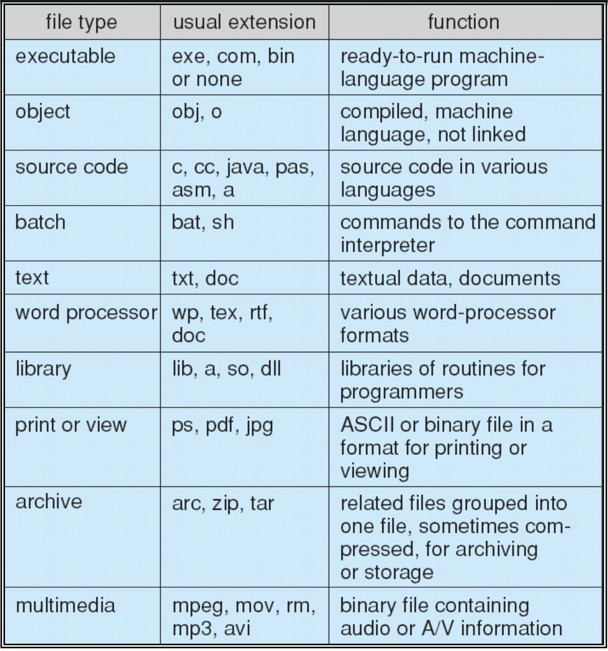

you can also write your own types of files (your own extension)

## File Structure

* **None**
  + sequence of words, bytes
* **Simple record structure**
  + Lines
  + Fixed length
  + Variable length
* **Complex Structures**
  + Formatted document
  + Relocatable load file
* Can simulate last two with first method by inserting appropriate control characters
* Decisions are made by:
  + Operating system
  + Program

## File Operations

* **Sequential Access**

we have a pointer indicates where we are in the file, we can do things at that point

* + ***reset***
  + ***read***next (advance file pointer automatically)
  + ***write***next (advance file pointer automatically)
* **Direct Access**

positioning within a file, we can add/move that position to new position in some ways

* + ***read n***
  + ***write n***
  + ***position***to *n*
  + ***read***next
  + ***write***next

*n* = relative block number

* File is an abstract data type
* *Create*
* *Delete*
* *Write* – at write pointer location
* *Read* – at read pointer location
* *Seek* – reposition within file
* *Truncate*
* $Open(F_{i})$– search the directory structure on disk for entry $F_{i}$, and move the content of entry to memory
* $Close (F_{i})$– move the content of entry $F_{i}$ in memory to directory structure on disk

trying to locate that file in file system when open successful we will get some handle that allows us to do read and write operations, once we open that file, later we can close it

## Access Methods

* **Sequential Access**

read next

write next n = relative block number

reset

* **Direct Access** – file is fixed length logical records

read n

write n

position to n

read next

write next

rewrite n

* Relative block numbers allow OS to decide where file should be placed

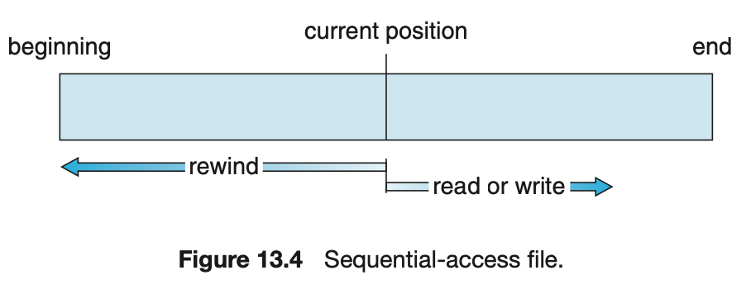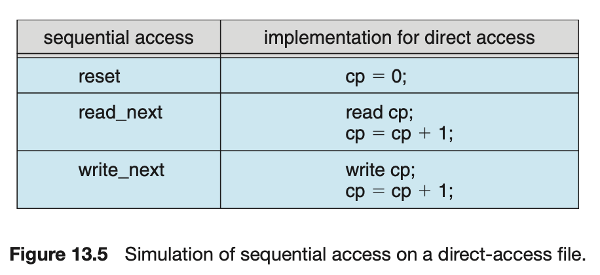

cp = current position

## Directory

Files can hold many things, one of the things is a directory. A directory is essentially a set of data, information about files (organizational information about how files are organized).

Directories are important because we need something to manage the relationship between files, to organize things.

They also provide us with the means to locate files (they give a pathway to the directory hierarchy to the file and where it lives in the hierarchical file system(organization) -> hierarchical file system.

|  |  |
| --- | --- |
| * A way of organizing files * Each directory entry has:   + File/directory name   + A way (pointer) to get to the data blocks of that file/directory * Both the directory structure and the files reside on disk |  |

## File System Details

A flat hierarchy has only a single directory which all the files are living in. they’re represented in the system directory vs. the hierarchical directory.

* **Flat** (only 1 directory) vs. **Hierarchical** file system

hierarchy is built from directory information

* File names: **relative** vs. **absolute**

relative names: relative to their paths within the file system

* **Directory Operations**:
  + Create
  + Delete directory
  + Open directory
  + Close directory
  + Read directory
  + Rename
  + Link (allow a file to appear in more than 1 directory) ❍ Unlink

## File System Hierarchy Standard

We start off with some file system that is mounted (or later) in our machine. That mounting effectively gives us access to the directory information that is part of that mounted file system

* UNIX ***Filesystem Hierarchy Standard* (FHS)**
  + Convention to enable software and users to find the location of installed files and directories

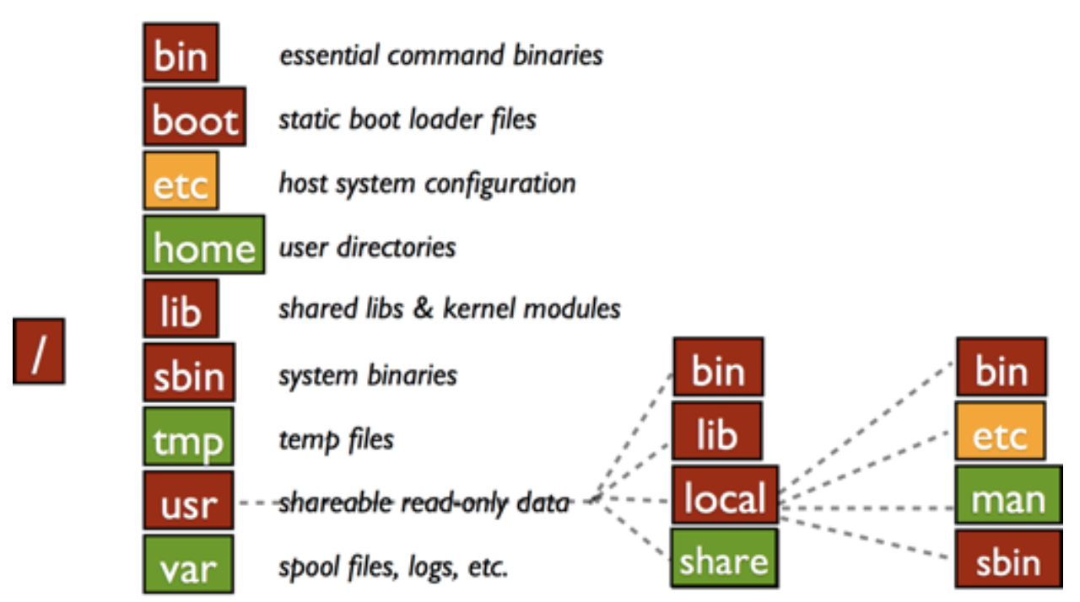

mounting: effectively gives us access to the directory information that’s part of the mounted file system and then we unfold…

## Disk Structure

* Disk can be subdivided into **partitions**
* Disks or partitions can be RAID protected against failure
* Disk or partition can be used raw – without a file system, or formatted with a file system

on the raw storage, we are implementing a file system, composed directories and files

* Partitions also known as minidisks, slices
* Entity containing file system known as a **volume**
* Each volume containing file system also tracks that file system’s info in device directory or volume table of contents

highest directory: volume

stores the file system, contains information about how that file system is structured from a directory hierarchical directory point of view, also keeps information about where that file system lives within the storage, where it is located,

* As well as general-purpose file systems there are many special-purpose file systems, frequently all within the same operating system or computer

how file systems are built…? important

## A Typical File-system Organization

|  |  |
| --- | --- |
| * Assume disk storage * Create partitions on disks were directories and files are stored   you can partition a disk, physical partitioning of that disk, and with that partition you can create a volume, a volume is effectively a file system, but I can partition a disk without file system on it | page26image59419408 |

## Types of File Systems

file systems conserve different purposes

* We mostly talk of general-purpose file systems
* But system frequently have may file systems, some general purpose and some special purpose

backing store: special purpose, put paging on that

* Consider Solaris has
  + *tmpfs* – memory-based volatile FS for fast, temporary I/O
  + *objfs* – interface into kernel memory to get kernel symbols for debugging
  + *ctfs* – contract file system for managing daemons
  + *lofts* – lookback file system allows one FS to be accessed in place of another
  + *procfs* – kernel interface to process structures
  + *ufs, zfs* – general purpose file systems

## Operating Performed on Directory

* search for a file
* create a file
* delete a file
* list a directory
* rename a file
* traverse the file system

## Directory Organization

* The directory is organized logically to obtain:
  + Efficiency – locating a file quickly
  + Naming – convenient to users
    - two users can have same name for different files
    - the same file can have several different names
  + Grouping – logical grouping of files by properties

(e.g., all Java programs, all games, …)

## Single-Level Directory

* A single directory for all users

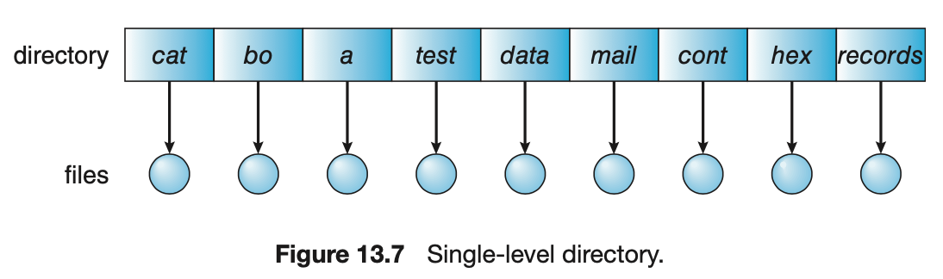

* Naming problem

Files have to have unique names

* Grouping problem

multi-level directory files can have same name, since the path name distinguish them

## Two-Level Directory

* separate directory
  + path name
  + can have the same filename for different user
  + efficient searching
  + no grouping capability

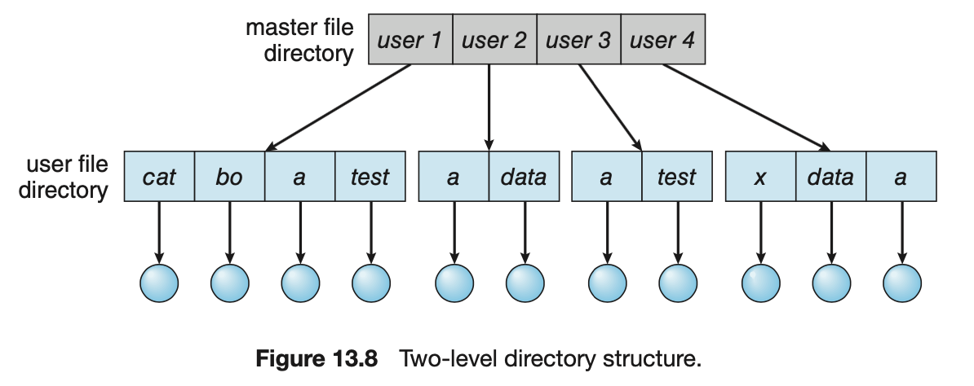

## Tree-Structured Directories

|  |  |
| --- | --- |
| * Efficient searching * Grouping capability * Current directory (working directory)   + cd / spell / mail / prog   + type list   no directory cross the trees |  |

## Path Names

* absolute or relative path name
* creating a new file is done in current directory
* delete a file
  + rm <filename>
* creating a new subdirectory is done in current directory
  + mkdir <dirname>

use the path names when we open files, be able to find a file within a file system

## Acyclic-Graph Directories

Not a pure tree, but we have multiple references pointing to the same file.

* have shared subdirectories and files

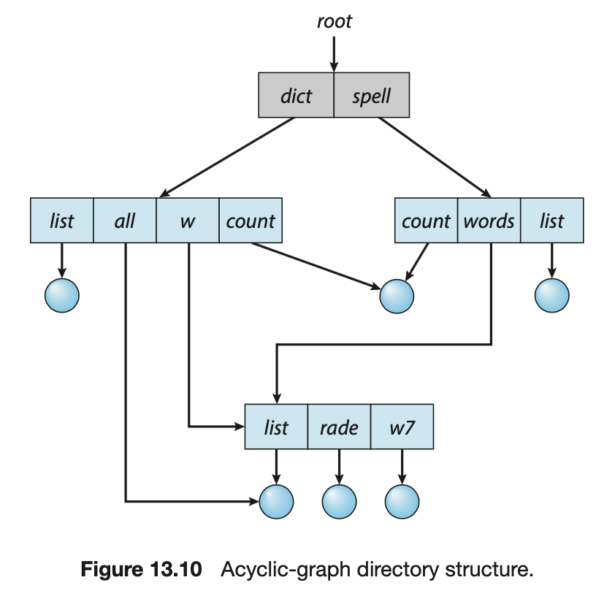

within the hierarchy, pointing to the same file, have directories that go to directories in common

## Links

something that is providing a link to a file through a different name 🡪 a file can appear in more than 1 directory

* two different names (aliasing)
* link – makes a file appear in more than 1 directory
* is a convenient in several situation
* 2 types of links:
  + soft links
    - create a file which contains the name of the other file
    - use this pathname to get to the actual file when it accessed
    - **problem**: extra overhead of parsing and following components till the file is reached
  + hard links
    - create a directory entry and make a reference that file
    - others may reference the same file

## Hard Link Problem

* What if the creator wants to delete the file?
  + there are still other references to the file, potentially
  + cannot free up until all the other references are removed
* **solutions**:
  + **backpointers**
    - so we can delete all pointers (variable size record a problem)
  + backpointers using a daisy chain organization
  + **entry-hold-count** solution
    - keep a counter that is incremented for each hard link
    - on removing a link, decrement counter
    - only if counter is 0, remove the file

## General Graph Directory

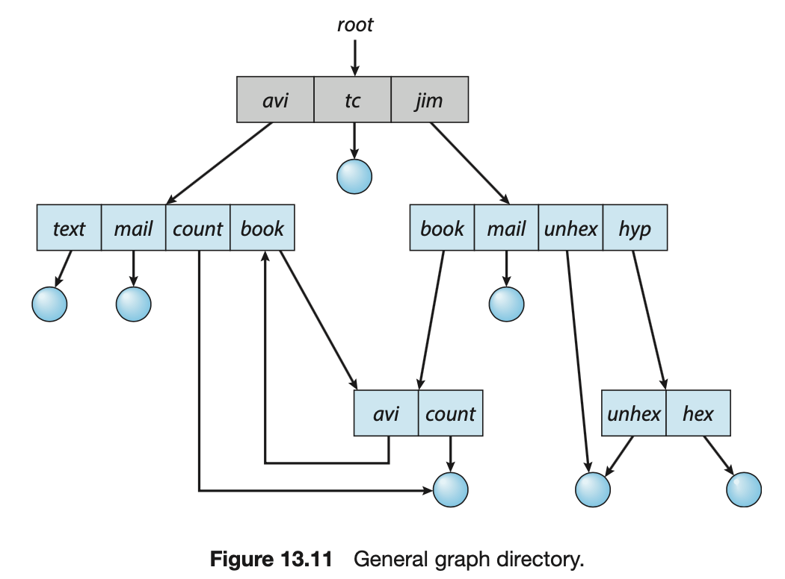

## General Graph Directory Problems

* How do we guarantee no cycles?
* Solutions:
  + allow only links to file not subdirectories
  + garbage collection
  + every time a new link is added use a cycle detection algorithm to determine whether it is OK

## Partitions

* a way of organizing directories
* each partition contains a file system of directories
* examples:
  + root file system ( / )
  + boot file system ( /boot )
  + user’s home ( /home )

## File System Mounting

* a file system must be mounted before it can be accessed
* an unmounted file system is mounted at a mount point

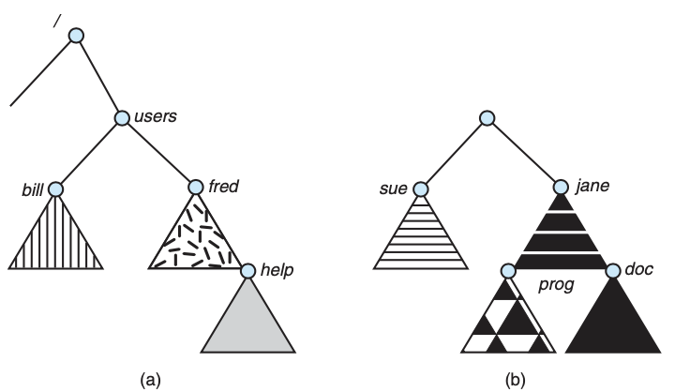

mounting a file system is effectively going to a place on the storage system where a file system is supposed to be stored and getting the file system information that is stored at a norm place, read in by the operating system who interprets that and then builds whatever it needs to understand about that file system to access it how its hierarchical directory structure looks like so that’s the idea of mounting

## Mount Point

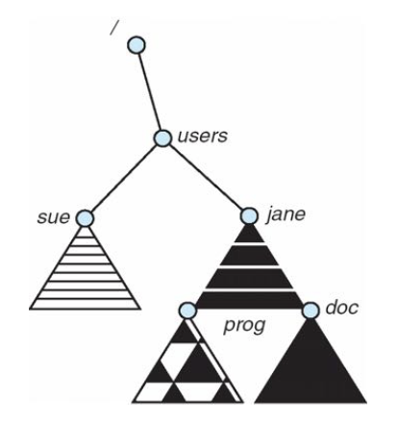

## File Sharing

* In a multi-user system,
  + There is interest in sharing files
* System files
  + Shared by all
  + Examples?
* Per user files
  + may want to work with others
  + or with particular groups of users

want protection and security to ensure file sharing is correct

### How to Share

* Files and links
  + short cut through the file system
    - hard
    - soft
* Directories
  + must provide the other user or group access to your directory
* Remote file systems
  + access files on different machines
  + must provide the other user or group access to your machine and directory

### File Sharing

We must have a protection scheme that allows us to use the identifiers we have as users.

Note: mostly when we work on files we’re doing so in the context of some program we’re using to do something with a file. That program itself can just be a shell, and you’re navigating through the system and looking at files.

So everytime you’re representing yourself with a set of permission that says whether you can navigate through those files and access them.

* Sharing may be done through a protection scheme
* On distributed systems, files may be shared across a network
  + *Network File System (NFS)* is a common distribute file sharing method
* In multi-user system
  + User IDs identify users, allowing permissions and protections to be per-user

Group IDs allow users to be in groups, permitting group access rights

* + Owner of a file / directory
  + Group of a file / directory

you’re representing yourself with a set of permissions that allow you to do that navigation and work with files.

### File Sharing – Remote File Systems

About file systems that are remote: These act in a way like support for client-server interactions between the processes, and essentially what you’re doing is taking a file system from a remote server, and mounting that into your machine. The file system acts the same as other file systems, except that it works through your mount point. The operations are being turned into actual remote operations through distributed process interaction in that type of a client-server model. One that is very familiar is the NFS.

* Uses networking to allow file system access between systems
  + **manually** via programs like FTP
  + **automatically**, seamlessly using distributed file systems
* Client-server model allows clients to mount remote file systems from servers
  + server can serve multiple clients
  + client and user-on-client identification is insecure or complicated
  + NFS is standard UNIX client-server file sharing protocol
  + CIFS is standard Windows protocol
  + Standard OS file calls are translated into remote calls
* Distributed Information Systems (distributed naming services) such as LDAP, DNS, NID, Active Directory implement unified access to information needed for remote computing

## Access Control / Authorization

* An access control system determines what ***rights*** a particular *entity* has for a set of *objects*
* It answers that questions
  + Do you have the right to read /etc/passwd?
  + Does Alice have the right to view the CIS website?
  + Do students have the right to share project data?
  + Does Prof. Malony have the right to change your grades?
* an *Access Control Policy* answers these questions

Within a system that we need to have some types of access to objects based upon what rights they have to do things to those objects, and contexts of file system it is those entities are using the files, files here become objects, and what rights do they have, read or modify

### Simplified Access Control

* Subjects are the active entities that do things to file
  + You, Alice, students, Prof. Malony
* Objects are passive things that things are done to (objects are those files)
  + /etc/passwd, CIS website, project data, grades
* Rights are actions that are taken
  + read, view, share, change

### The Access Matrix

|  |  |
| --- | --- |
| * An access matrix is one way to represent policy   + Frequently used mechanism for describing policy * columns – Objects   rows – Subjects   * To determine if Si has right to access object Oj, find the appropriate entry * Succinct descriptor for entries * There is a matrix for each right |  |

### Access Control

|  |  |
| --- | --- |
| * Suppose the private key file for J is object O1   + Only J can read * Suppose the public key file for J is object O2   + All can read, only J can modify * Suppose all can read and write from object O3 * What’s the access matrix? |  |

## Protection vs Security

* **Protection**
  + Security goals met under trusted processes
  + Protects against an error by a **non-malicious** entity
* **Security**
  + Security goals met under potentially malicious processes
  + Protects against any **malicious** entity

### File Protection in Unix

* File owner/creator should be able to control:
  + what can be done
  + by whom
* Types of access:
  + read
  + write
  + execute
  + append
  + delete
  + list

## Access Lists and Groups

* Mode of access: read, write, execute
* 3 classes of users on Unix / Linux

|  |  |  |  |  |  |  |  |  |  |  |  |  |  |
| --- | --- | --- | --- | --- | --- | --- | --- | --- | --- | --- | --- | --- | --- |
| |  |  |  | | --- | --- | --- | | 1. owner access | 7 => | rwx | | 111 | | 1. group access | 6 => | rwx | | 110 | | 1. public access | 1 => | rwx | | 001 | | page52image4515168 |

* Ask manager to create a group (unique name), say G, and add some users to the group
* For a particular file (say game) or subdirectory, define an appropriate access

Attach a group to a file 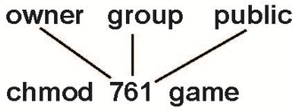

chgrp G game

## Permissions

* Permissions are properties of files and directories
  + System calls have built-in checks to permissions
    - Only succeed if proper permissions are in place
* 3 classes of permissions
  + **User**: access for whoever owns the file
    - You can also prevent yourself from accessing a file!

But you can always change it back

* + **Group**: allow a UNIX group to access a file
  + **Other**: allow anyone on the system to access a file

## Change File Mode

* chmod

This gives you a way to change the access control lists for files by modifying the file mode bits through this command

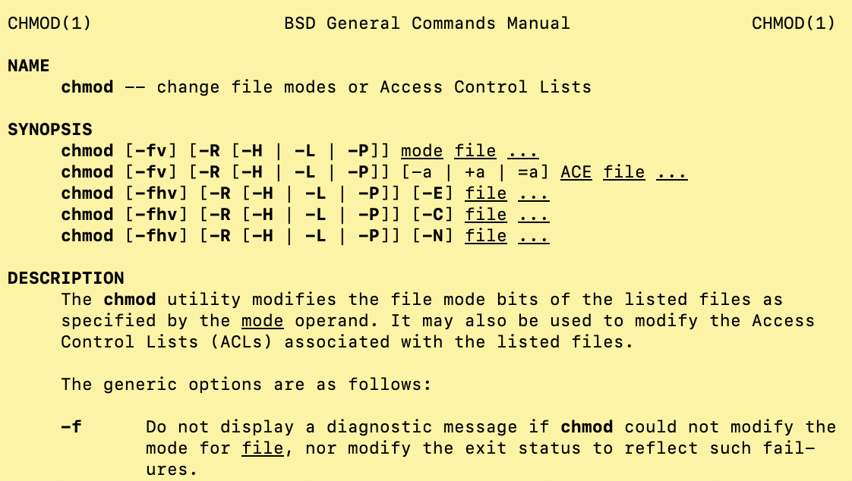

## Unix Commands for Groups

* chgrp
  + changes the group for a file or directory
  + chgrp <group> <filename>

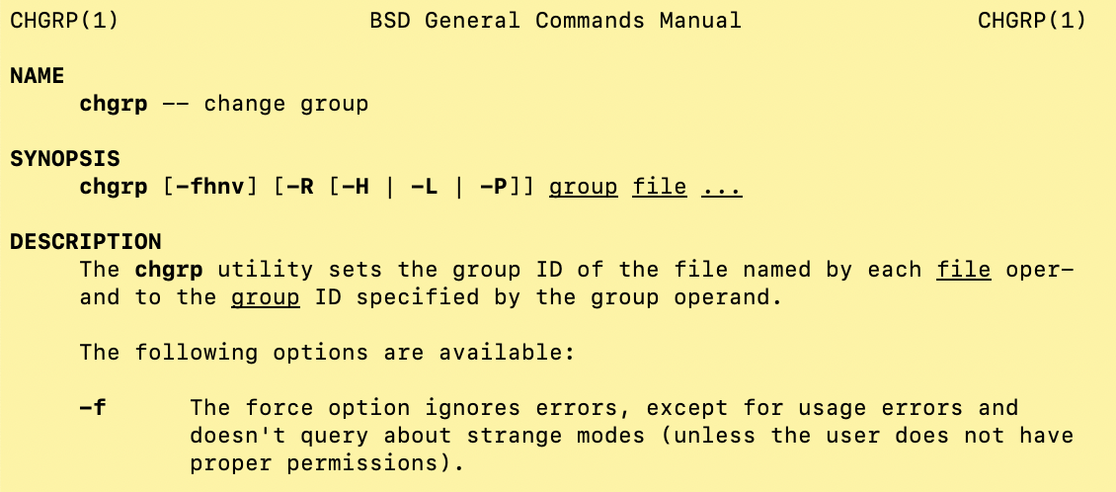

* groups
  + lists groups you are in

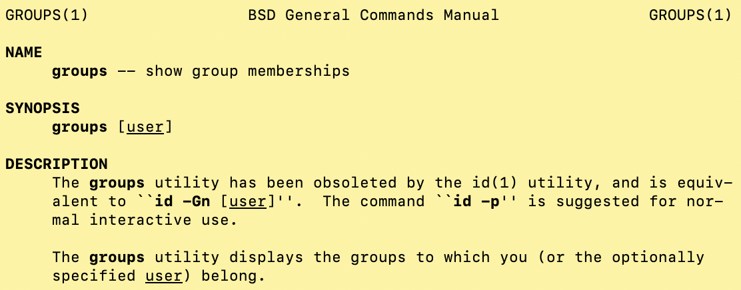

## Long Listing

* ls -l
  + long listing of files
* for each file, it shows:
  + File permissions
  + Number of links to the file
  + Owner
  + Group
  + File size
  + Date of last change
  + Filename
* A sample UNIX directory listing

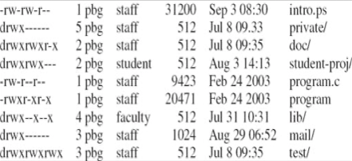

* + d indicates directories
  + It also shows the size of the files, when it was created, the group associated with that file, etc.

## Distributed File Systems

Remotely mounted file systems, they can be viewed through mount point on local machine

* Remote directories are visible from the local machine
  + Server has the files
  + Client makes file requests
* Share by partition
  + Mount to remote file system
  + Convert local file request to client-server request to access remote file
  + Like an RPC
* Examples
  + Network File System (NFS)
    - What we use
    - Very common
  + Andrew File System (AFS)
    - Other universities use
  + Distributed Computing Environment (DCE)
    - Commercial system
  + Distributed file access
    - WWW, ftp, CIFS (Samba), …

## Summary

* File System Interface
  + Files
  + Directories
  + Partitions
* Operations on the interface
  + Mounting (partitions)
  + Sharing (files)
  + Protection (files)

# Lecture 12 – File System Implementation

Idea: so we have the theory in mind, that files live out there somewhere (logically) on storage devices, and we have this high level interface to get access to those files. And that the OS does some mapping from this high level interface, to the low level mapping of the files. But there’s a lot of gap in between and a lot of issues arise.

We have a need within the OS to maintain information about files, and we use a control block to do so and that's what the OS works with when we have files that have been opened by processes (we access them through the control block).

## Outline

* File-System Structure
* File-System Implementation
* Directory Implementation
* Allocation Methods
* Free-Space Management
* Efficiency and Performance
* Recovery
* NFS

## File-System Structure

* *File structure*

architecture in a way of file system look like, logic view

* + logical storage unit
  + collection of related information
* *File system* resides on secondary storage (disks)
  + provided user interface to storage
    - Mapping logical to physical
  + provides efficient and convenient access to disk by allowing data to be stored, located retrieved easily
* *File system* organized into layers

Organized in ways that supporting these high-level operations to low-level data transfers and so on

* *File Control Block (FCB)*
  + Storage structure consisting of information about a file
* *Device driver* controls the physical device

## Disks as Secondary Store

Secondary storage has traditionally and continued to be implemented for file system storage using disks because they’re very high volume, they provide fast access, high I/O transfer rates, and so forth.

* What makes them convenient for storing files?
  + rewrite in place
    - read, modify in memory, write back to original location
  + access any block (sequentially or random)
    - got to move the head to get there
  + I/O transfers performed in blocks of sectors
    - Usually 512 bytes
* Solid-State Drives (SSDs) becoming more prevalent

Implemented for data storage, file systems, using disks

## Layered File System

|  |  |
| --- | --- |
| * Think of file system as a hierarchical organization   + Well-defined layers   + Supports abstraction between layers * Start with the physical layer and work up * Use abstraction to support upper-layer functionality while hiding lower-layer complexity   when initially start up, OS doesn’t know anything, so it has to learn about what file system is connected to it, and does so in a standard procedure by reading special locations to get that information, and get everything initially booted up to configure | page7image4747664 |

## File System Layers

* ***Device drivers*** manage I/O devices at the *I/O control layer*
  + High-level commands like:

“read drive 1, cylinder 72, track 2, sector 10, into memory location 1060”

* + Translate into low-level hardware specific commands to hardware controller
* Basic file system given command like “retrieve block 123” translates to device driver
* Also manages memory buffers and caches (allocation, freeing, replacement)

to help in performance, a lot of intermediary: caching and buffering

* + Buffers hold data in transit

🡪 smooth out the performance in a way that you maintain some standard data rate, smooth out the I/O rate, so that you don’t have hookups in some ways

* + Caches hold frequently used data

Try to capture some data that might be frequently used, where it’s holding on somewhere temporarily, in a faster memory than just the I/O device. In this way, get the benefit of file locality. Locality of using that file.

* ***File organization module*** understands files, logical address, and physical blocks
  + Translates logical block # to physical block #

Info about everything: what files are associated with logical addresses and physical blocks, and info about where free spaces on the storage devices, and so forth

* ***Logical file system*** manages metadata information
  + Translates filename into file number, file handle, location by maintaining file control blocks
    - inodes in UNIX
  + Directory management
  + Protection

Information about the file systems, what is used to manage the file system. With perspective what the files are located there, the directory hierarchy, some access control information, and so forth

Also giving mappings between files and where they located within the storage system, so all file control block information is there as well.

* Layering useful for reducing complexity and redundancy, but adds overhead and can decrease performance
  + Logical layers can be implemented by any coding method according to OS designer

Layering provides for complexity hiding, giving you some abstractions at higher levels that reduces the amount of needed reimplementation because you have modifications variation of lower layers.

If we can have more robust interfaces in abstractions that they can map to different underlying implementations and still allows for processes to program to be portable between different machines

* Many different file systems
  + Sometimes many within an operating system
  + Each with its own format
    - CD-ROM: ISO 9660
    - UNIX: UFS (UNIX File System), FFS (Fast File System)
    - Windows: FAT, FAT32, NTFS, floppy, CD, DVD Blu-ray
    - Linux: has more than 40 types, with extended file system ext2 and ext3 leading, plus distributed file systems, …
  + Now ones still arriving
    - ZFS, GoogleFS, Oracle ASM, FUSE, Lustre, …

## File System Implementation

How are files systems implemented? We have these high level API calls, but the real question is how is the file system constructed and how is it identified by the OS? What things are stored where? How do we keep track of things?

It all starts with a boot block, it’s all the information needed by the OS to boot from that volume. It is the control block, it’s where the OS boots from and gets its initial information.

Each volume has its own control block which is the master file table for that volume. it has all the details for this volume.

* We have system calls at the API level, but how do we implement their functions?
  + On-disk and in-memory structures
* **Boot Control Block (BCB)** contains info needed by system to boot OS from that volume
  + Needed if volume contains OS
    - Usually first block of volume

Initial info tells something about from itself, started learn about its environment

* **Volume Control Block (VCB)** (superblock, master file table) contains volume details

(aka **Partition Control Block**)

* + total # of blocks
  + # of free blocks
  + block size
  + free block pointers or array
* Directory structure organizes the files
  + Names and inode numbers
  + Master file table

## File Control Block

FCB exists for every file, it has file permissions, info about when it is created, the access control lists. FCB is immediate to understand how to access that file

* per-file *File Control Block (FCB)*
* logical file system’s representation of a file
* contains many details about the file
  + permissions, size, dates, …
* In UNIX, called an inode

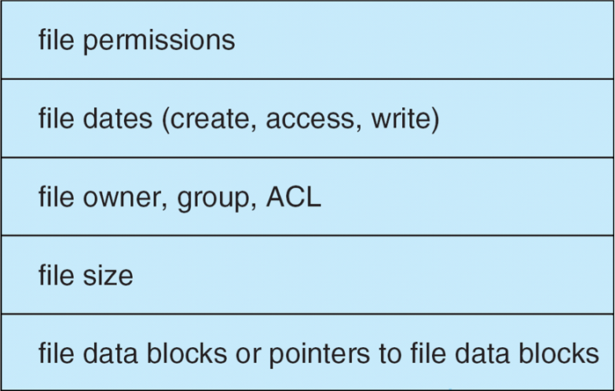

ACL: Access Control List

## Inode (index node)

* inode是指在许多“类Unix文件系统”中的一种数据结构(data structure)，用于描述文件系统对象(object)。
* 每个inode保存了文件系统对象数据(object’s data)的属性(attributes)和磁盘块位置 (disk block location)。
* 文件系统对象属性包含了各种元数据(metadata)，也包含用户组和权限数据。
* 文件夹是inode的名字。
* 一个文件夹包含自身节点，父节点和每个子节点

## File System Structures – In Memory

Files are not being used, are in the file system, and they have some information that tells you about those files. When you start to use a file, then what you are doing is opening a file, and bringing information about that file into the OS, so the OS can support the operations you are gonna take, gonna happen on that file while it’s open.

* In-memory structures

What are the structures are actually in memory that the OS is using to tell you about the file system to support file system operations

* + **Partition table**
    - Current mounted partitions
  + **Directory structure**
    - Information on recently accessed directories
  + **System-wide, open file table**
    - All currently open files
  + **Per-process, open file table**
    - All of a given process’s open files

Why in memory 🡪 it’s faster to access information

* **Mount table** storing file system mounts, mount points, file system types
* Necessary OS file system structures to **open a file**

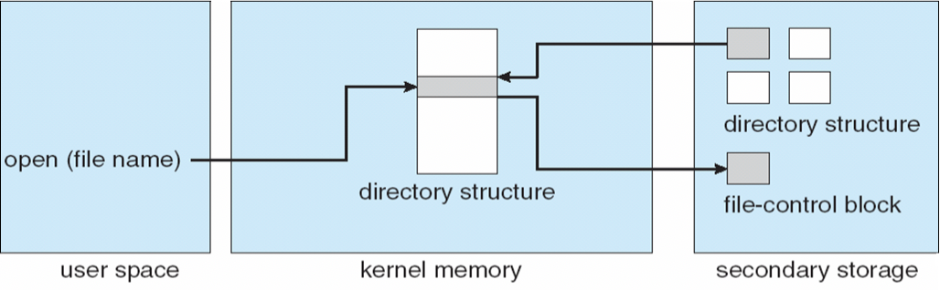

What’s in the kernel memory is a directory structure that allows me to rapidly find the file that I’m trying to open. If I don’t have that directory structure, that directory structure is living on the secondary storage, which is living with the file system. It’s a part of that file system, it’s information that’s necessary to be able to access the file system. But it might not be living in the kernel memory yet, just because we haven’t open any files within that file system. When we do, we will bring in that directory structure into the kernel memory, and then we will use that directory structure, think of it as a hierarchical directory for file system to navigate and find a particular file that we are interested in. and that should tell us where the FCB is, which is living on secondary storage so we can go and access the FCB and then now we can start to open that file.

What’s get returned is a file handle that can be used by that process.

* Buffers hold data blocks from secondary storage
* open returns a file handle for subsequent use
* For open() syscall

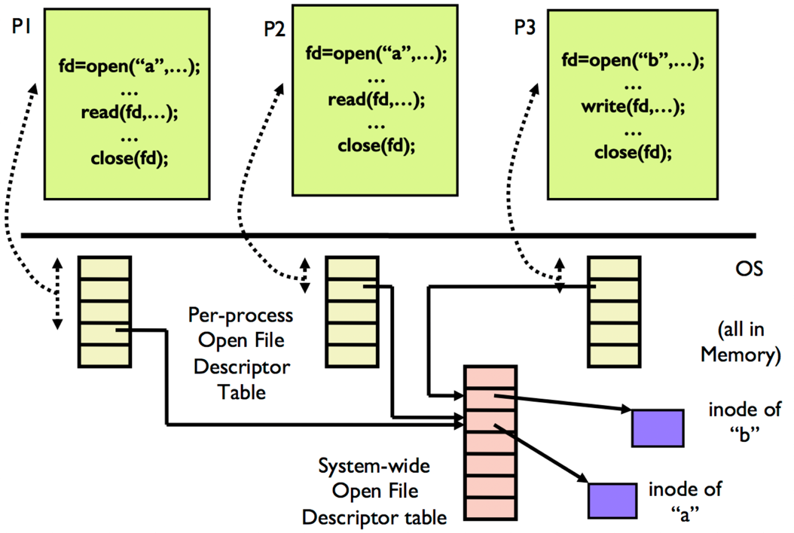

3 processes here, each one of them has own open file descriptor table, are located in memory. This open file descriptor tables are part of the Process Control Block (PCB), associated with a process. When we open, what we have in the file descriptor table is that we have pointers to the system-wide open file descriptor tables, they are pointers to that table where the information about that file is living. The file information where is located out within the file system is stored in the file descriptor table.

Open, is when things are getting setup that these file descriptors are getting established and put into these tables and made them available as handles for future read and write operations.

* Necessary OS file system structures to **read a file**

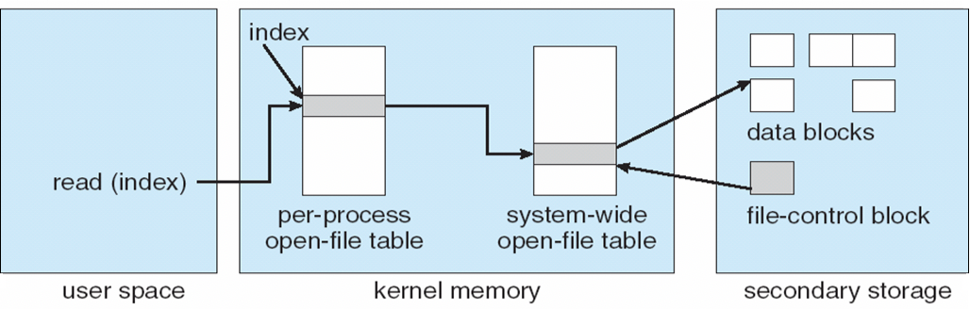

Put a file descriptor in this case represented as an index to the system-wide open file table, now I have all info that I need in order to do read and write operations. I can do more efficiently because of they are in memory OS data sturctures.

* Data from read eventually copied to specified user process memory address

## Partition Structures

* Layout of a file system on a disk (secondary storage devices)
* A disk is partitioned
* A partition can be:
  + **Raw**: just a sequence of blocks without file system
    - E.g., swap space, database
  + **Cooked**: a volume containing a file system
    - E.g., directories

Partition stores systems to create file systems that can be mounted, once it’s mounted we have info that be able to allow for file accesses, and through that access, operations for read and write and so forth that gets setup through the procedure of polling in info about the file through in file descriptor that could be more rapidly accessed in memory.

## Boot Partition

* Contains information to boot the system
  + Image to be loaded at boot time
* Boot block can point to boot volume or boot loader

Boot loader is loaded at very beginning

* + Set of blocks that contain enough code to know how to load the kernel from the file system
  + Or a boot management program for multi-OS booting
* May boot more than one system
  + How is this done?
  + Bootloader is booted first
    - Then you choose the OS to boot
    - [GNU GRUB](https://www.gnu.org/software/grub/) is a multiboot boot loader

## Partitions and Mounting

* **Root partition** contains the OS

find where the OS is, it’s a piece of software

* + Mounted at boot time
* Other partitions can hold other OSes, other file systems, or be raw
  + Other partitions can mount automatically or manually
* At mount time, file system consistency checked
  + Is all metadata correct?
    - If not 🡪 fix it, try again
    - If yes 🡪 add to mount table, allow access

## Mount Table

* OS has an in-memory table to store:
  + each file system that has been mounted
    - a file system (partition) is a device in UNIX
  + where it is mounted
    - a directory
  + the type of the file system
    - physical file system (e.g., ext3, ntfs, …)
  + some other attributes
    - read-only, …

can be multiple file systems mounted and available, they live in a mount table, if they are mounted, which is another piece of data structure that is in the memory, it contains information about what type of volume it is, how it is being used, permissions available to it, … and other physical information regards the file system implementation

## File System Layers

|  |  |  |
| --- | --- | --- |
| page21image4338688 | Virtual File System | the high-level layers can be thought of as supporting of virtual file system (or logical file system).  with some of the physical realities of file system implementation, we are interested in having robust interfaces for accessing the file objects, and under certain semantics, permissions, access authority and in part with the goal of having that be robust as well as portable across different computer systems, since we may have programs run on different computers, and we don’t have to rewrite them. |
| Physical File System |
| Device Drivers |

## Virtual File Systems

Keep in mind, this virtual file layer is essentially providing for operations on files, providing some management functionality that keeps track of everything with respect to user’s view of file systems, how they would want to operate with the file system, where the physical file system responsibilities that managing on real files, real platforms

* File systems have general and storage method-dependent parts
  + **Virtual file system** is specific to the OS
    - file system-generic operations
    - works with inodes (FCB), files, directories, superblocks (partitions)
    - the stuff that we have discussed
  + **Physical file system** is specific to how secondary storage will be used to manage data
    - Converts the objects above into blocks
* *Virtual File Systems (VFS)* on UNIX provide an **object-oriented** way of implementing file systems
* VFS allows the same system call interface (the API) to be used for different types for file systems
  + Separate file-system generic operations from implementation details
  + Implementation can be one of many file system types, or network file system
    - implements vnodes which hold inodes or network file details
  + Then dispatches operation to appropriate file system implementation routines
* VFS interface is a high-level API, rather than a specific type of file system

Acts as a high-level API, also acts as a portability interface where it allows that high-level API essentially to be mapped onto file system types for purposes of more portable programing of file system interaction

* + Makes it possible to write portable programs

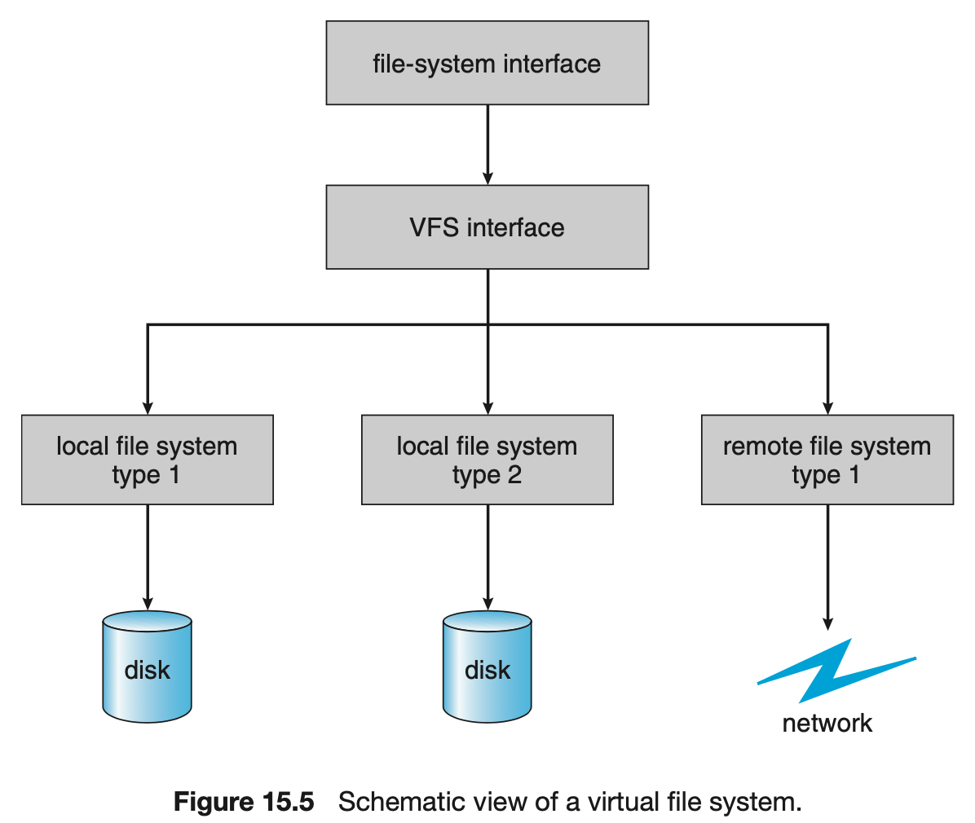

## Virtual File System Implementation

* Linux has 4 object types:

At more organization level, we need to have information about what is in a file, that gets stored in the File Control Block (FCB)

* + *inode*
  + *file*
  + *superblock*
  + *dentry*
* VFS defines set of operations on the objects that must be implemented
  + Every object has a pointer to a function table
    - Function table has addresses of routines to implement that function on that object

|  |  |
| --- | --- |
| int open(…) | - open a file |
| int close(…) | - close an already-open file |
| ssize_t read(…) | - read from a file |
| ssize_t write(…) | - write to a file |
| int mmap(…) | - memory-map a file |

These are abstract interfaces that need to be implemented depending on what the device is using for the file system storage

## Directory Implementation

It’s a list of filenames, each has a ptr to where that file is in the system through the information that we have in the File Control Block about that file.

It is typically not the greatest to have linear list of filenames, rather we like is a hierarchy of in the directory.

The hierarchy allows much more robust organization and in fact separation within that file system, name space for keeping track of things quickly finding things in the file system.

* Linear list of file names with pointer to the data blocks
  + Simple to program
  + Time-consuming to execute
    - linear search time
    - could keep ordered alphabetically via linked list or use B+ tree
* Hash Table – linear list with hash data structure
  + Decreases directory search time
  + *Collisions* – situation where two file names hash to the same location
  + Only good if entries are fixed size, or use chained-overflow method

## File System Implementation

* View the **disk** as a logical sequence of blocks
* A **block** is the smallest unit of allocation
* Issues:
  + How do you assign the blocks to files?
  + Given a file, how do you find its blocks?

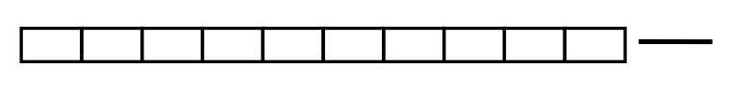

## File Allocation

Similar to memory allocation. It’s the same type of thing that you have storage resources, and these resources made upon spaces that you want to allocate to different files (processes).

* An allocation method refers to how disk blocks are allocated for files
* Direct access of disks gives us flexibility in implementing files
  + Relate to memory management problem
* Choices
  + Contiguous blocks
  + Non-contiguous blocks
    - linked
    - indexed

## Contiguous Allocation

* Contiguous allocation is where each file occupies set of contiguous blocks
* Advantages:
  + Simple
    - Only need to know the starting location to access any block is
    - and the number of blocks we have (length)

then we can index from that point

* + Good performance when reading successive blocks on disk
    - best performance in most cases

when dealing with storage devices (e.g., disks), then you are thinking about accessing some data on a block that you might be accessing a certain amount of data, and as you are accessing the initial part of that data, you want rest of the data you are going to access to be also right there, that you can read from the storage device without having to seek to another position within that storage system.

On disks, this is a problem:

Because disks typically are organized having multiple platters, it might be you have to move between platters to get the next piece of data for this file. Or you even within the platter, you might need to move between tracks and so on.

* Disadvantages:
  + File size has to be known a priority
    - need to find space for the file of that size
  + External fragmentation (because file sizes can be different)
  + Need for compaction off-line (downtime) or on-line
* Mapping from logical to physical

|  |  |
| --- | --- |
| Block to be accessed = Q + starting address  Displacement into block = R  Q = LA // 512  R = LA % 512 |  |
| LA: logical address block size: 512 bytes | |

## Extent-Based File Systems

Links extents (extent – a set of disk blocks)

* Many newer file systems use a modified contiguous allocation scheme
* **Extent-based file systems** allocate disk blocks in extents and then links extents with each other
  + An **extent** is a contiguous set of disk blocks
  + If an extent is not enough for a file, another extent is allocated and linked with the previous one
  + A file consists of one or more extents
  + Internal fragmentation can be a problem
  + If extents are different sizes, external fragmentation could occur
* Why not just link blocks?

That’s what linked allocation does ↓

## Linked Allocation

Links the blocks

It says “lets go to a non-contiguous allocation method. And i’ll just take free blocks within my storage system, and as i allocate blocks for a file it’ll just link them together”. I essentially have a linked list of blocks, that the last block has a nil pointer.

* Linked allocation allocates a linked list of blocks to a file
  + Keep a pointer to the first block of a file
  + Each block contains pointer to next block
  + File ends at nil pointer (last block has a null pointer, so you know it’s the end)
  + Free space management system called when new block needed

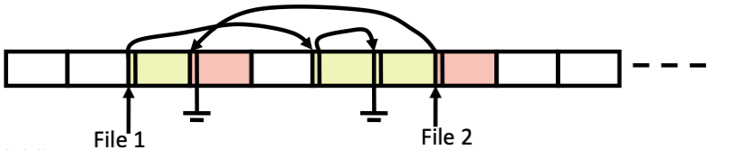

* **Advantages**
  + No external fragmentation
  + No compaction

But you need to keep track of blocks

* **Disadvantages**
  + Reliability can be a problem (if you lose pointers…)
  + Locating a block can take many I/Os and disk seeks (because the pointer itself is stored in the block)

|  |  |
| --- | --- |
|  | each block contains the pointer to next block #, in this figure, it’s 9 🡪 16 🡪 1 🡪 10 🡪 25 |

If I have a file with thousands of blocks, and I want to get to the block next to the last block, then I don’t have a way to do that unless I have a double linked-list, otherwise I would have to walk through the whole list

* **FAT (File Allocation Table)** variation
  + Beginning of volume has table, indexed by block number
  + Much like a linked list, but faster on disk and cacheable
  + New block allocation simple

## File Allocation Table (FAT)

* Bring all of “links” in a single table
* Relieves having to make spaces for them in the fil blocks
* FAT allows for fast random access if cached in memory

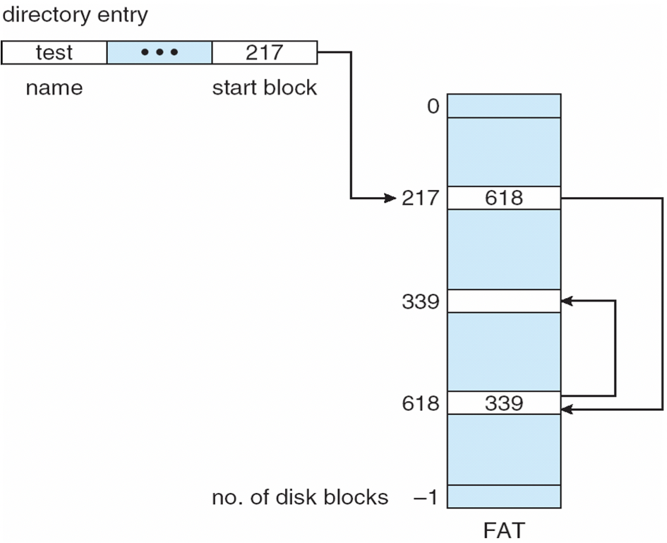 used in MS-DOS

## Indexed Allocation

Idea: is kind similar to page table, have a data structure that gives you a way to use the block index to find the logical position in the file that you want to go to, to map that to a block that is associated with that logical position.

* For each file, direct pointers to all its blocks
* Number of pointers for a file can itself become large
* UNIX uses inodes
* An inode contains: (find control information)
  + File attributes
    - time of creation, permissions, …
  + 10 direct pointers
    - logical disk block ids

associate that with actual physical blocks which are not contiguous

Just like page tables, if it gets large, you want some hierarchy in order not to implement a full single level page table. To use hierarchy to get some of efficiencies

* + 1 one-level indirect pointer
    - points to a disk block which in turn contains pointers
  + 1 two-level indirect pointer
    - points to a disk block of pointers to disk blocks of pointers
  + 1 three-level indirect pointer
    - points to a disk block of pointers to disk blocks of pointers to pointers of disk blocks
* Each file has its own index block(s) of pointers to its data blocks
* Logical view

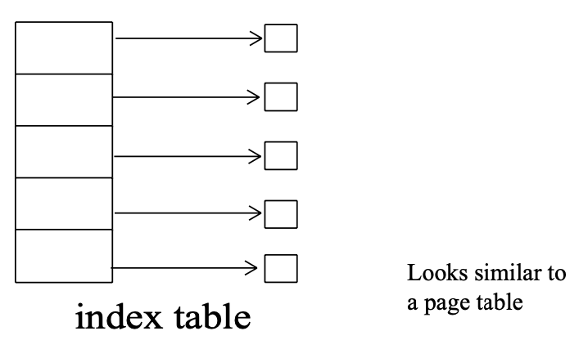

* Example

|  |  |
| --- | --- |
|  | Idea: you have a table that given a logical block id, you index into the table, and it tells you where the physical block is. That table lives on the storage device, is part of the File Control Block (it’s a part of inode in UNIX). It stores the actual indexes.  This table has fixed size, for this particular file, the last 3 blocks are not accessible (available) |

## Indexed Allocation

Indexed allocation is more supportive for random access, while a linked file allocation might not be good for random access, it supports sequential reading and writing fine.

* Need index table
* Random access
* Dynamic access without external fragmentation, but have overhead of index block
* Mapping from logical to physical in a file of max size of 256K bytes and block size of 512 bytes
  + We need only 1 block for index table

|  |  |  |
| --- | --- | --- |
|  | Q = displacement into index table (Quotient)  R = displacement into block (Remainder) | LA:  logical address |

I take the logical address, which is just the block number, and that quotient will tell me the block number. And r which is the remainder is the displacement into that block.

I have 512 blocks, each of them is 512 Bytes.

## Indexed Allocation – Mapping

* Mapping from logical to physical in a file of unbounded length (block size of 512 words)
* **Linked scheme**
  + Link blocks of index table (no limit on size)
  + Each reserves 1 entry for link

|  |  |
| --- | --- |
|  | Q1 = block of index table  R1 is used as follows: |
|  |  |
|  | Q2 = displacement into block of index table  R2 displacement into block of file |

Suppose I want something bigger than the previous example, and 256K isn’t that much. The index table itself can get large.we could actually link index tables together.

We allocate index tables and we link those together - using one of the entries to link them together. So the idea here is to take the logical address, which is a full word level address, and we are first creating a quotient -Q1-, which is a block in the index table, to find out where that part of the overall index table that we’re using- what block is holding that portion of the index table.

And the remainder is a remainder that we would further want to evaluate by dividing by the number of the size of the words in a block number to index into that portion of the index table that is allocated on the block that we just calculated, and the remainder will give the displacement to the block.

This is a way to use the linking scheme both for the index table itself, and to do so with respect to the linked allocation in terms of what’s stored in that table. So it’s a way of applying the linking scheme that we talked about earlier to blocks and to portions of blocks that are holding the index table.

It does have some of the suffering of random access so we can turn to a two-level index approach.

* **Two-level index**
  + 4K blocks could store 1,024 four-byte pointers in outer index
  + 1,048,567 data blocks and file size of up to 4GB

|  |  |
| --- | --- |
|  | Q1 = displacement into outer-index  R1 is used as follows: |
|  |  |
|  | Q2 = displacement into block of index table  R2 displacement into block of file: |
|  | |

## Suppose we have 4k blocks. In the first level of index it's pointing to others indeed that we are then going to go to as we then decompose the logical address, all this is saying is that suppose we have $K blocks of 4K size and they could store a pointer of 4 bytes to point to other indicis. In this case it would allow for 4K blocks and the outer index would point to 1,024 other indices of each being 4K in size. So it's really a 1,024x1,024 data blocks that are available for this file size.

## So with a 2-level index, what I’m doing is taking the logical address and dividing it by a certain number, you use that outer index to see what index you need to go to (in the picture it should be 1,024x1,024 instead of 512x512), to find the displacement into the outer index, and then the remainder of that is going to be in that next level of index divided again by (it should be 1,024 again instead of 512), to give you which block again you need to go into, the index into the table to get the physical the physical block number that you need to go to, to get the remainder within that block.

## So essentially what’s going on is like what we saw in a hierarchical page table (indexed page table) is that we use this indicis to be more efficient in finding the block number that's actually in the storage device. By organizing these indicis in multiple levels that allow us to use the organizational structure of a hierarchy to more rapidly index, vs something like a linked block index and so as you add additional levels here then it requires an extra step to go and get the next pointer, to get to the next block index. And that’s all part of the file positioning operation that happens for reading and writing.

## Combined Scheme – UNIX Inode

Now the way that the UNIX inodes work is kind of clever. They have a varying index scheme, they first have an index block for direct blocks, that is to say this here is a one level index and it could index to a certain number of blocks, and you could go off and get the data. (just to be clear, the data squares are data blocks)

But these direct blocks, there’s a certain number that are allowing for a direct link to where the data blocks are on disk. If that is not enough, then you drop down t a single level index (just like we were talking about)

NOTE: the direct block is a one level index, and the single indirect is a two level index!!!

And in the double indirect we’re at a 3 level index!! These are indicis which point to the next level index, which point to the next level index, …

|  |  |
| --- | --- |
| 4K bytes per block, 32-bit addresses | UFS: UNIX File System |
| page43image4562864 | |
| More index blocks than can be addressed with 32-bit file pointer | |

## Performance

When we start thinking about performance there’s a lot of things that come into play. Are we accessing files randomly? Given the type of file that might not make sense (ex, a movie file is sequential). In contrast to databases where you might access stuff randomly.

* Best method depends on file access type
  + Contiguous great for sequential and random
  + Linked good for sequential, not random
* Declare access type at creation
  + Select either contiguous or linked
* Indexed more complex
  + Single block access could require 2 index block reads, then data block read
  + Clustering can help improve throughput, reduce CPU overhead
* Adding instructions to the execution path to save one disk I/O is reasonable
  + Intel Core i7 Extreme Edition 990x (2011) at 3.46Ghz = 159,000 MIPS

<http://en.wikipedia.org/wiki/Instructions_per_second>

* + Typical disk drive at 250 I/Os per second
    - 159,000 MIPS / 250 = 630 million instructions during one disk I/O
  + Fast SSD drives provide 60,000 IOPS
    - 159,000 MIPS / 60,000 = 2.65 million instructions during one disk I/O

## Free-Space Management

In any of these allocation methods we’re talking about lock allocation. This would suggest that we would allocate free blocks to files and we would need to keep track of the free blocks.

Free space management could be something where we’re only concerned with what’s free → we would use a bitmap and set it to 1 if it's free and 0 if it's occupied. It’s fast and uses little memory compared to the file we’re trying to store.

* File system maintains **free-space list** to track available blocks/clusters
  + Using term “block” for simplicity
* Bit vector or bit map (*n* blocks)

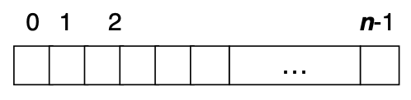

$$bit\left[i\right]=\left\{\begin{aligned} 1⇒block\left[i\right] free \\ 0⇒block\left[i\right] occupied\end{aligned}\right.$$

Block number calculation:

(number of bits per word) * (# of 0-value words) + (offset of first 1 bit)

* Bit map requires extra space

*block size* = 4KB = 212 bytes

*disk size* = 240 bytes (1 terabyte)

*n* = disk size / block size = 240 / 212 = 228 bits (or 32MB)

if clusters of 4 blocks 🡪 8MB of memory

* Easy to get contiguous files

## Linked Free Space List on Disk

Instead of the bitmap you could keep a list (not unreasonable). Here you’re linking blocks and putting the links to the blocks in here. This is fine. No extra storage for bitmap or anything like that!

|  |  |
| --- | --- |
| * Linked list (free list)   + cannot get contiguous space easily   + no waste of space   + no need to traverse the entire list     - if # of free blocks recorded |  |

## Free-Space Management

* **Grouping**
  + Modify linked list to store address of next $n-1$ free blocks in first free block, plus a pointer to next block that contains free-block-pointers (like this one)
* **Counting**
  + Because space is frequently contiguously used and freed, with contiguous-allocation allocation, extents, or clustering
    - Keep address of first free block and count of following free blocks
    - Free space list then has entries containing addresses and counts
* **Space Maps**
  + Used in ZFS
  + Consider metadata I/O on very large file systems
    - Full data structures like bit maps couldn’t fit in memory 🡪 thousands of I/Os
  + Divides device space into *metaslab* units and manages metaslabs
    - Given volume can contain hundreds of metaslabs
  + Each metaslab has associated space map
    - Uses counting algorithm
  + But records to log file rather than file system
    - Log of all block activity, in time order, in counting format
  + Metaslab activity 🡪 load space map into memory in balanced-tree structure, indexed by offset
    - Replace log into that structure
    - Combine contiguous free blocks into single entry

## Efficiency and Performance

* **Efficiency** dependent on:
  + Disk allocation and directory algorithms
  + Types of data kept in file’s directory entry
  + Pre-allocation or as-needed allocation of metadata structures
  + Fixed-size or varying-size data structures
* **Performance**:
  + Keeping data and metadata close together
  + Buffer cache – separate section of main memory for frequently used blocks
  + Synchronous writes sometimes requested by apps or needed by OS
    - No buffering / caching – writes must hit disk before acknowledgement
    - Asynchronous writes more common, buffer-able, faster
  + Free-behind and read-ahead
    - Techniques to optimize sequential access
  + Reads frequently slower than writes

## Finding Files

* Now we know how to retrieve the blocks of a file once we know:
  + The FAT entry for DOS
  + The inode of the file in UNIX
* BUT how do we find these in the first place?
  + The directory where this file resides should contain this information

## Directory

* contains a sequence (table) of entries for each file
* In DOS, each entry has
  + [fname, extension, attributes, time, date, size, first block number]
* In UNIX, each entry has
  + [fname, inode number]

## Accessing File Block in UNIX

* Get “/” inode from disk (usually fixed, e.g., #2)
* Get block after block of “/” using its inode until entry for “a” is found (gives its inode #)
* Get inode of “a” from disk
* Get block after block of “a” until entry for “b” is found (gives its inode #)
* Get inode of “b” from disk
* Get block after block of “b” till entry for “c” is found (gives its inode #)
* Get inode of “c” from disk
* Find out whether block you are searching for is in 1st 10 ptrs, or 1-level or 2-level or 3-level indirect.
* Based on this, you can either directly get the block, or retrieve it after going through the levels of indirection

## Inode Caching

Inodes are file control blocks, they have the metadata associated with that block and they have the support for accessing the file a lot of it has to do with where the files are located and how they’re accessed the Inode file control block is an important thing to have in memory in order to have fast access to that data and fast access to that table.

When we open a file and that operation results in bringing in that information about the file into the OSs memory so that you have it there you do subsequent operations on that file. That lives as part of your process control block, but since you have processes that share files, then you have a system wide open file table that keeps the information. But these inodes are the individual file control blocks and keeping them in memory helps them be more efficient.

* Imagine searching through the inodes each time you do a read() or wirte() on a file
* 🡪 too much overhead!
* Once you have the inode of the file (or FAT entry in DOS), then it is fairly efficient
* You want to cache the inode (or the ID of the FAT entry) for a file in memory and keep re-using it
* Open file descriptor table kept in memory does this for us

## File Caching

* Even if after all this (i.e., bringing the pointers to blocks of a file into memory), may not suffice since we still need to go to disk to get the blocks themselves
* We address this problem by **file caching**
  + Cache disk (data) blocks in main memory

## File Caching / Buffering

* Cache disk blocks that are in need in physical memory
* On a read() system call, first look up this cache to check if block is **present**
  + This is done in software
  + Look up is done based on logical block id
  + Typically perform some kinds of hashing
  + If **present**:

🡪 Copy this from OS cache/buffer into the data structure

* + - data structure is passed by user in read() system call
  + **Otherwise**

🡪 Read block from disk, put in OS cache, then copy to user data structure

## Page Cache

We can also do something clever and use pages rather than disk blocks for purposes of accessing files. We memory map the file through pages and we use memory addresses as if we were accessing the file in memory in order to access the file. The OS ends all supporting all of this for us.

* A **page cache** caches pages rather than disk blocks using virtual memory techniques and addresses
* Memory-mapped I/O uses a page cache
* Routine I/O through the file system uses the buffer (disk) cache

## File Caching / Buffering

* 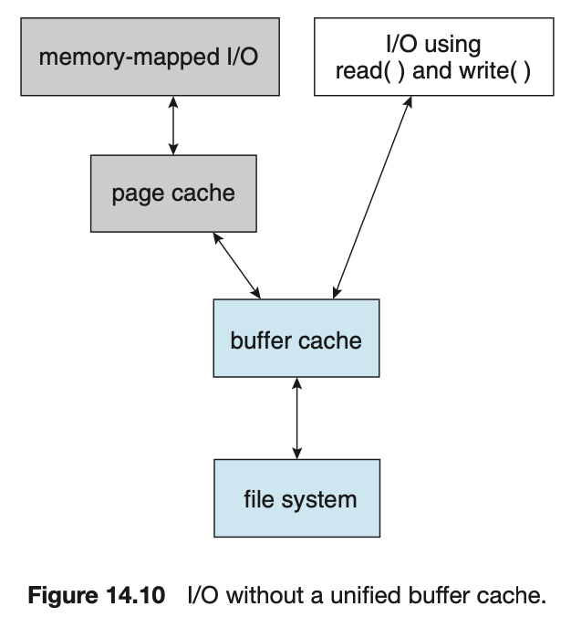The OS ends all supporting all of this for us. On this path here (on the right), I can use the OSs disk block buffer cache to support more efficient access to blocks in a file I'm using.
* But on the left, I can also do something where I’ve memory mapped a file and in this way through memory mapped I/O or memory mapped files I access the file through logical addresses that are in my address space, and in that case they are supported that translation of an address in my process address space to a file where that file is accessed through pages that have been allocated to that file (NOTE: we don’t have to have all of the pages in memory, just the ones that are being used). → the way that that works with files is that it builds upon already the block level buffer cache that the OS is maintaining and that is being mapped to pages within this memory mapped addressing space.
* The main difference is allowing the files to be in memory, rather than to access the files in the file system.
* NOTE: THE PAGE CACHE AND THE BUFFER CACHE ARE IN MEMORY

## Caching and Writing

* On a write, should we do write-back or a write-through?
  + With **write-back**
    - You may lose data that is written if machine goes down before write-back
  + With **write-through**
    - You may lose performance
    - Loss in opportunity to perform several writes at a time
    - Perhaps the write may not even be needed
* DOS uses write-through
* UNIX:
  + Writes are buffered, and they are propagated in the background after a delay
    - Every 30 seconds there is a sync() call which propagates dirty blocks to disk
  + This is usually done in the background
  + Metadata (directories / inodes) wirtes are propagated immediately

## File System Prefetch

You can do some other efficiency directed things by anticipating where you might want to be accessing a file next. It might be the case that you want additional file blocks and you’ll prefetch them into memory (when you’re accessing a file sequentially).

* Often we are reading data sequentially (e.g., file system backup)
* If file system detects sequential workload based on current or previous I/O offsets, it can predict that the next reads will likely be sequential as well
* Populate the file system cache with these prefetches

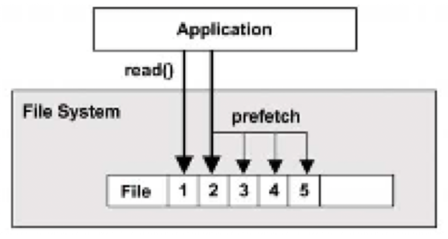

## page65image4372496Linux File System Caches

**Page cache**: cache of virtual memory pages including memory-mapped files

**Buffer cache**: stores blocks from disk, now unified with the page cache (why?)

**Page scanner**: schedules dirty pages to be written to disk

**Dentry cache**: remembers mappings from directory entry to inode (for what purpose?)

**Inode cache**: stores inodes in hash table for fast lookup

So this gives you a view of what's happening within Linux file systems and all that’s it trying to bring into play for support for accessing files. From down at the disk where we could have some memory allocated for buffering or caching blocks that have been accessed through this disk, or it could go straight to the block device interface and then it might go up into these layers of file systems that we’ve talked about, and all the OS supporting data structures for these systems and the individual file control information.

## Cache Space Limitations

* We need a replacement algorithm
* Here we can use LRU, since the OS gets called on each reference to a block and the management is done in software
* However, you typically do not do this on demand
* Use High and Low water marks:
  + When the # of free blocks falls below Low water mark, evict blocks from memory till it reaches High water mark

## Buffer / Cache Management

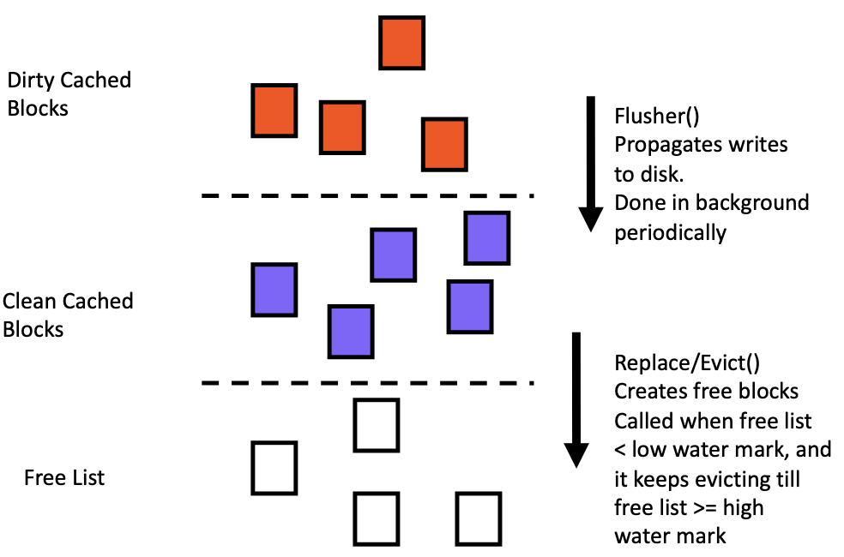

## Unified Buffer Cache

* A **unified buffer cache** uses the same page cache to cache both memory-mapped pages and ordinary file system I/O to avoid double caching
  + But which caches get priority, and what replacement algorithms to use?

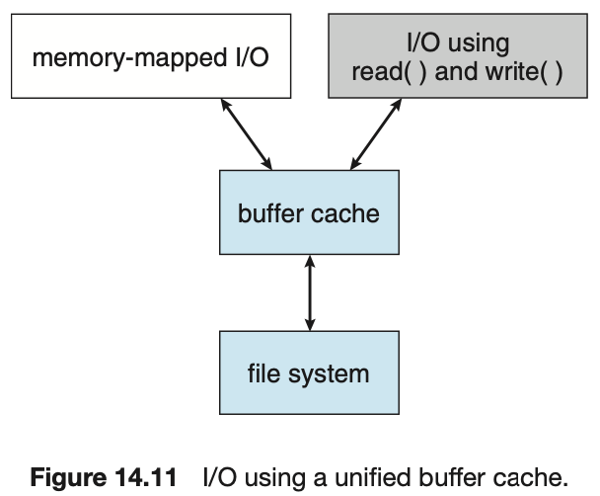

## Block Sizes

* Larger block sizes

=> higher internal fragmentation

=> higher disk transfer rates

* Median file size in UNIX environments ~ 1K
* Typical block sizes:
  + 512, 1K or 4K

## Free Space

* Find the block to use when one is needed
  + Find space quickly
  + Keep storage reasonable
* Options
  + Bit vector
  + Linked list
  + Grouping
  + Counting

## Sun Network File System (NFS)

We’ve talked about network file systems before, this is an implementation that happened a long time ago initially by Solaris and SunOS where it builds upon an interprocess communication support for allowing a remote file system that’s on one machine to be seen by another machine on the network.

The idea is that it’ll support network file based services. But what it requires is that the OS essentially allow for a remove mounting of a file system across the network, and it utilizes support that was developed at the time along with NFS to do this type of interprocess communication in this case between the OSes running on those remote machines themselves, to allow use level read and write operations to get to these files.

* An implementation and a specification of a software system for accessing remote files across LANs (or WANs)
* The implementation is part of the Solaris and SunOS operating systems running on Sun workstations using an unreliable datagram protocol (UDP/IP) and Ethernet
* Interconnected workstations viewed as a set of independent machines with independent file systems, which allows sharing among these file systems in a transparent manner
  + A remote directory is mounted over a local file system directory
    - Mounted directory looks like an integral subtree of the local file system, replacing the subtree descending from the local directory
  + Specification of the remote directory for the mounted operation is nontransparent; the host name of the remote directory has to be provided
    - Files in the remote directory can then be accessed in a transparent manner
  + Subject to access-rights accreditation, potentially any file system (or directory within a file system), can be mounted remotely on top of any local directory

Other big advantages that come is that you can have heterogeneity with respect to the machines that are running as long as they adopt the protocol that’s necessary to support the file service. It builds on RPC methods (we’ve discussed before, which is an interprocess communication mechanism)

* NFS is designed to operate in a heterogenous environment of different machines, operating systems, and network architectures; the NFS specification independent of these media
* This independence is achieved through the use of RPC primitives built on top of an External Data Representation (XDR) protocol used between two implementation-independent interfaces
* The NFS specification distinguishes between the services provided by a mount mechanism and the actual remote-file-access services

### NFS Mount Protocol

At a basic level it utilized a remote mounting, it uses the mounting concept or local file systems and leverages that knowing that a remote file system is what’s exactly being mounted. So it involves some interaction with the machine initially, to find out what file systems are wanting to be mounted, and goes through the protocol for doing so.

* Establishes initial logical connection between server and client
* Mount operation includes name of remote directory to be mounted and name of server machine storing it
  + Mount request is mapped to corresponding RPC and forwarded to mount server running on server machine
  + Export list
    - specifies local file systems that server exports for mounting,

along with names of machines that are permitted to mount them

* Following a mount request that conforms to its export list, the server returns a file handle – a key for further accesses
  + File handle
    - a file system identifier, and an inode number to identify the mounted directory within the exported file system
* The mount operation changes only the user’s view and does not affect the server side

### NFS Protocol

Once you have a mounted file system in place, then you can do the various things you can imagine doing with local file systems (understanding that NS is dealing with remote file systems), it’s also using underlying protocols that are trying to be robust and efficient, and so forth.

The advantage is that it’s quite successful and it gives you a degree of flexibility in system environments where you can get sharing for the file systems.

* Provides a set of remote procedure calls for remote file operations.

The procedures support the following operations:

* + Searching for a file within a directory
  + Reading a set of directory entries
  + Manipulating links and directories
  + Accessing file attributes
  + Reading and writing files
* NFS servers are stateless; each request has to provide a full set of arguments (NFS V4 is different, stateful)
* Modified data must be committed to the server’s disk before results are returned to the client (lose advantages of caching)
* NFS protocol does not provide concurrency-control mechanisms

### Three Major Layers of NFS Architecture

* **UNIX file-system interface** (based on the open, read, write and close calls, and file descriptors)
* **Virtual File System (VFS) layer** – distinguishes local files from remote ones, and local files are further distinguished according to their file-system types
  + The VFS activates file-system-specific operations to handle local requests according to their file-system types
  + Calls the NFS protocol procedures for remote requests
* **NFS service layer** – bottom layer of the architecture
  + Implements the NFS protocol

### Schematic View of NFS Architecture

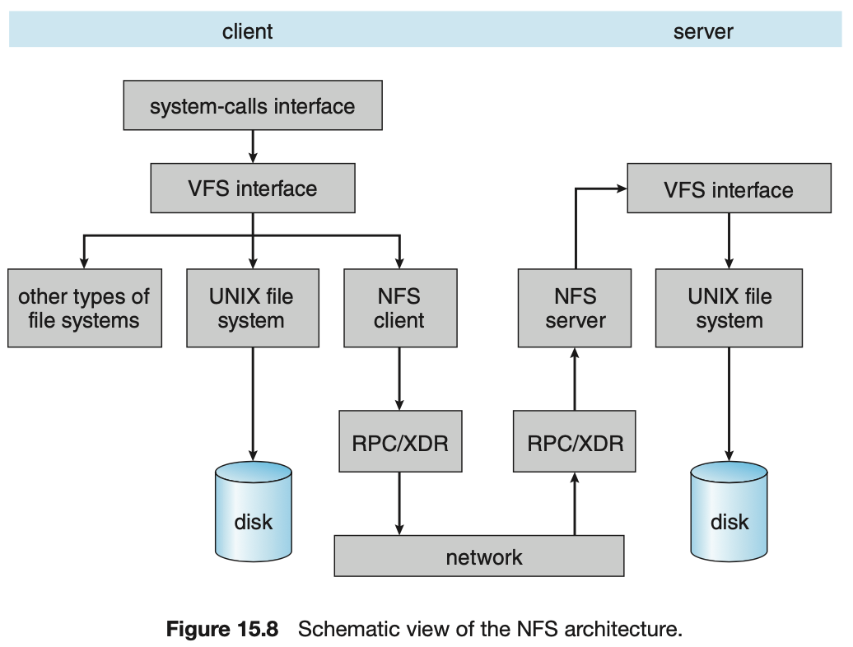Here is an example of the NS architecture, clients and servers and you have your local file systems, and you’ve implemented the NFS protocol and underneath it uses the RPC (remote procedure calls), uses an interesting way of taking the data that you’re moving across the network and encapsulating it and allowing that to have the same read/write operations that you would have on a remote disk.

### NFS Path-Name Translation

* Performed by breaking the path into component names and performing a separate NFS lookup call for every pair of component name and directory vnode
* To make lookup faster, a directory name lookup cache on the client’s side holds the vnodes for remote directory names

### NFS Remote Operations

* Nearly one-to-one correspondence between regular UNIX system calls and the NFS protocol RPCs (except opening and closing files)
* NFS adheres to the remote-service paradigm, but employs buffering and caching techniques for the sake of performance
* File-blocks cache – when a file is opened, the kernel checks with the remote server whether to fetch or revalidate the cached attributes
  + Cached file blocks are used only if the corresponding cached attributes are up to date
* File-attribute cache – the attribute cache is updated whenever new attributes arrive from the server
* Clients do not free delayed-write blocks until the server confirms that the data have been written to disk

# Lecture 13 – I/O

## Outline

## Overview

## I/O hardware

## Application I/O Interface

## Kernel I/O Subsystem

## Transforming I/O Requests to Hardware Operations

* STREAMS
* Performance

## Overview

The idea of I/O is interesting because it is what is essentially allowing your program to interact with the rest of the world.

The OS manages the device drivers that it has configured in its kernel to support that interaction with those devices that exist and the processes that want to talk to them.

* I/O management is a major component of operating system design and operation
  + Important aspect of computer operation
  + I/O devices vary greatly
  + Various methods to control them
  + Performance management
  + New types of devices frequent
* Ports, busses, device controllers
  + Provide connection to various devices
* Device drivers encapsulate device details
  + Present uniform device-access interface to I/O subsystem

## I/O hardware (1)

## One of the interesting things about this is the variety of I/O devices that can be used and the support they need. That support can be stored but it is definitely needed.

## The challenge here is that given the variety of hardware, is coming up with a layering of software interfaces and support that enables the programs and even the OS itself to utilize devices without having to be overloaded with how each particular device needs to be talked to.

## The challenge is with the OS and how it’s accessed and its layers of abstraction but also standards within that hardware with respect to these interfaces and how the hardware is functioning to support devices of different types and different standard based interfaces and protocols that are used to send signals and communicate with those devices.so just some of the common concepts that we see here are a port, which is a connection point. A bus, which is a shared access that connects through the bus devices to the computer CPU or memory, PCI is an example of this (its commonly found in PCs and computers) what bus is an I/O bus which is enabling these communications. There might be different types of buses like expansion buses which mainly deal with slower devices. (normally you have an expansion bus or another type of bus connected to the main I/O bus.

* Incredible variety of I/O devices
  + Storage
  + Transmission
  + Human-interface
* Common concepts
  + Signals from I/O devices interface with computer
  + ***Port*** – connection point for device
  + ***Bus*** – daisy chain or shared direct access
    - ***PCI bus*** common in PCs and servers, ***PCI Express (PCIe)***
    - expansion bus connects relatively slow devices
  + ***Controller*** – electronics to operate port, bus, device
    - sometimes integrated
    - sometimes separate circuit board (host adapter)
    - contains processor, microcode, private memory, bus controller, …

You also have controllers, which are hardware devices that have electronics to support the hardware signaling that takes palace on those ports and buses. You sometimes have integrated on some devices, and sometimes they’re separate on a circuit board.

## A Typical PC Bus Structure

Much that we’ve talked about during this course is concentrated on the red line. Where you have a processor that is using a high speed memory bus, which we called an address bus (that is shown here in red). But there’s the rest of the computer system that may contain a variety of devices and you would need a way for them to interact with the processes- which is the PCI bus. Most of the controllers for those devices “hang around” the bus, and their controllers implement the PCI interface,they implement the PCI protocol. Those controllers are acting like extensions for the processors in a way, because they’re executing certain functionality that is enabling the communication across this bus to take place. Most importantly to be able to take place when it requested a bridging between the memory bus (or the address bus) and the I/O bus.

But you also see on the other side of the controller, it is that functionality of that particular controller that’s doing something.

On the bottom left for example, here’s an IDE disk controller where you have IDE disks that are IDE standard. So that controller is on this side controlling the IDE protocol, doing the IDE stuff.

Similarly, on the upper right corner, we have the SCSI controller, and we have SCSI disks.

For slower devices, like keyboards, mice, and so forth, they might live on a slower bus with an aggregation on that bus with different slower types of devices. And what the expansion bus interface does is provide an interface with the expansion bus and the PCI bus to make the PCI bus be more performant (to not have the PCI bus do all the jumps all the time). It also makes the expansion bus less hardware intense.

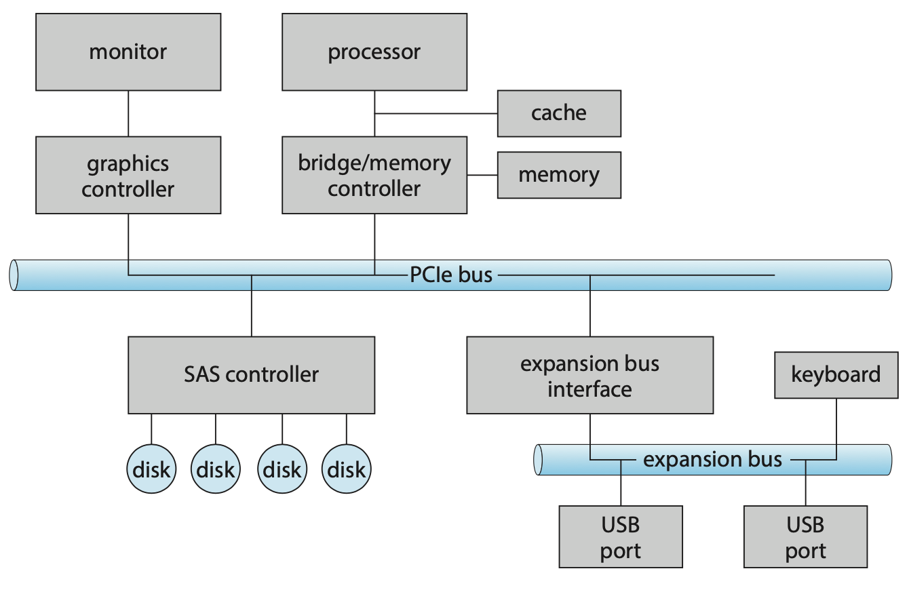

## I/O hardware (2)

How does it actually work?

Typically what the devices themselves have, and you can think about controllers here, is the controllers are pieces of hardware. Depending on the type of device that you have you usually have something that you can access on the device to access its behavior. Devices have registers, and that device driver would program those registers to get data into those registers, these could be commands, addresses, … and it is through this hardware interface that you get the I/O device to do something.

You might have data-in / data-out registers, status registers, or control registers. There’s things that you might on the device drivers side, be looking at, at the state of the device and what’s going on.

* I/O instructions control devices (***programmed I/O***)

that’s if you have I/O instructions in the CPU instructions (mostly CPUs do, because it makes a simpler design for that systems, but it is more common that in general purpose computers that a majority of the devices are going to be using what’s called, memory-mapped I/O. IDEA: the devices have these registers and data-in/data-out buffers, and other things mapped to memory addresses. And so instead of using explicit I/O instructions that are implemented in the CPU architecture, the way they’re programmed is to use common memory addresses. And it is the fact that the Kernel sets up in the memory space of a device driver, the addresses that when you use those addresses you are essentially talking to those interface registers of that device)

* Devices usually have registers where device driver places commands, addresses and data to write/read data from registers after command execution
  + Data-in / data-out register, status register, control register
  + Typically 1-4 bytes, or FIFO buffer
* Devices have addresses, used by
  + Direct I/O instructions
  + ***Memory-mapped I/O***
    - Device data/command registers mapped to processor address space
    - Especially for large address spaces (graphics)

## Device I/O Port Locations on PCs (partial)

For instance, if I was to just look at some of these port locations: this is the idea behind ports, you should think of ports as interfaces to the device that are representing data registers, or status registers, or …

Suppose i map those port locations to addresses and these addresses are in the memory space (in the memory address space), and if i do read and write operations to these addresses, it's effectively doing those operations to the device, where that device hardware interface is essentially mapped to these addresses ← this is the idea for memory mapped I/O

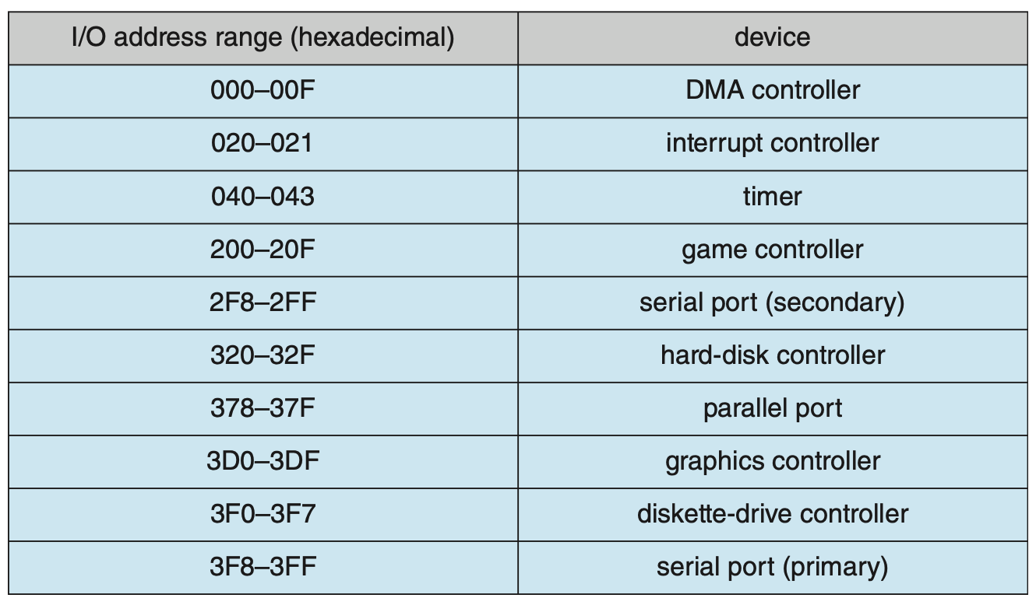

## Polling

What that interaction looks like with an I/O device? We have two types of “interactions,” (Ways you interface to a device to do I/O). One is polling, and one if interrupt based.

* For each byte of I/O
  + Read busy bit from status register until 0
  + Host sets read or write bit
    - if write, host copies data into data-out register
  + Host sets command-ready bit
  + Controller sets busy bit and executes transfer
  + Controller clears busy bit, error bit, command-ready bit when transfer done
* Step 1 is *busy-wait* cycle to wait for I/O from device
  + Reasonable if device is fast
  + But inefficient if device slow
  + CPU switches to other tasks?
    - but if miss a cycle data overwritten / lost
* Polling requires attention from the host
  + Instructions are being executed on the CPU
  + Typically by a device driver
* Polling has overhead due to busy waiting
  + Of course, the program does not have to just sit there
  + If does have to attend to the device in a regular way
* How a program polls the device depends on the type of device and the frequency/rate of data
  + A keyboard device driver knows that there is a lot of time between keystrokes
  + It just needs to check regularly enough to get the next character
  + It does not need to sit there and wait

## Interrupts (1)

* Polling can happen in 3 instruction cycles
  + Read status, logical-and to extract status bit, branch if not zero
  + How to be more efficient if non-zero infrequently?
  + How to avoid the overhead of polling?
* CPU ***interrupt-request line*** triggered by I/O device
  + Checked by processor hardware after each instruction
* ***Interrupt handler*** receives interrupts
  + *Maskable* to ignore or delay some interrupts
* ***Interrupt vector*** to dispatch interrupt to correct handler
  + Context switch at start and end
  + Based on priority
  + Some *nonmaskable*
  + *Interrupt chaining* if multiple devices at same interrupt number

### Interrupt-Driven I/O Cycle

So if you have interrupts, you can use interrupts as the bases of communication with the I/O device. What we have here is an example where you have a device drivers and its saying i was to do some I/O, and it initializes the I/O. what it does in that initiation is talk directly to the I/O device and say “hey, I’m gonna set you up to do some I/O” and the I/O device essentially does that I/O.

But on the CPU side, you can go do other things, and what it’s showing you here is that it’s not really the CPU executing checks for interrupts, it doesn't do that explicitly, it’s in the hardware. The CPU goes and does other things until it gets an interrupt (until the I/O device does what it was supposed to do and an interrupt is signaled back that can say a variety of things, but typically it’s some time of completion of what you asked it to do), at that point, you’re back to executing the interrupt handler and it executes the driver to check if it was done correctly, and then the CPU gets back to what it was doing.

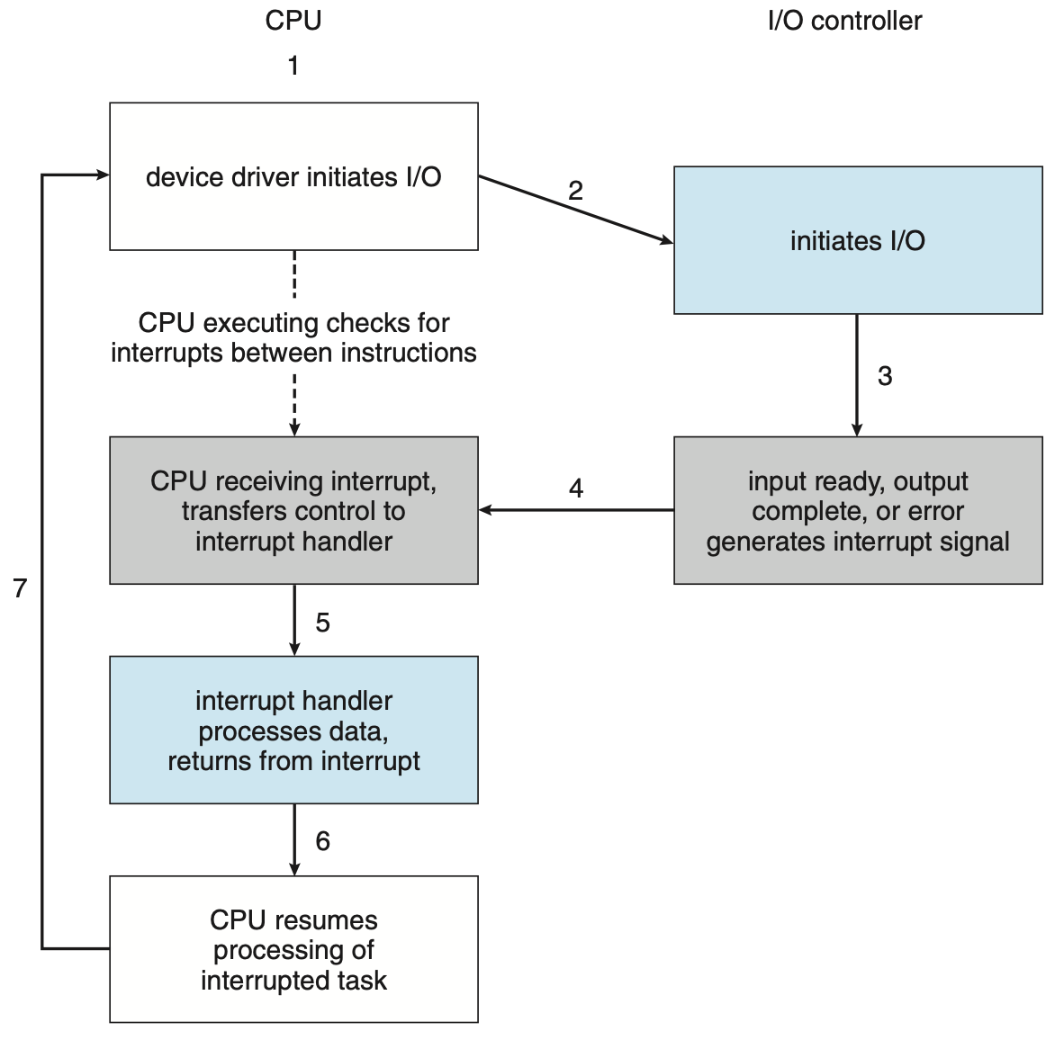

### Latency Command on Mac OS X

* Interrupts over a 10 second period
* Otherwise quiet desktop

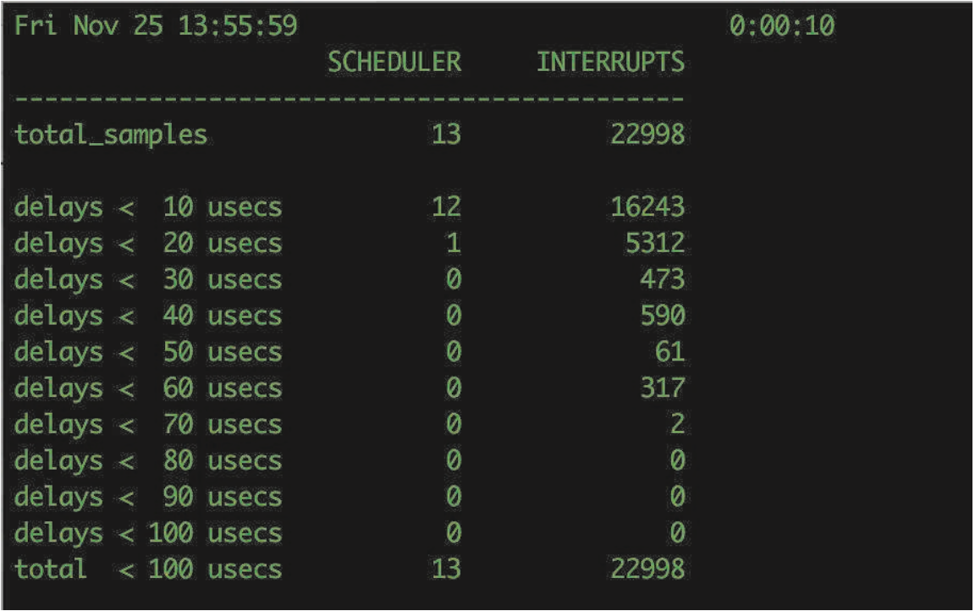

### Intel Pentium processor event-vector table

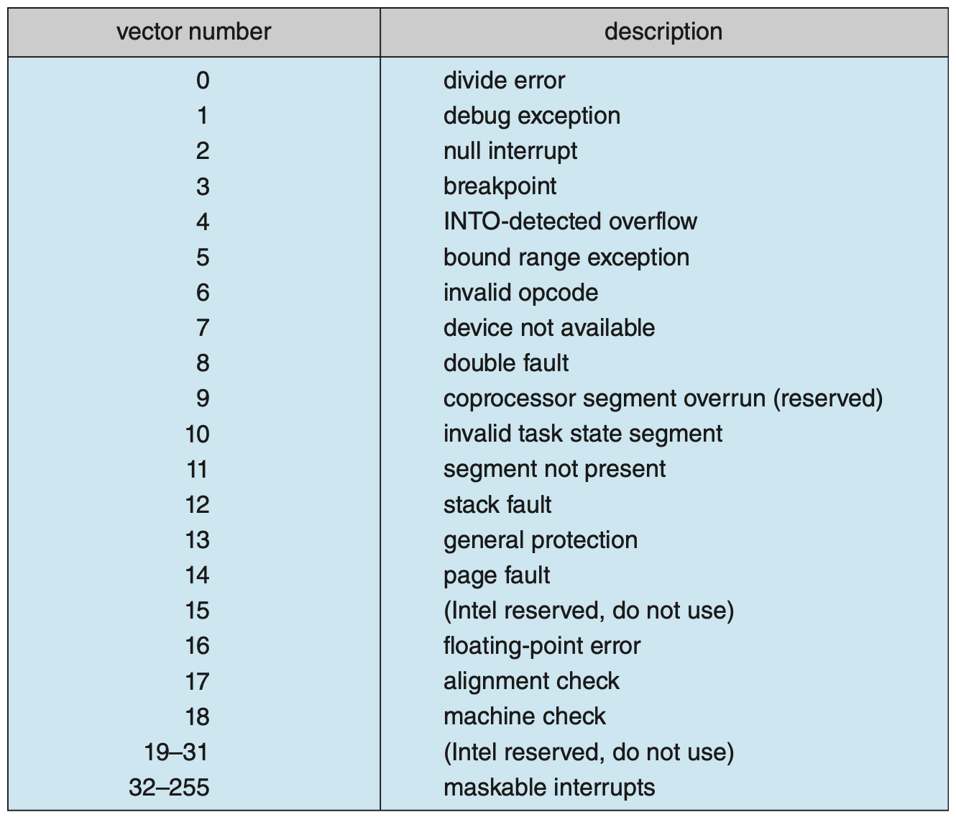

## Interrupts (2)

* Interrupt mechanism also used for ***exceptions***
  + Terminate process, crash system due to hardware error
  + Page fault executes when memory access error
* System call executes via ***trap*** to trigger kernel to execute request
* multi-CPU systems can process interrupts concurrently
  + If operating system designed to handle it
* Used for time-sensitive processing
  + Frequent interrupts that must be processed fast

## Direct Memory Access (DMA)

What programmed I/O is you are the one in your program that is doing the data movement (read and write operations) to the I/O, your program is doing the I/O one byte at a time.

* Used to avoid overhead of ***programmed I/O*** (one byte at a time)
  + Primarily for large data movement
* Requires DMA controller
  + CPU is no longer writing each byte
  + Data is transferred directly between I/O device and memory
* OS writes DMA command block into memory
  + Set source (write) or destination (read) addresses
  + Set read / write mode
  + Set # of bytes to transfer
  + Writes location of command block to DMA controller
  + DMA controller is a *bus master* of memory bus
    - Grabs memory bus from CPU
    - ***Cycle stealing*** from CPU but still more efficient
  + When done, interrupts to signal completion
* If aware of virtual addresses, it can be even more efficient
  + ***Direct Virtual Memory Access (DVMA)***

### Six Step Process to Perform DMA Transfer

We have a CPU on the top, and down here it says I want to transfer this buffer that’s in memory, I want to transfer it to drive 2. It sets up that transfer and passes it to the DMA controller, and it takes one byte and writes it to the drive, and does that until you have no more bytes left.

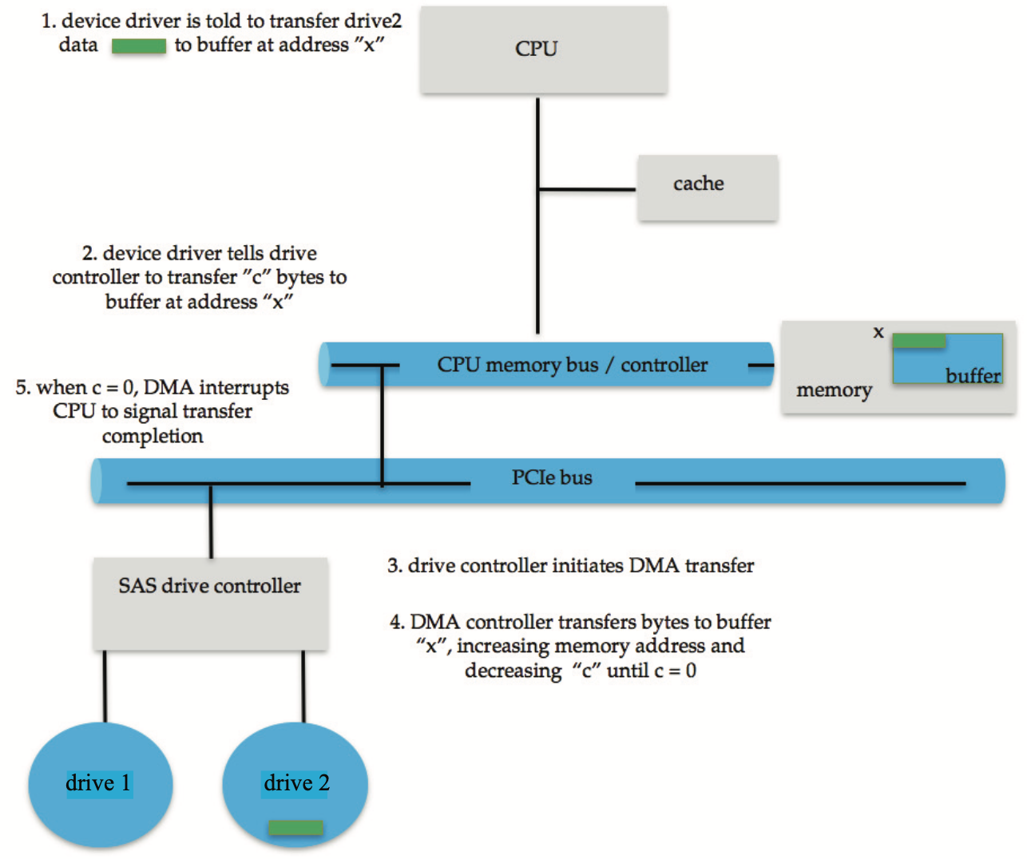

## Application I/O Interface

* I/O system calls encapsulate device behaviors in generic classes
* Device-driver layer hides differences among I/O controllers
  + Kernel can be shielded from details
* New device already-implemented protocols
* Each OS has its own I/O subsystem structures and device driver frameworks
* Devices vary in many dimensions
  + ***Character-stream***or ***Block***
  + ***Sequential***or ***Random-access***
  + ***Synchronous***or ***Asynchronous***(or both)
  + ***Sharable***or ***Dedicated***
  + ***Speed*** of operation
  + ***Mode: read-write***, ***read only***, or***write only***

### A Kernel I/O Structure

|  |  |
| --- | --- |
|  | It helps in the kernel to give some layering and some support so that it can utilize a more generic interface at one level to these I/O interfaces and get more specific in another level to talk to specific I/O devices. |

### Characteristics of I/O Devices

|  |  |
| --- | --- |
|  | Different types of devices have different aspects to them in terms of their data transfer mode and how they are accessed. In particular there are things having to do with their speed, and that might cause us to think how we might want to communicate with these devices and how they behave. |

* Subtleties of devices handled by device drivers
* Broadly I/O devices can be grouped by the OS into
  + Block I/O
  + Character I/O (Stream)
  + Memory-mapped file access
  + Network sockets
* For direct manipulation of I/O device specific characteristics, usually an escape / backdoor
  + UNIX ioctl() call to send arbitrary bits to a device control register and data to device data register

## Block and Character Devices

* Block devices - work with blocks of data
  + Includes disk drives and other storage devices
  + Commands: read(), write(), seek(), …
  + Type: Raw I/O, direct I/O, or file-system access
  + Memory-mapped file access possible
    - File mapped to virtual memory and clusters brought via demand paging
  + DMA
* Character devices - typically with bytes of data
  + Include keyboards, mice, serial ports
  + Commands: get(), put()
  + Libraries layered on top allow line editing

## Network Devices

* Different enough from block and character to have own interface
  + Many different varieties of network devices
* Linux, UNIX, Windows and many others include ***socket*** interface
  + Separate network protocol from network operation
  + Includes select() functionality to multiplex requests among multiple sockets
* Approaches vary widely (pipes, FIFOs, streams, queues, mailboxes)

## Clocks and Timers

they are devices

* Provide current time, elapsed time, timer
* Normal resolution about 1/60 second
* Some systems provide higher-resolutions timers
* ***Programmable interval timer*** used for timings, periodic interrupts
* ioctl()(on UNIX) covers odd aspects of I/O such as clocks and timers

## Non-Blocking and Asynchronous I/O

How do we interact with a device?

From the point of view of a process that is doing I/O, if the process has to wait for the I/O to complete, then we call that blocking ← blocking based I/O, by blocking here what we mean is that it's going to a wait queue for this process until a particular event (Which represents the I/O) happens and we can continue.

We could also have nonblocking I/O, it gets what it can get by the time the I/O call is made, it doesn't block or wait, it returns something and gets back.

* ***Blocking***- process suspended until I/O completed
  + Easy to use and understand
  + Insufficient for some needs
* ***Nonblocking***- I/O call returns as much as available
  + User interface, data copy (buffered I/O)
  + Implemented via multi-threading
  + Returns quickly with count of bytes read or written
  + select() to find if data ready,read() or write() to transfer
* ***Synchronous***is equivalent to blocking

a more general term here that depends on I/O completing

* ***Asynchronous***– process runs while I/O executes
  + More tricky to use
  + I/O subsystem signals process when I/O completed

Asynchronous is this notion that a process runs while something is happening. You can do something while the I/O executes.

## Two I/O Methods

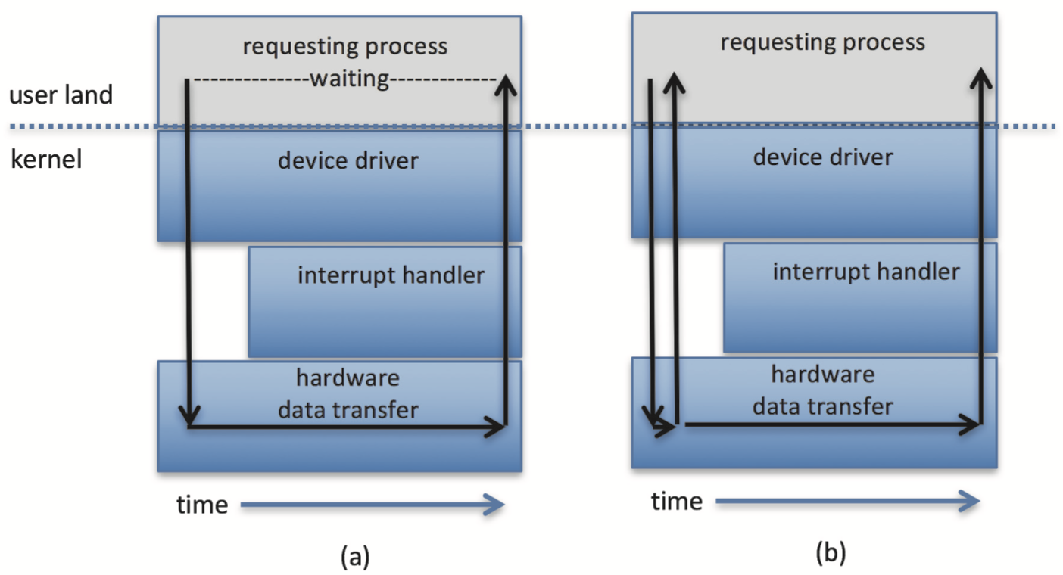

Synchronous Asynchronous

In a synchronous based I/O you have to wait for completion.

In the case of asynchronous, you initiate the I/O and then you return, you do not wait. At some point later you check to see if something has transpired.

## Vectored I/O

* ***Vectored I/O*** allows one system call to perform multiple I/O operations
* For example, UNIX readve() accepts a vector of multiple buffers to read into or write from
* This ***scatter-gather*** method can be better than multiple individual I/O calls
  + Decreases context switching and system call overhead
  + Some versions provide atomicity
    - avoid for example worry about multiple threads changing data as reads / writes occurring

## Kernel I/O Subsystem

* ***Scheduling***of I/O operations on devices
  + Some I/O request ordering via per-device queue
  + Some OSs try fairness
  + Some implement Quality Of Service (i.e. IPQOS)
* ***Buffering*** - store data in memory while transferring between devices
  + To cope with device speed mismatch
  + To cope with device transfer size mismatch
  + To maintain “copy semantics”
  + ***Double buffering*** - two copies of the data
    - kernel and user
    - varying sizes
    - full / being processes and not-full / being used
    - copy-on-write can be used for efficiency in some cases

## Device-status Table

So this is an example of a device status table that is kept in the OS to keep track of what’s happening with particular devices. Each one might have a request queue.

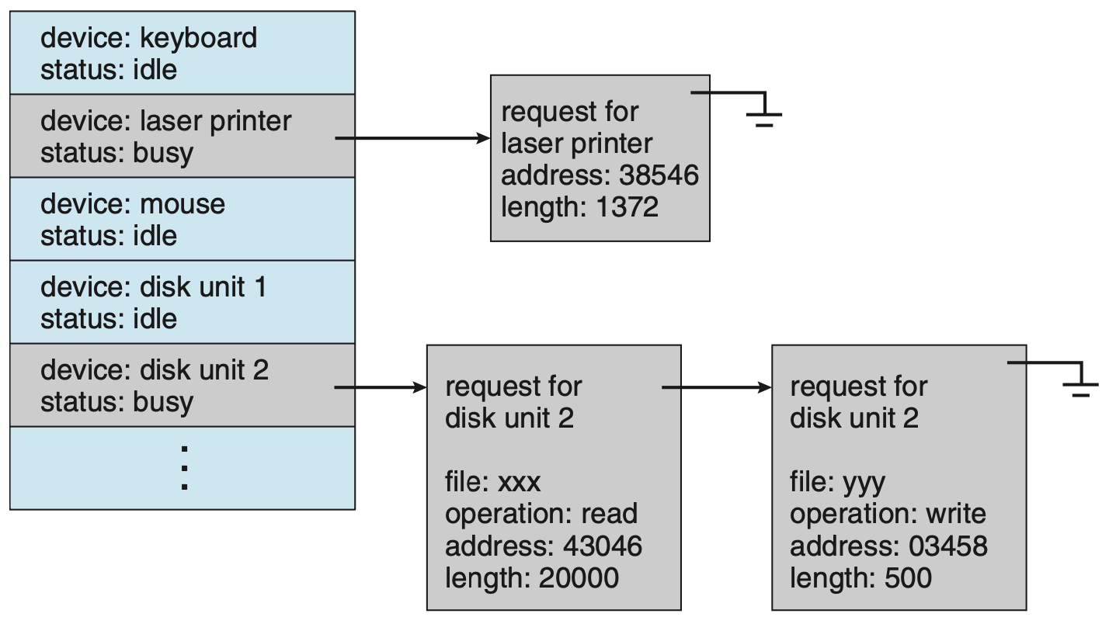

## Common I/O Device and Interface Speeds

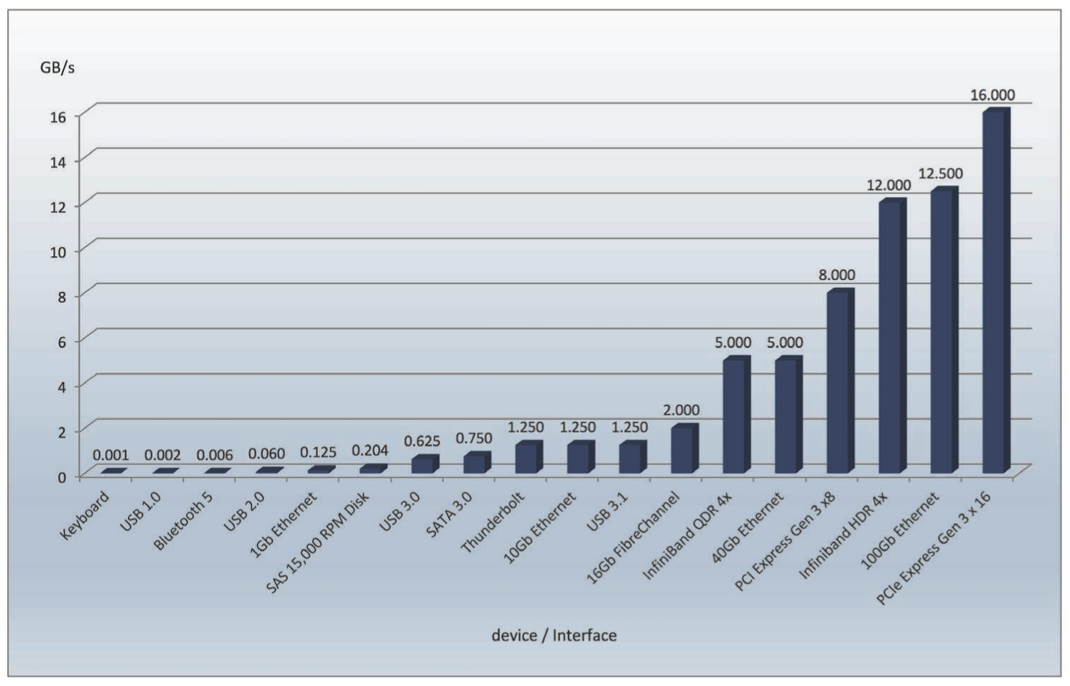

## Kernel I/O Subsystem

* ***Caching*** – faster device holding copy of data
  + Always just a copy
  + Key to performance
  + Sometimes combined with buffering
* ***Spooling*** – holding output for a device
  + If device can serve only one request at a time
* ***Device reservation*** – exclusive access to a device
  + System calls for allocation and de-allocation
  + Watch out for deadlock

## Error Handling

* OS can recover from disk read, device unavailable, transient write failures
  + Retry a read or write, for example
  + Some systems more advanced
    - Track error frequencies, stop using device with increasing frequency of retry-able errors
* Most return an error number or code when I/O request fails
* System error logs hold problem reports

## I/O Protection

* User process may accidentally or purposefully attempt to disrupt normal operation via illegal I/O instructions
  + All I/O instructions defined to be *privileged*
  + I/O must be performed via system calls
    - memory-mapped I/O must be protected
    - I/O port memory locations must be protected too

### Use of a System Call to Perform I/O

## Kernel Data Structures

* Kernel keeps state info for I/O components
  + Includes open file tables, network connections, character device state
* Many, many complex data structures to track buffers, memory allocation, “dirty” blocks, …
* Some use object-oriented methods and message passing to implement I/O
  + Windows uses message passing
    - Message with I/O information passed from user mode into kernel
    - Message modified as it flows through to device driver and back to process

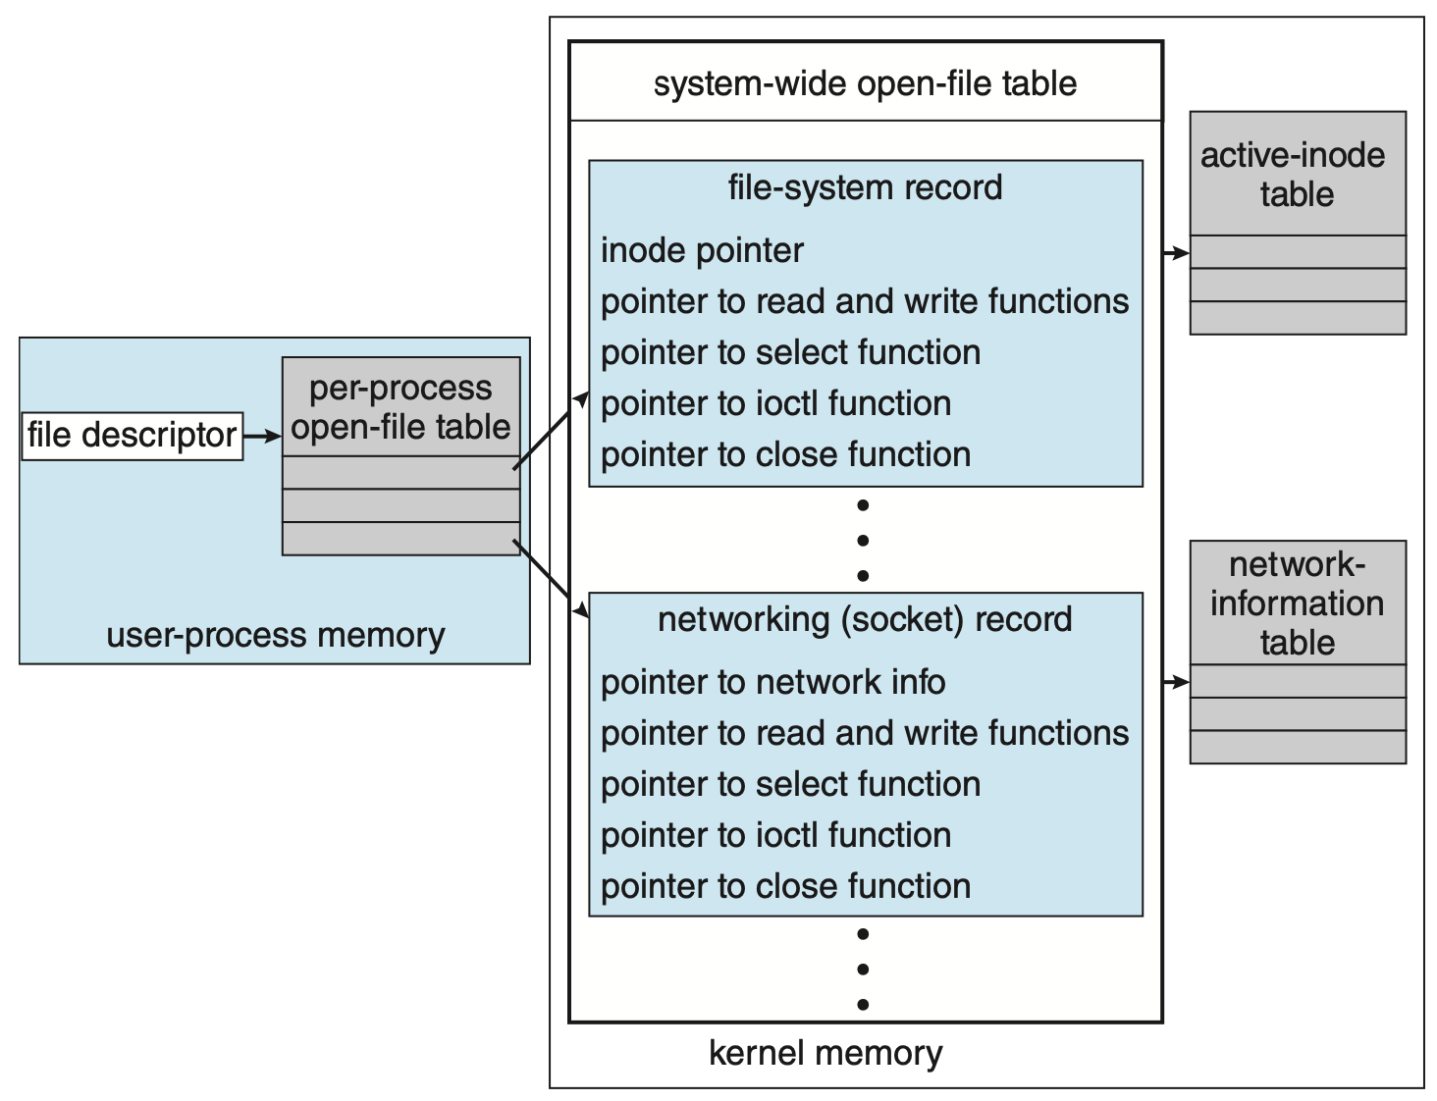

## I/O Requests to Hardware Operations

* Consider reading a file from disk for a process:
  + Determine device holding file
  + Translate name to device representation
  + Physically read data from disk into buffer
  + Make data available to requesting process
  + Return control to process

## Life Cycle of an I/O Request

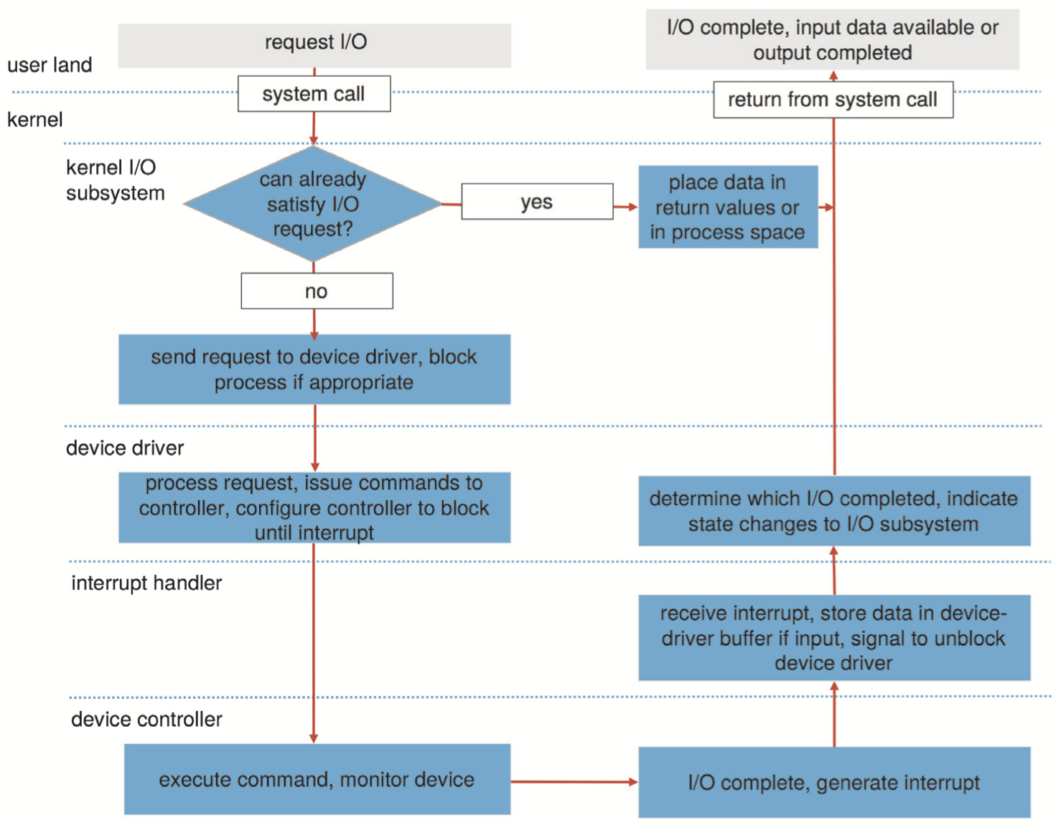

1. A process issues a blocking read() system call to a file descriptor of a file that has been opened previously.
2. The system-call code in the kernel checks the parameters for correctness. In the case of input, if the data are already available in the buffer cache, the data are returned to the process, and the I/O request is completed.
3. Otherwise, a physical I/O must be performed. The process is removed from the run queue and is placed on the wait queue for the device, and the I/O request is scheduled. Eventually, the I/O subsystem sends the request to the device driver. Depending on the operating system, the request is sent via a subroutine call or an in-kernel message.
4. The device driver allocates kernel buffer space to receive the data and schedules the I/O. Eventually, the driver sends commands to the device controller by writing into the device-control registers.
5. The device controller operates the device hardware to perform the data transfer.
6. The driver may poll for status and data, or it may have set up a DMA transfer into kernel memory. We assume that the transfer is managed by a DMA controller, which generates an interrupt when the transfer completes.
7. The correct interrupt handler receives the interrupt via the interrupt- vector table, stores any necessary data, signals the device driver, and returns from the interrupt.
8. The device driver receives the signal, determines which I/O request has completed, determines the request’s status, and signals the kernel I/O subsystem that the request has been completed.
9. The kernel transfers data or return codes to the address space of the requesting process and moves the process from the wait queue back to the ready queue.
10. Moving the process to the ready queue unblocks the process. When the scheduler assigns the process to the CPU, the process resumes execution at the completion of the system call.

## STREAMS

* STREAM – a full-duplex communication channel between a user-level process and a device in UNIX System V and beyond
* A STREAM consists of:
  + STREAM head interfaces with the user process
  + Driver end interfaces with the device
  + Can be multiple STREAM modules between them
* Each module contains a ***read queue*** and a ***write queue***
* Message passing is used for queue communication
  + Flow control option to indicate available or busy
* Asynchronous internally, synchronous where user process communicates with STREAM head

### The STREAMS Structure

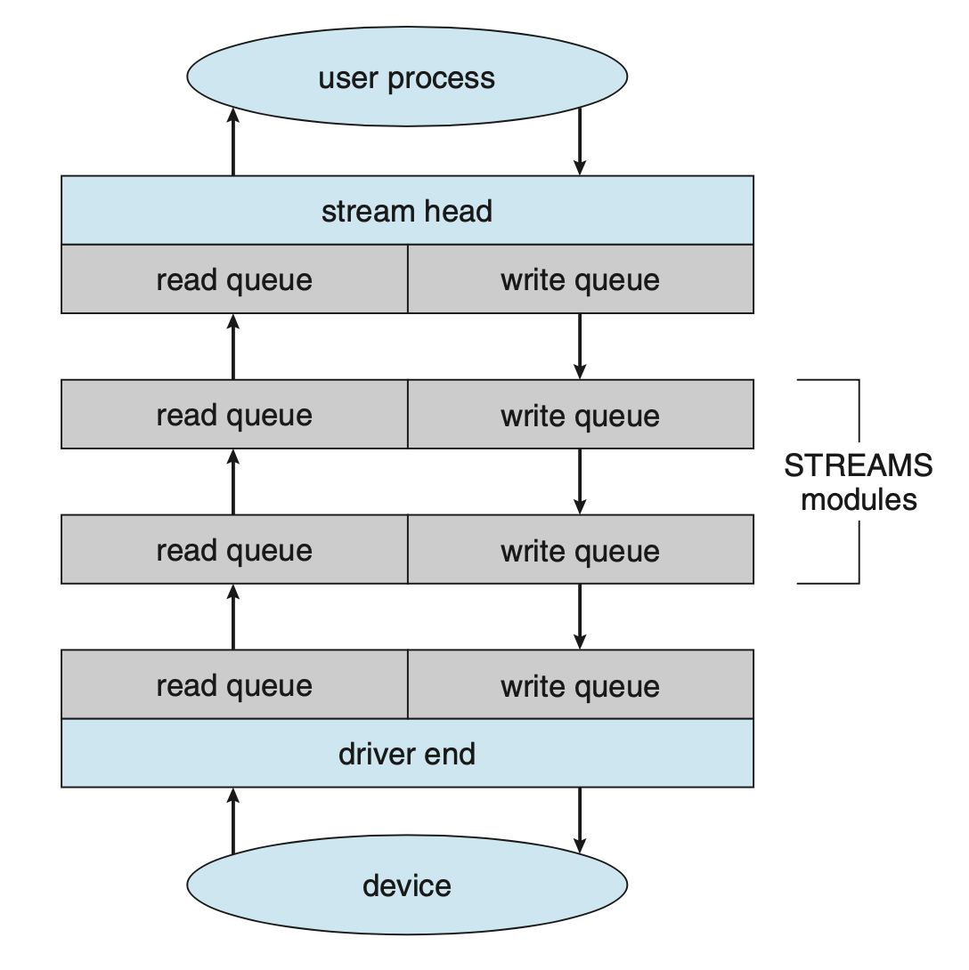

## Performance

* I/O a major factor in system performance:
  + Demands CPU to execute device driver
  + Demands CPU to kernel I/O code
  + Context switches due to interrupts
  + Data copying
  + Network traffic especially stressful

## Intercomputer Communications

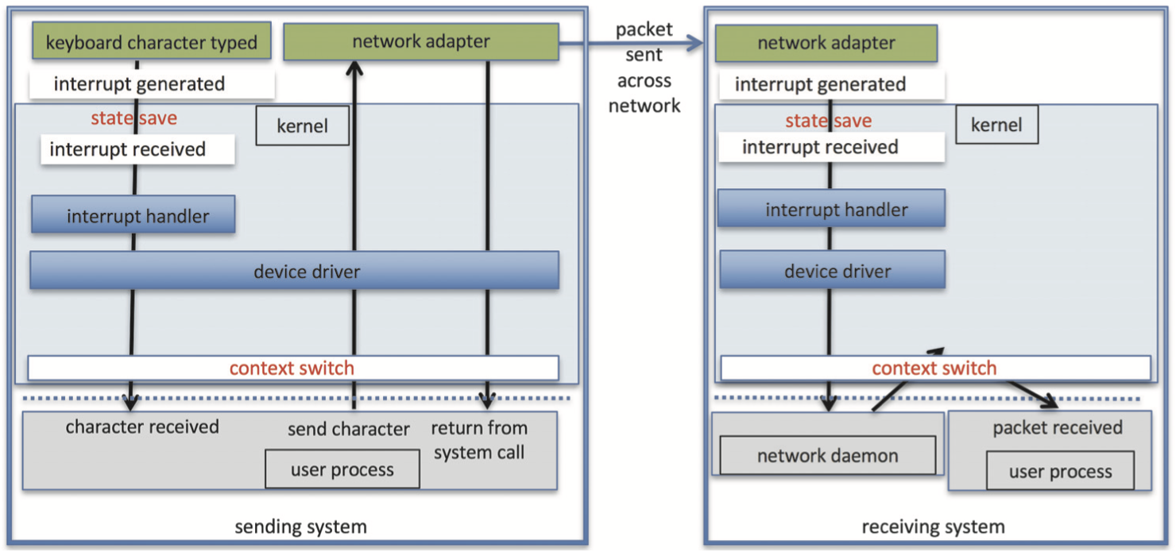

### Improving Performance

* Reduce number of context switches
* Reduce data copying
* Reduce interrupts by using large transfers, smart controllers, polling
* Use DMA
* Use smarter hardware devices
* Balance CPU, memory, bus, and I/O performance for highest throughput
* Move user-mode processes / daemons to kernel threads